The Climate Impacts Group (CIG) is leading the development of a Northwest Climate State of Knowledge Synthesis for ecosystems, species and habitats.

Goal: Develop a resource that synthesizes existing scientific knowledge of climate projections, impacts to natural systems and adaptation options relevant to natural resource management in the Northwest (Washington, Oregon, Idaho and western Montana). The primary audience for the synthesis is technical staff in wildlife and land management agencies of federal, state, local and tribal governments. We anticipate that this resource will be used in planning documents and vulnerability assessments as well as for increasing awareness within agencies about potential climate impacts and adaptation options.

BACKGROUND

Land and wildlife managers need impartial, scientifically robust information on climate impacts to inform management decisions and planning. Climate science evolves rapidly; keeping up with the prolific information available is a daunting challenge, even for natural resource agencies with staff dedicated to climate resilience. The challenge is even greater for agencies without staff dedicated to resilience. The Northwest Climate State of Knowledge synthesis will increase the accessibility and utility of climate science, thereby increasing the capacity of the region's wildlife and land management agencies to help species and ecosystems adapt to climate change. The Northwest Climate State of Knowledge will synthesize existing information in three areas of climate science:

- Projected changes in the climate relevant for ecosystems and species, including biophysical changes (e.g., temperature and precipitation), and changes in processes (e.g., wildfire and flooding).
- Expected impacts of these changes on multiple ecosystems and habitats. Ecosystems will likely include coastal and marine systems, wetlands and aquatic habitats, forests, grasslands and shrublands.
- Adaptation options to reduce negative impacts as well as existing information on the potential effectiveness of these options.

Compilations of existing information, including research supported by the NW CASC, will be delivered in a user-friendly format and accessible to a wide audience of land and wildlife managers to support their use of climate science in management decisions.

By consolidating and highlighting science findings in a single resource for the region, it is our hope that this shared resource can facilitate collaborative and cross-agency climate change responses.

The Northwest Climate State of Knowledge Synthesis strives to:
> Assist land and wildlife managers with the daunting challenge of staying current on rapidly evolving climate science.
> Provide impartial, scientifically robust information to support decision making.
> Facilitate regional coordination on climate resilience through common information.
> Increase accessibility and utility of science on climate impacts and adaptation for species and ecosystems in the Northwest.

PROCESS AND PRODUCT: 3 PHASES

- Scope and Team build In the scoping phase, we will listen to the needs and interests of Northwest CASC Stakeholder Advisory Committee and broad audience regarding information needs for climate projections, climate impacts science, and adaptation options. This process will include building a project team from NW CASC consortium universities to fill the expertise needed to complete the synthesis.

- Develop Content: We will synthesize literature, with a focus on the last 5 years, to describe current understanding of climate impacts to species and ecosystems. Sectoral and ecosystem focus areas will depend on information gathered during the scoping phase and the expertise of the project team. In addition to climate projections and impacts, each section will include current understanding of adaptation options and their effectiveness.

- Format and Deliver: Information will be aggregated, and data summaries provided, at multiple geographic scales relevant for resource management (e.g., ecoregion and watersheds). Climate projections will be provided in succinct descriptions of projected changes that can easily be included in reports and plans. Science findings will be presented in an “easy-to-skim” format with functionality to query by impact or ecosystem. The product will include features such as annotated lists of datasets and bibliographies and links to data sources. We will explore creative delivery formats beyond the traditional multichapter reports.

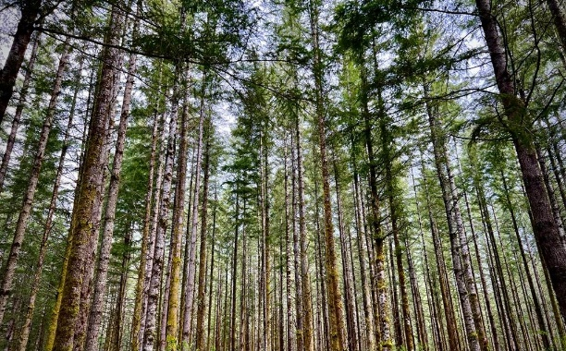

STATE OF KNOWLEDGE SYNTHESIS: CONCEPT & EXAMPLES

The Climate Impacts Group’s State of Knowledge reports for Washington State and the Puget Sound regionPuget Sound set the stage for a new approach to synthesizing climate science and impacts for a region. These reports recognized that adaptation practitioners need quick access to internally consistent, quantitative information about projected future conditions. The Northwest Climate State of Knowledge will build from this experience and the feedback we’ve received regarding the utility of these products.

The project team will explore creating high-level briefs for some topic areas depending on the interest and need of the Northwest CASC stakeholders. These will be modeled after CIG’s success with briefs developed to summarize large international climate reports including Shifting Snowlines and Shorelines and No Time to Waste.

The Northwest Climate State of Knowledge synthesis will complement other climate syntheses underway, including the Northwest Regional Chapter of the Fifth National Climate Assessment and topic-specific chapters such as Forests and Ecosystems and Biodiversity.

110
Climate change research projects funded by the Northwest Climate Adaptation Science Center since 2017.

PROJECT DETAILS

Project Funder: USGS Northwest Climate Adaptation Science Center

Project Lead: Crystal Raymond, Climate Adaptation Specialist, Climate Impacts Group, clrfire@uw.edu

Project Timeline: Completion expected fall 2023

