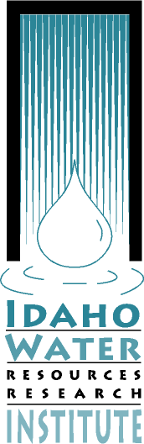**Idaho Water Resources Research Institute**

**Moscow Coeur d’Alene Boise**

UI Morrill Hall 105 1031 N. Academic Way 322 Front Street

875 Perimeter Dr. Room 216 Suite 242

MS 3010 Coeur d’Alene, ID 83844 Boise, ID 83720

Moscow, ID 83844-3010

(208) 885-6689 (208) 664-7027 (208) 332-4422



Date

October 19, 2015

To: Water Resources Research Faculty

From: Interim Director, Idaho Water Resources Research Institute

Re: Request for Proposals for the FY 2016 USGS Section 104(b) Program

The Idaho Water Resources Research Institute requests proposals to support water resources research and outreach activities on topics of importance to the State of Idaho through the United States Geological Survey’s Section 104(b) grant program.

Research and outreach proposals submitted under this RFP are intended to address water resources problems of significance to Idaho, with the principal objectives of this program being to:

1. Conduct novel research relevant to Idaho’s water problems or issues;
2. Conduct innovative outreach activities that serve to inform management agencies and the general public about water resource issues of importance to Idaho;
3. Serve as seed funding for projects that can grow into larger programs;
4. Foster graduate student involvement in water research; and
5. Encourage highly innovative and creative investigation and communications.

For this RFP, proposals are solicited that address the issue of meeting future water information needs for Idaho. These studies can include:

* + Impacts and implications of water use transition in urbanizing areas;
  + Development and implementation of Integrated Water Resource Management
  + Incorporating climate change in municipal water resource planning; and
  + Development of methods to forecast future demand by all sectors of Idaho’s water users.

We anticipate that we will be able to fund three seed projects at a funding level of $15,000 for each project for Idaho’s Section 104(b) program this year. Applicants must match each federal dollar requested with not less than two (2) non-federal dollars. Proposals that can demonstrate the leveraging of existing research activities or identify a non-university match (i.e. through state agencies, local governments or private entities) will be given the highest priority for funding.

No indirect costs may be charged to the federal portion of the project funds, but federal and non-federal indirect costs may be included as part of the matching funds requirement. The award can begin on March 1, 2016 and the award period may run for up to one year.

Full proposals must be submitted to the Idaho Water Resources Research Institute in electronic format by **December 4, 2015**. The proposal submittal form is given in Attachment A to this announcement and proposals should be submitted using this form. Proposals must be submitted in electronic form (WORD files) to:

Mark D. Solomon, Associate Director

Idaho Water Resources Research Institute

University of Idaho – Coeur d’Alene

1031 N. Academic Way

Coeur d’Alene, ID 83814

(208) 664-7027

msolomon@uidaho.edu

The principal investigators for successful proposals will be notified by January 5, 2016. All letters identifying cost share commitments for successful proposals must be delivered to IWRRI by January 12, 2016. In addition, faculty with successful proposals from ISU and BSU will need to work with their sponsored project’s office to submit forms SF 424, SF 424a and SF 424b electronically as a pdf file to IWRRI by January 12, 2016. If you have any further questions, please call, write or e-mail Dr. Solomon.

Thank you

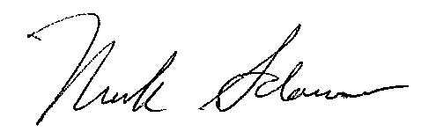

Mark D. Solomon, Associate Director

Idaho Water Resources Research Institute