Taking the next step
http://cb-ot-devst05.ad.wsu.edu/featherman/NewFor2018/Multiple_Itemson_Invoice.aspx
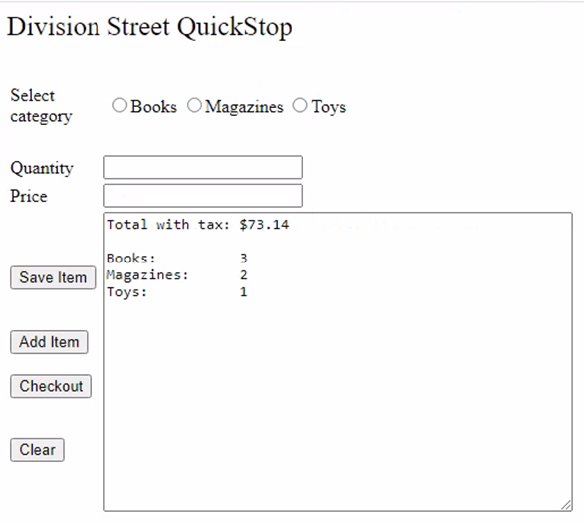
Partial Class NewFor2018_Multiple_Itemson_Invoice
Inherits System.Web.UI.Page
'this program is an upgrade from the first HW assignment where only one product could be purchased these global variable are to store totals for one transaction only. This program does not keep daily totals.
Public Shared gdecTotalBooks, gdecTotalMags, gdecTotalToys, gdecInvoiceTotal As Decimal

Protected Sub Button1_Click(sender As Object, e As EventArgs) Handles btnSave.Click
'this procedure enters only the first item of the transaction. first we zero out all the variables
gdecInvoiceTotal = 0
gdecTotalBooks = 0
gdecTotalMags = 0
gdecTotalToys = 0
'error checking is needed
If txtPrice.Text = Nothing OrElse txtQuantity.Text = Nothing OrElse RadioButtonList1.SelectedIndex = -1 Then
Exit Sub
End If
'calculate the current line item
gdecInvoiceTotal = Convert.ToDecimal(txtQuantity.Text) * Convert.ToDecimal(txtPrice.Text)

'increment the running total for only the selected product category
Select Case RadioButtonList1.SelectedItem.Text
Case "Books"
gdecTotalBooks += Convert.ToDecimal(txtQuantity.Text)
Case "Magazines"
gdecTotalMags += Convert.ToDecimal(txtQuantity.Text)
Case "Toys"
gdecTotalToys += Convert.ToDecimal(txtQuantity.Text)
End Select
'clear out the data entry controls to speed up the entry of additional items
txtPrice.Text = Nothing
txtQuantity.Text = Nothing
RadioButtonList1.SelectedIndex = -1
'give a prompt to the program user telling them their options
txtOutput.Text = "enter another item and press Add Item button, or checkout if done"

'this procedure enters only the first item of the transaction, so we hide this button 'after the procedure. Now show the right buttons for the next step in the transaction.
btnSave.Visible = False
btnAddItem.Visible = True
btnCheckout.Visible = True
End Sub

Protected Sub btnAddItem_Click(sender As Object, e As EventArgs) Handles btnAddItem.Click
'if the program user wants to buy another item, this procedure adds new items to the totals we need to make sure the first button is hidden and not used by accident. We can't use the first procedure again, because that zero's out all the variables.
btnSave.Visible = False 'error checking is needed
If txtPrice.Text = Nothing OrElse txtQuantity.Text = Nothing OrElse RadioButtonList1.SelectedIndex = -1 Then
Exit Sub
End If

'add the price of the new line item to the total, then increment the quantity for only the correct category
gdecInvoiceTotal += (Convert.ToDecimal(txtQuantity.Text) * Convert.ToDecimal(txtPrice.Text))

Select Case RadioButtonList1.SelectedItem.Text
Case "Books"
gdecTotalBooks += Convert.ToDecimal(txtQuantity.Text)
Case "Magazines"
gdecTotalMags += Convert.ToDecimal(txtQuantity.Text)
Case "Toys"
gdecTotalToys += Convert.ToDecimal(txtQuantity.Text)
End Select
'clear out the data entry controls to speed up further data entry
txtPrice.Text = Nothing
txtQuantity.Text = Nothing
RadioButtonList1.SelectedIndex = -1
End Sub

Protected Sub btnCheckout_Click(sender As Object, e As EventArgs) Handles btnCheckout.Click
'ok checkout - calculate the tax and show the totals
gdecInvoiceTotal *= 1.06
txtOutput.Text = "Total with tax: " & gdecInvoiceTotal.ToString("C2") & vbNewLine & vbNewLine
txtOutput.Text &= "Books: " & vbTab & vbTab & gdecTotalBooks & vbNewLine & "Magazines: "
& vbTab & gdecTotalMags & vbNewLine & "Toys: " & vbTab & vbTab & gdecTotalToys
btnSave.Visible = True
End Sub

Protected Sub btnClear_Click(sender As Object, e As EventArgs) Handles btnClear.Click
'set the buttons on the form to only show the useful buttons and hide the buttons that should not be used yet
btnAddItem.Visible = False
btnCheckout.Visible = False
btnSave.Visible = True

'clear the data entry controls
txtPrice.Text = Nothing
txtQuantity.Text = Nothing
txtOutput.Text = Nothing
RadioButtonList1.SelectedIndex = -1

'zero out all the variable to get ready for the next customer.
gdecInvoiceTotal = 0
gdecTotalBooks = 0
gdecTotalMags = 0
gdecTotalToys = 0
End Sub
End Class

