Featherman’s DAX adventures: In-Class Exercise Making Calculated Columns
DAX is the programming language inside PowerBI and PowerPivot (which is inside Excel). DAX is used primarily to produce calculated columns in tables and calculated measures.

This in-class exercise introduces DAX’s RELATED function which is similar to VLOOKUP() which is a favorite of accountants/financiers that use Excel as their database. Because we build a data model we can leverage the fact that the tables are related with a foreign key relationship.

Open up PowerBI, connect to Featherman_Analytics database and load the AW_Products_Flattened table.
Server = cb-ot-devst03.ad.wsu.edu
Database = Featherman_Analytics
UserID = mfstudent
Pwd = BIanalyst
When entering the UserID and password be sure to click on the database tab on the left.
Next use the GetData or Recent Data Sources options to retrieve the FactResellerSales table. Rather than load the table, click edit to remove the columns from the FactResellerSales table that you do not see in the picture on the left. The purpose is to remove columns that are not currently needed and just clutter this learning experience.

The next portion of the document makes several columns in the Fact table using the formulas in the left hand column.
2 | LineItemCostPerUnit = RELATED(AW_Products_Flattened[Cost]) | In the data table click add column and type the formula on the left. This formula pulls a column from another RELATED table into your analysis table. The next example shows that you can pull a value from another table into your formula. It is important to remember that this formula adds a value for every single row in your datatable. PowerBI keeps the process fast however as advanced memory management is used.
3 | LineItemProfitPerUnit = FactResellerSales[UnitPrice] - RELATED(AW_Products_Flattened[Cost]) | The unit cost for each product is master data and is retrieved from the Products table. Here we use the RELATED function as part of our formula.  After adding this formula, on the Modeling Tab change the formatting to comma with 2 decimal places. Right-click the OrderQuantity column and sort the table descending. If you scroll back to the LineItemProfitPerUnit column you just made, you will discover that some invoice line items are losing quite a bit of money!
4 | LineItemTotalProfit = FactResellerSales[LineItemProfitPerUnit] * FactResellerSales[OrderQuantity] | Notice this formula uses a calculated column created by a prior formula. While this is expected functionality in Excel, recall that SQL does not do this easily. Now right click this formula and sort this column ascending. Now it’s time to put on your revenue analytics (or auditing) hat on. Let’s do some research on why this company lost money on invoice. We need to look at when was the money lost, how much money was lost, on what products was money lost, to what reseller was money lost. We need to keep in mind the RFM approach to analytics (recency, frequency, and monetary).
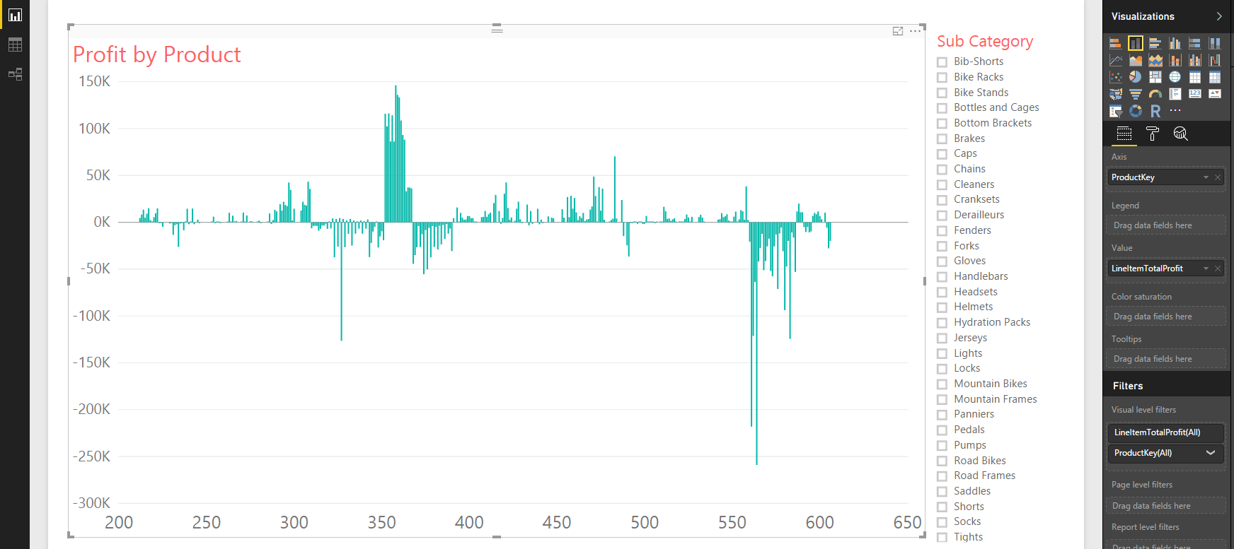
Make the chart as shown with ProductKey in the axis and Line item total profit in the value. Add a slicer on sub category and examine profit.
Duplicate the chart, remove the slicer and put Sub category in the Axis column to continue the analysis (see below).
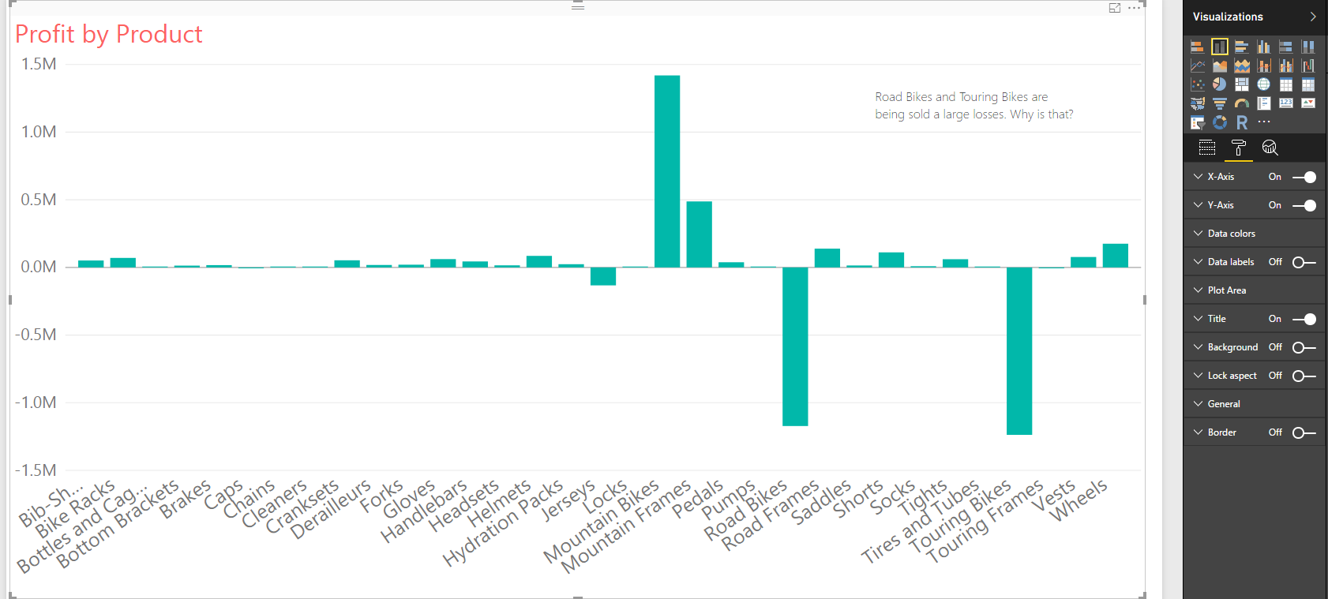
A textbox was put onto the report.

It looks like Road and Touring bikes are both sold at a loss. What is your first response?
Some questions are:
a) is it all colors and models of the bikes?
b) how long has this been going on?
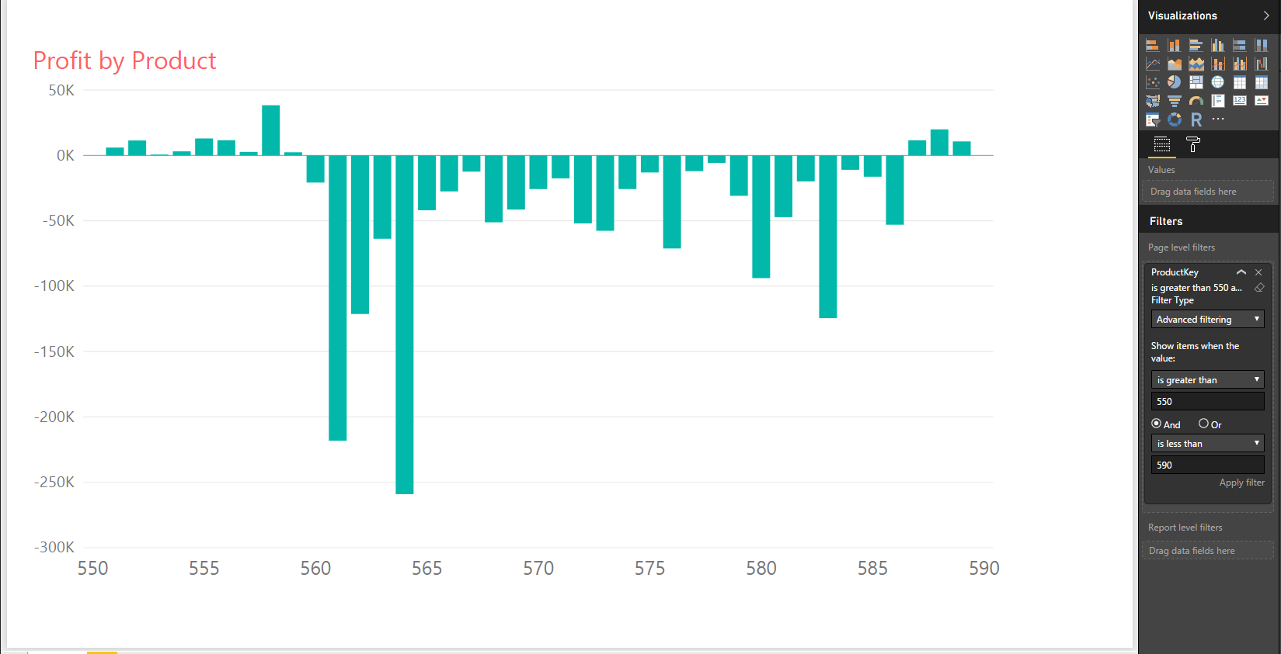
If you did not have a field that categorized the products into groups, you can also change the page level filter – here filter the product ID’s as show > 550 and < 590.
 | Use either sub-category filtering or product ID filtering. What factors are driving these losses?
Product 561 and 564 are generating the worst losses. What are the next steps?
1) Identify what products are these?
2) Identify the pricing of these products and the cost of these products (see if that changed over time). Research why the price is set too low and does not cover cost.
3) Examine the resellers that are purchasing these two products. Are they receiving unauthorized discounts? Is there a pattern of salesrep and reseller collusion to sell products below cost?
4) Examine the promotions, are promotional pricing to blame for the large losses?
5) Are there certain colors that need to be discounted to sell? If this is true, is it possible to repaint/re-assemble the remaining inventory?

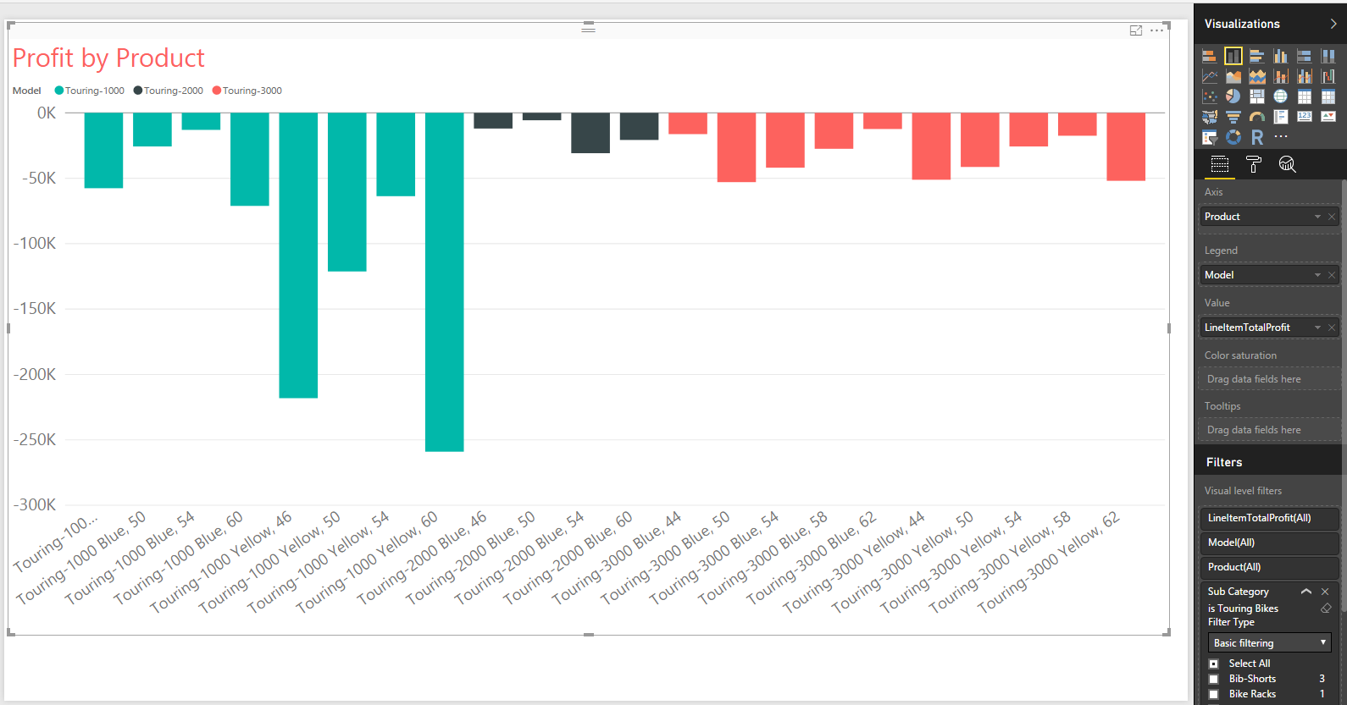
The products table has many dimensions, model, color, cost, prices. Go ahead and experiment with different fields in the axis and legend fields.
Should all touring bikes be discontinued?
5 | LineItem%Profit = FactResellerSales[LineItemProfitPerUnit] / FactResellerSales[UnitPrice] | While the prior formual show dollars ha can be counted, this next formula allows examination of profitability of each product as a %
6 | YearMonth = (FactResellerSales[OrderDate].[Year] *100) + FactResellerSales[OrderDate].[MonthNo] | Add this YearMonth formula using DAX. Here is another way to do the yearmonth calculation, rather than use the = (YEAR(OrderDate) *100) + Month(orderDate) which would also work. Be sure to change the datatype for this column to text so that the chart is drawn correctly.
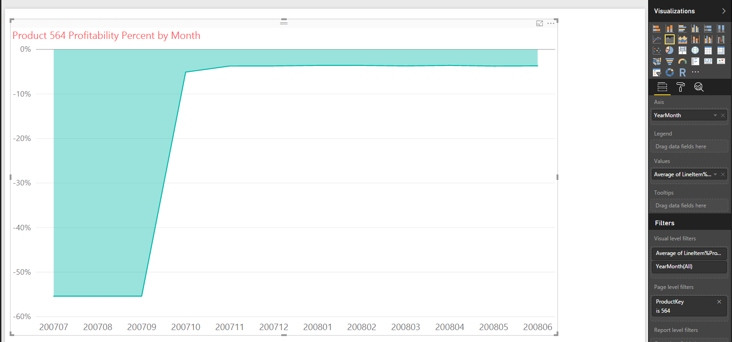
Well it looks like product 564 is now sold at an average 5% loss, but in an earlier time period was sold at an average 55% loss.
The auditor or revenue analyst would need to follow-up this analysis and put in controls to ensure this type of discounting, pricing and product offering is not repeated. Sales systems should be altered to stop this type of mistake. For example a managerial approval can be installed to allow products to be sold at a loss.
 | Continue the analysis and provide your recommendations to modify the product line and any controls that can be put in place to prevent further similar revenue problems.

