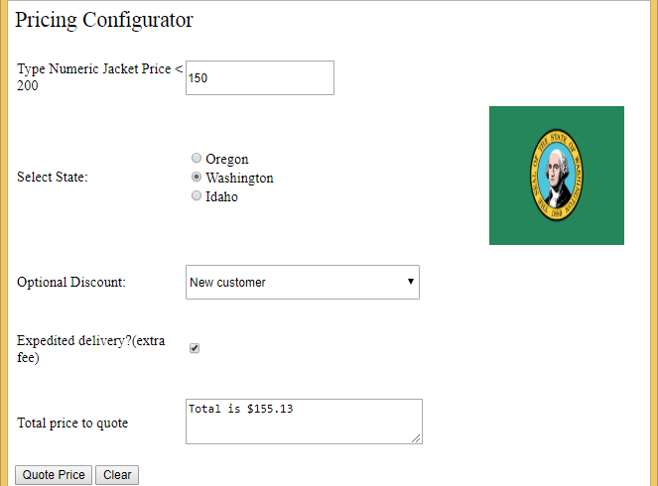
Using Select Case

' The program is a pricing configurator that a sales representative would use to quote an "out the door" price to a customer. The program and provides a different price quote depending on shipping type and state tax levels.This program shows how to change the picture being shown to the program user. Also SELECT CASE processing is used for the first time to make the web page perform differently depending on different user selections.

'We assign a value to a variable, then += add to it (taxes and shipping) or -= subtract from that value (discount). This is very useful!
Partial Class IntroDevClass_Mod3_jackets
Inherits System.Web.UI.Page
Public Shared decTaxRate As Decimal

Protected Sub Button1_Click(sender As Object, e As EventArgs) Handles Button1.Click

Dim dectotal As Decimal
'here we have 3 test conditions to check for. If any of them equate to true then the program will stop and show the error message. Error detection is used to enforce business rules, for examample here none of the jackets is list priced for more than $200 so the program checks for that data entry error.

If IsNumeric(txtPrice.Text) = False OrElse txtPrice.Text = Nothing OrElse txtPrice.Text.Contains("$") OrElse CDec(txtPrice.Text) > 200 Then
txtOutput.Text = "Please check jacket price is numeric only with not $ sign, less than 200"
Exit Sub
Else
'many developers like to tuck assignment operators inside an if-then-else-end if statement.
dectotal = Convert.ToDecimal(txtPrice.Text)
End If

'Apply optional discount. Here we deduct a discount from the sales price if a discount is selected. The values in the dropdown list are small decimals such as .15, .20 so multiplying the listprice * the discount results in the discount amount which can be subtracted from the decinal variable.

If ddlDiscounts.SelectedIndex > 0 Then
dectotal -= dectotal * ddlDiscounts.SelectedValue
End If

'apply the tax if a state was selected. Again the value for the tax rate is stored in the item collection's .value property, making this code parsimonious. Actually Washington does not have a sales tax, so consider this example as the business owner collecting a city tax.

If rblStates.SelectedIndex < 0 Then
txtOutput.Text = "Please select a state"
Exit Sub
Else
'you can write the code like this dectotal += (dectotal * rblStates.SelectedValue)
'this can also be written as

dectotal *= (1 + rblStates.SelectedValue)
End If

'apply differential shipping rate if the delivery is expedited
If chkDelivery.Checked = True Then
dectotal += 10
End If

txtOutput.Text = "Total is " & dectotal.ToString("C2")

End Sub

Protected Sub Button2_Click(sender As Object, e As EventArgs) Handles Button2.Click
'clear the form
txtPrice.Text = Nothing
txtOutput.Text = Nothing
rblStates.SelectedIndex = -1
ddlDiscounts.SelectedIndex = -1
chkDelivery.Checked = False
Image1.ImageUrl = Nothing
End Sub

Protected Sub rblStates_SelectedIndexChanged(sender As Object, e As EventArgs) Handles rblStates.SelectedIndexChanged
'This code will only run if an item was selected so there is no need for that error checking to see if an item was selected
'this code runs when an item in the radiobutton list is selected. When the program starts (or the control is cleared of previous selections) the index of the item changes from -1 (meaning nothing selected) to a larger number (the index number of the item selected). This change in the index number from -1 to another number fires this procedure and the rest of the code runs

'Here is how you show a picture in a control on a web page. You can add an image control to the web page and use the imageURL property and type in the name of the picture. So its best to keep the names of the pictures really brief!

'the term next to the Select case term is the condition being evaluated. Here the word in the text property of the radiobutton list is evaluated whether the term is Idaho, Washington, or California.

Select Case rblStates.SelectedItem.Text
Case "Idaho"
Image1.ImageUrl = "Idaho.gif"
Case "Washington"
Image1.ImageUrl = "Washington.png"
Case "Oregon"
Image1.ImageUrl = "Oregon.png"
End Select

End Sub
End Class

