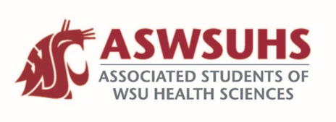
ASWSUHS Senate Meeting
Thursday, November 12th, 6-7 PM

“Our ASWSUHS Senate aims to promote a culture of inclusion, engagement, and collaboration across all programs. We intend to advocate on behalf of the students and their needs and to accomplish this objective through visibility and open communication.”

Meeting was call to order at 6:01 PM by Vice President Hovrud.
Attendance was taken by icebreakers. 11 senators were present.
Minutes of the previous meeting were read and then approved 11-0.

- Introduction and Check-In
  - Check-In/Icebreaker Question
- New Business
  - Suture Clinic Advertising
    - Document in your email with information and the RSVP form.

  - Clothing Drive Advertising
    - Nutrition Professionals for Success is doing a clothing drive for Blessings Under the Bridge! Last collection date is Friday, November 20th. Collection boxes in each building including SAC! It will be COVID safe. Looking for socks, jackets, sweaters, hats etc.

  - ASWSUHS Survey results:
    - Most people knew the senators
    - Majority had heard of ASWSUHS.
    - Pharmacy had a large majority of the voters.!
    - Many people are able to get involved with RSO’s
    - Requests
      - Campus gym & workout classes
      - financial assistant resources
      - library access
      - increase technology access
      - ways to access food and health services
      - etc. document was sent to your email for further information!
    - Program specific requests are also included in the document so please look at those so they can be addressed!

  - RSO Events
    - Please send Keelin Hovrud an email containing your programs events for the month of December to be added to a campus calendar on Friday, November 20th.
  - Gender Affirming Care
    - Thursday December 3rd at 6:00 PM
    - Great for all healthcare providers! Contact Ross Budreau for more information.

  - S&A Fees Committee
    - Excess funds left over that we all paid for within tuition was not completely used by the school due to a lack of events due to COVID.
    - Refunding Spokane and Yakima students $50. Remaining money in the fund would be for one-time projects such as:
      - update NEP buildings
      - extra equipment needed for the fitness center
    - Still needs to be passed by the board of Regents and spoken between the Campus Life and Improvement Committee as well as decided by the senate.

  - Payment Paperwork
    - An email should have been sent out to approve payment for next semester. Please fill that out and return it ASAP!

  - Community Fellows Mask Up Video
    - Students, faculty and staff make a 10 second video on ‘why you choose to mask’.
    - Deadline November 20th.
    - Send to Sam!
    - Look out for an email with more information

Before concluding the meeting, questions and concerns were addressed. Having no further business, the meeting was then adjourned at 6:50 PM.

