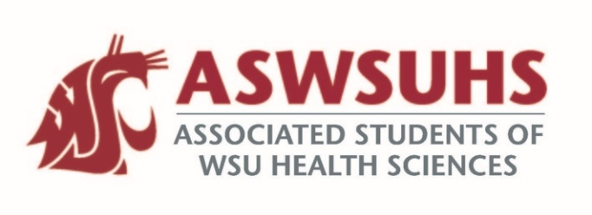
ASWSU Executive Board
Meeting December 8, 2020

Board Members:
President – Nidhi Patel
Vice President – Keelin Hovurd
VP Legislative Affairs – Colin Beauvais
Director of Finance – Arsanuos Balamoun
Chief of Staff – Samuel Nahulu
Director of Yakima Relations – Grayson Aames
Advisor – Jim Mohr / Pat McQuitty

Agenda:
- Welcome back
- Approval of Last Week’s Minutes
- Position Updates
  - President
    - Gift Card Giveaways
      - Still have four gift cards to give away to students
        - Probably give this away during exam week; market this on Instagram, Facebook, etc.
      - Gift Cards potentially not being allowed next year
  - VP
    - Senate Updates
      - Menstrual Hygiene products in the bathrooms in our buildings
        - Only senators can sponsor a resolution.
      - Funding request from campus pantry
    - We have to do a first reading and second reading Passing resolutions
      - We can move to the second meeting if we have 2/3 vote of the senate.
      - Having senate next week or not.
      - Have the year it was passed and the order it was passed (Ex: 21-01)
  - VPLA
    - Testing accommodation for distanced learning Pharmacy Specific
      - Wearing noise cancelling headphones not being allowed
        - Email later clarified that students are being able to wear ear plugs incase you are in a noisy environment.
        - Having ear plugs on campus for students?
      - Do students have any rights?
        - Students should be guaranteed an accommodation for distanced learning.
    - Legislative Session Updates
      - Meeting last Thursday with friends of the future.
      - Budget deficit is not as bad as they were expecting.
        - Only predicting a 3 billion dollar budget cap as expected (expected 9-11 billion dollar)
      - We don’t need to fight as hard in order to protect all the funding for higher education currently. She also mentioned she has the potential to expand access.
      - Rejected the first SGC proposal due to not being able to go over what the proposal was.
        - Figured it out though.
  - Chief of Staff
  - Director of Finance
  - Director of Yakima Relations
  - Advisor

