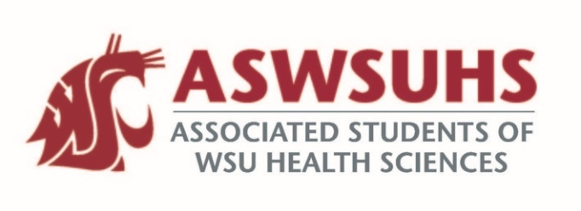
ASWSU Executive Board
Meeting December 1, 2020

Board Members:
President – Nidhi Patel
Vice President – Keelin Hovurd
VP Legislative Affairs – Colin Beauvais
Director of Finance – Arsanuos Balamoun
Chief of Staff – Samuel Nahulu
Director of Yakima Relations – Grayson Aames
Advisor – Jim Mohr / Pat McQuitty

Agenda:
- Welcome back
- Approval of Last Week’s Minutes
- Position Updates
  - President
    - Student Life and Campus Improvement Committee
      - Fund the gym equipment as much as we could
      - Talked about trying to get professional contracts with people from local gyms on top of the gym deals already being offered to our local students
        - Partnering with local gym to do a weekly gym class.
      - Fixing up specific buildings
        - Stairwells aren’t well kept, consistently dirty, not enough study space and lounging area, etc.
        - Yakima building
          - Figuring out what their needs are
            - Suggestions for the new PNWU campus – Grayson.
        - Emergency Buttons in the Parking Lot
      - The Green 6 Gravel Parking Lot
        - Trying to see if we can use that part of campus for future campus development.
        - Not going to use asphalt because its over $1,000,000 dollars.
        - Trying to get more lighting in that area.
          - Fall 2018 – Fall 2019, the lot got a lot brighter.
          - Also more lighting in other parts of campus that includes parking lots.
      - Campus Study Space and Campus Heating
        - 7:30 AM to 4:30 PM Monday – Friday.
      - Parking permits added to the WSU Spokane App.
    - March 7 - Planning to have the all campus wide student leadership conference. It’s not mandatory, but it’s something that we might be interested in going to.
      - Leadership opportunities
      - How to grow as a leader
      - Different symposiums, speakers, etc.
    - Keelin – One time S&A Funding ($65K)
      - Prioritizing the HERB Building and Yakima campus and updating some of the furniture there.
      - Creating some sitting areas in Yakima for both Pharmacy and for Nursing
      - Gym
        - Potentially purchasing more equipment
      - Create work groups in the senate
        - Work with faculty over winter break, and come back next semester with those proposals.
  - VP
    - Senate Updates
      - Two funding requests
  - VPLA
    - Legislative Session Updates
      - Meeting with Randy and Information from Chris
      - No public access is allowed anywhere on the capitol grounds
        - Many senators will be in Olympia regardless; will not take public meetings or anything like that.
        - Senators and representatives to propose 4-7 bills during this entire session.
          - No companion bills be introduced.
          - Bills with urgent need due to COVID-19 and racial equity are probably going to be heard from what we are hearing.
          - A good 50% of our issues will be heard.
      - Will not be traveling to Olympia reallocate these funds for other issues.
        - Potentially using that money to hire a temporary student job to create social programs on campus.
    - COVID Vaccine Student Distribution
      - It’s going to be a discussion, but tentatively speaking (Pharmacy, Nursing, Medicine, etc. that have in person patient care) will qualify for first year vaccines or second year vaccines.
      - Vaccination happening in California.
  - Chief of Staff
  - Director of Finance
  - Director of Yakima Relations
  - Advisor
    - Reallocating funds from Colin’s travel budget to a potential student worker that we can hire to put on social events, etc. S&A committee has to fund this though.

