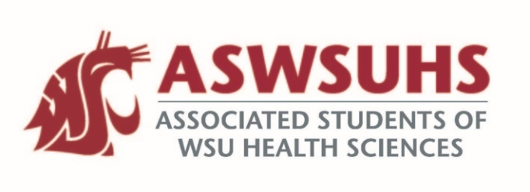
ASWSU Executive Board
Meeting November 10, 2020

Board Members:
President – Nidhi Patel
Vice President – Keelin Hovurd
VP Legislative Affairs – Colin Beauvais
Director of Finance – Arsanuos Balamoun
Chief of Staff – Samuel Nahulu
Director of Yakima Relations – Grayson Aames
Advisor – Jim Mohr / Pat McQuitty

Agenda:
- Welcome back
- Approval of Last Week’s Minutes
- Position Updates
  - President
    - Meeting with student life and campus improvement committee to create spaces that we can improve prior to coming back in Fall of 2021.
  - Veronica Puente: Director of Student Equity, Leadership, and Community
Division of Student Affairs
    - New Job Diversity, Equity and Inclusion position for an executive team member
    - Cougs in the Community Advised by Veronica
    - Looking at developing a student counsel that will meet at least monthly to keep everyone updated.
  - VP
    - No funding requests, etc.
  - VPLA
  - Chief of Staff
    - Nutrition Professionals for Success club is doing a Clothing Drive to support the Blessings Under the Bridge.
    - Ally training in a potential meeting.
  - Director of Finance
    - Travel Grant
      - 6 applicants
        - Approved 5 out of the 6; requested more information for that.
        - Everyone got approved 100% of their request
          - Came out to a total of $293
  - Director of Yakima Relations
  - Advisor
    - Student Fee Committee Meeting
      - Health fee will stay the same No refund for this; we will spend the money.
        - Will split the savings Will give a $50 refund to all the students
        - $61,000 will be going to the Senate Will not go to programming.
      - Christopher Szlenk is the chair of this committee.
        - Will send an email about this; technically the board will reject it but they probably won’t.
