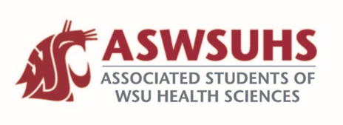
ASWSUHS Senate Meeting
Thursday, October 1st, 6-7 PM
“Our ASWSUHS Senate aims to promote a culture of inclusion, engagement, and collaboration across all programs. We intend to advocate on behalf of the students and their needs and to accomplish this objective through visibility and open communication.”

Meeting was call to order at 6:05 PM by Vice President Hovrud.
Attendance was taken by highs/lows. 11 senators were present, and quorum was met.
Minutes of the previous meeting were read and approved 11-0.

- Old Business
  - Office Hours:
    - Please send in office hours with your zoom link. An email was sent out with a list of who to email those to. Also, if you didn’t earlier this fall, please fill out the social media introduction being put on.
  - Get to Know You project:
    - If you haven’t done the project for Art yet, please fill this out to help. He sent an email to your official email with the information needed. This will take approximately 5 minutes.
  - Meet and Greet:
    - Has been officially scheduled for Thursday, October 15th from 6-7 pm. Spread the word and there will be Starbucks e-gift cards for prizes!

- New Business
  - Survey:
    - How students are doing and what they want to see from us! This has been posted on social media and we would love to see involvement from the student body if you can please spread the word. Share to your programs, there is an e-gift card for a prize!
  - SGC Update:
    - Student Government Council includes President, Vice President and President of Affairs from all WSU campuses. In the previous meeting they discussed pay switch for ASWSU and unfortunately makes it so international students can get taxed up to 30% of their income from their school job.
    - Conversations are taken place to figure out who is being recognized as a worker of WSU, who is being taxed and how we are being paid.
    - Forum on October 16th, time TBD.
  - Travel Grant Extension:
    - We have extended the date by 2 weeks; you can now apply until October 22nd. There is a lot of confusion on who can apply and when, so we want to give them more time. The form is on Give Pulse if you need to access or forward it.
  - Employees within Student Services:
    - Veronica is now the Director of Student Equity, Leadership and Community (ELC) and there will now be an Assistant Director of Student ELC. Veronica’s position has more flexibility than the previous position did so we are excited to see what we can do with students.
    - Increase of programming will come from this restructuring of community engagement. This provides more opportunities for growth and development within the system.
    - Diversity center will operate as normal when campus opens.
    - October 10th is the last paycheck of the ‘typical’ pay period before we switch over to being paid once a month. Next pay date will be November 25th.

- Closing Remarks
  - Still looking for S&A members, reach out to your programs to see if anyone is interested!
  - Please keep pushing the Childcare Survey, Meet and Greet and Travel Grant to those in your programs!
Before concluding the meeting, questions and concerns were addressed. Having no further business, the meeting was then adjourned at 6:38 PM.

