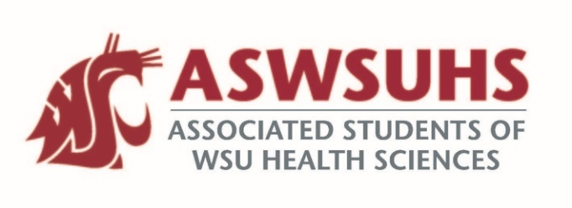
ASWSU Executive Board
Meeting October 6, 2020

Board Members:
President – Nidhi Patel
Vice President – Keelin Hovurd
VP Legislative Affairs – Colin Beauvais
Director of Finance – Arsanuos Balamoun
Chief of Staff – Samuel Nahulu
Director of Yakima Relations – Grayson Aames
Advisor – Jim Mohr / Pat McQuitty

Agenda:
- Welcome back
- Approval of Last Week’s Minutes
- Position Updates
  - President
    - Survey Review
      - Have about 56 replies with a majority of the responses being from Pharmacy students and Nursing students.
      - 6 Starbucks and 4 Amazon Gift Cards. All of these will be $10 gift cards.
      - Student Success and Mental Health Resources were the top two. Virtual Social Hangouts was in the top 3.
      - Any other comments
        - Teacher transparency
        - Admin transparency
    - Masks Purchase with SEB, CITC, and Coug Fellow
      - Purchases 400 masks for the community, would like to collaborate with student governments to purchase a 1000 masks and filters to send to every student. Trying to figure out the logistics for students.
        - Masks are $3.50 per mask.
        - Final numbers hopefully by Thursday.
  - VP
  - VPLA
    - Recap of Meeting with Chancellor DeWald
      - Financial Model
      - Started the Official Financial Evaluation
        - Currently evaluating the different financial models.
        - Lack of money will be going into the savings account.
      - Creating a Task Force with Some Students on it.
      - Business financial model update
        - Hasn’t been done before; will be highly evaluated by other campuses on exactly what we’re doing.
        - Will be implemented ASAP.
    - Legislative Agenda Updates
      - Legal Mandate for every single class on campus to be recorded and uploaded to BlackBoard.
        - Colin voted no against this takes away the experience of students coming to class and incentivizes students to skip classes. Additionally, students may have private things on screen capture that could be on the internet forever.
      - Minimum required stipend for assistantship/mentorship?
      - NAPLEX/SAT for teaching
        - Discriminates on people who are put into a school region that are disadvantaged.
      - Police Reform
        - Ban police dogs completely from campus – didn’t like the idea to ban the dogs.
        - Allocate resources – maybe.
        - Not allowing policemen on campus with a disciplinary record any violations, any abuse of power, use of excessive force, etc.
      - Title IX
        - Trying to keep the policy the same as it was during the Obama Era.
      - Giving transparency to students on what to expect the pay for jobs
        - Colin voted no on this.
  - Chief of Staff
  - Director of Finance
  - Director of Yakima Relations
  - Advisor

