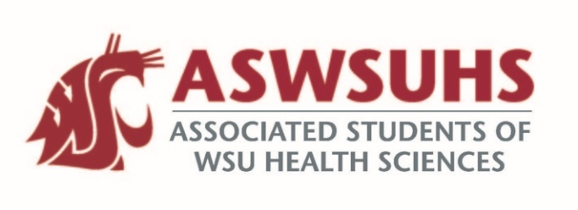
ASWSU Executive Board
Meeting September 1, 2020

Board Members:
President – Nidhi Patel
Vice President – Keelin Hovurd
VP Legislative Affairs – Colin Beauvais
Director of Finance – Arsanuos Balamoun
Chief of Staff – Samuel Nahulu
Director of Yakima Relations – Grayson Aames
Advisor – Jim Mohr / Pat McQuitty

Agenda:
- Welcome back
- Position Updates
  - President
    - Gym update
      - Asbestos
        - Will likely push reopening of the gym back to the Fall semester.
      - Gym Reimbursements
        - All approved for $43 reimbursement for Gym Apps instead of going to the Gym for students from Spokane Campus outside of Spokane and for Students in Yakima
      - Professor will teach Yoga
        - Virtual Yoga can be an option for students
          - Can have professional Yoga classes, etc.
    - Pictures
      - Take a professional photo of yourself. Professional photos for the ASWSUHS page are usually taken during retreat, but unfortunately we have not had that opportunity yet.
    - S&A Budget
      - ASWSU Programs
        - Fitness Memberships – No change. Will revisit this.
        - STA Bus Passes – No change. Will revisit this in the middle of the semester. May potentially cut some funding.
        - Promotional Material – Will cut requested funding to $3000 (From $4800) for the whole year.
        - Campus Improvement – No change.
        - Senate Funding request – No change.
        - Legislative Affairs Programming – No change. Will revisit this in the middle of the semester. May potentially cut some funding.
        - WSA Dues – No change.
        - Civic Engagement Council – No change.
        - Yakima Programming – No change.
        - Yakima Student Pantry – No change.
          - Currently no actual place for the Student Pantry.
        - Meet and Greet – Will cut approved funding to $750 (From $1000) for the whole year.
          - Cut $250
        - Travel Grants – Will cut approved funding to $76,000 (From $85,000) for the whole year
          - Cut $9000
      - ASWSU Admin
        - Wages – No change.
        - Goods and Services – No change.
        - Travel
          - General Travel – Will cut approved funding to $500 (from $650) for the whole year.
            - Cut $150.
          - SGC Travel – Will cut approved funding to $2200 (from $4200) for the whole year.
            - Cut $2000.
        - Benefits – No change.
        - Modernization Fee – No change.
  - VP
    - First Senate Meeting – IDI meeting on Thursday, September 3
  - VPLA
    - CEC Recap
      - Secretary of State Voter Presentation – October 5th
        - Will send this information out to all of the other Universities within the State of Washington.
    - Mental Health Awareness Project
      - REI
        - Get Faculty and Staff to talk about their ability to cope with mental health issues during the COVID-19 Pandemic.
        - Get individuals to go outside more, take care of their mental health, etc.
  - Chief of Staff
    - None.
  - Director of Finance
    - Travel Grants should be live within the next week
      - Link should be up fairly soon.
      - Travel Grants Committee
        - Nidhi and Keelin will assign individuals to these roles on the Travel Grants Committee.
  - Director of Yakima Relations
  - Advisor
    - Covid-19 Testing
      - A little difficult for on Campus testing. Still figuring this out.

