Innovation for transformational Energy Systems- A view from Germany.
Friday, September 29, 2017
ETRL 101
11am-12pm

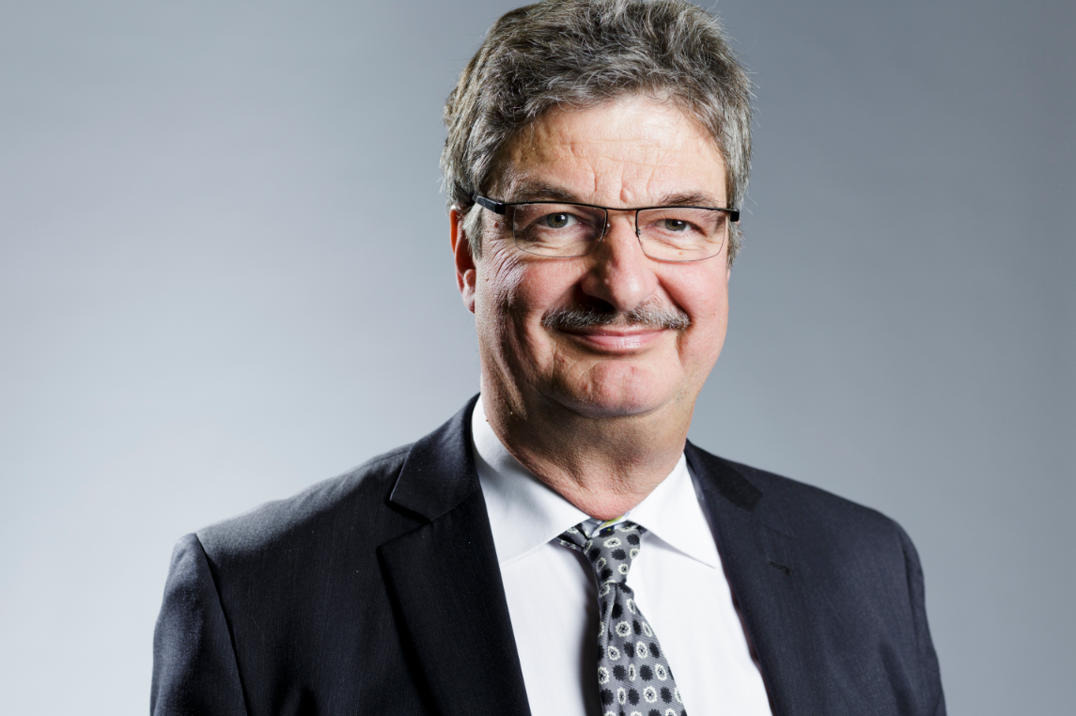

Prof. Dr. Maximilian Fleischer
Siemens AG

Maximilian Fleischer was born in Munich, Germany, where he studied technical physics. With a research thesis on high temperature semiconducting Ga₂O₃ thin films and their usage as gas sensors, he received the doctoral degree in Physics from the Technical University in Munich. With the continuation of his gas sensor research, he received his habilitation in Physics and a honorary professorship from the Technical University of Budapest.
He is a long years member of the Corporate Technology of Siemens AG, bridging academic and industrial research. His work includes piezoelectric motors, new types of semiconducting metal oxides, high-T electrochemical sensors, tunable laser diode spectroscopy for gas sensing, IR-spectroscopy for on-line analysis, work function type MEMS gas sensors and living cell based sensors. His recent activities include energy related topics with a certain focus on conversion of renewable electricity into chemicals, new energy storage and dispersed photovoltaic energy generation. He is acting as Chief Expert Energy Technologies where he takes the scientific lead of the research directions and long-term technology road mapping.
He is engaged in various entities, member of the editorial board of the Journal for Measurement Science & Technology, member of the board of trustees for Max Plank and Fraunhofer Institutes, member of the steering committee in various conferences. He published about 300 times, yielding an H-index and is co-inventor in about 180 international patent families.
Abstract:
Innovation is fundamental to meet the challenges of a fast changing energy system. It is driven by the availability of cheap renewable energies and new business model, as well as by widespread requests of the reduction of the CO₂. But how a 170 years old global company like Siemens addresses such challenges and sustains innovation? Prof. Fleischer will introduce Siemens Corporate Technology and its innovation structure specifically focusing on Energy Systems. He will then dive into topics related to Energy Systems such as the use of new material “Perovskite” for PV, transformational technology with decentralized and distributed grid, integration between mobility and grid, future generation of stationary industrial type batteries, and direct electrochemical conversion of CO₂ to CO and Hydrocarbons among others. Please come and join us for an exciting session.

For administrative support please contact: Kelly Lindsley
Please attend this session in person, if possible.

