________________ School District
September 2008

Growing Healthy Children…
…



Kids Can Cook!

Zucchini Boats
A fun way to enjoy all that summer
zucchini. Makes 2 “boats.”

1 medium-sized zucchini, washed, ends trimmed off
1/2 cup spaghetti sauce
1/4 cup corn (frozen or fresh)
1/4 cup bread or cracker crumbs or left-over rice
1/4 cup reduced-fat cheese, grated

1. Cook zucchini in boiling water until crisp-tender.
2. When cool, cut zucchini in half lengthwise and scoop out
the pulp, or flesh, of the zucchini leaving just the skin.
3. Mix zucchini pulp, sauce, corn and bread crumbs (or
cooked rice).
4. Spoon mixture into zucchini shells. Top with grated cheese.
5. Put under broiler for 2-3 minutes until cheese melts.


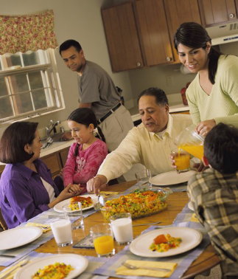

When families enjoy meals together all sorts of good things happen! In America and Europe those who study families notice that when adults and children eat their main meal together several times per week children feel more loved and valued. They also do better in school and get into trouble less often. The family tends to eat more nutritious foods too.

One key to eating together is being able to fix quick and easy meals. It’s a good idea to think ahead of time about what you will fix for dinner each night of the week. Perhaps on Saturday morning before heading to the grocery store, jot down several dinner menus and get all the ingredients. Plan to double some recipes so that you can cook once and eat twice. Leftovers become “planned-overs” and when you serve them with different side dishes they taste new.


Sharing a Meal. . .
Find a way to have at least several meals together
each week. Talk with your family and agree on certain days. Have family members decide what they’d like to eat at those meals. Then put family meal dates on the calendar.
Loving your Family…
…
Scrub-a-Dub
Did you know your hands have many germs even though you can’t see them? They can make you and your loved ones sick. To be safe, wash hands before you touch, prepare or eat food. And wash all fruits and veggies before preparing or eating them. September is National Food Safety Month; find out more at www.fightbac.org.




