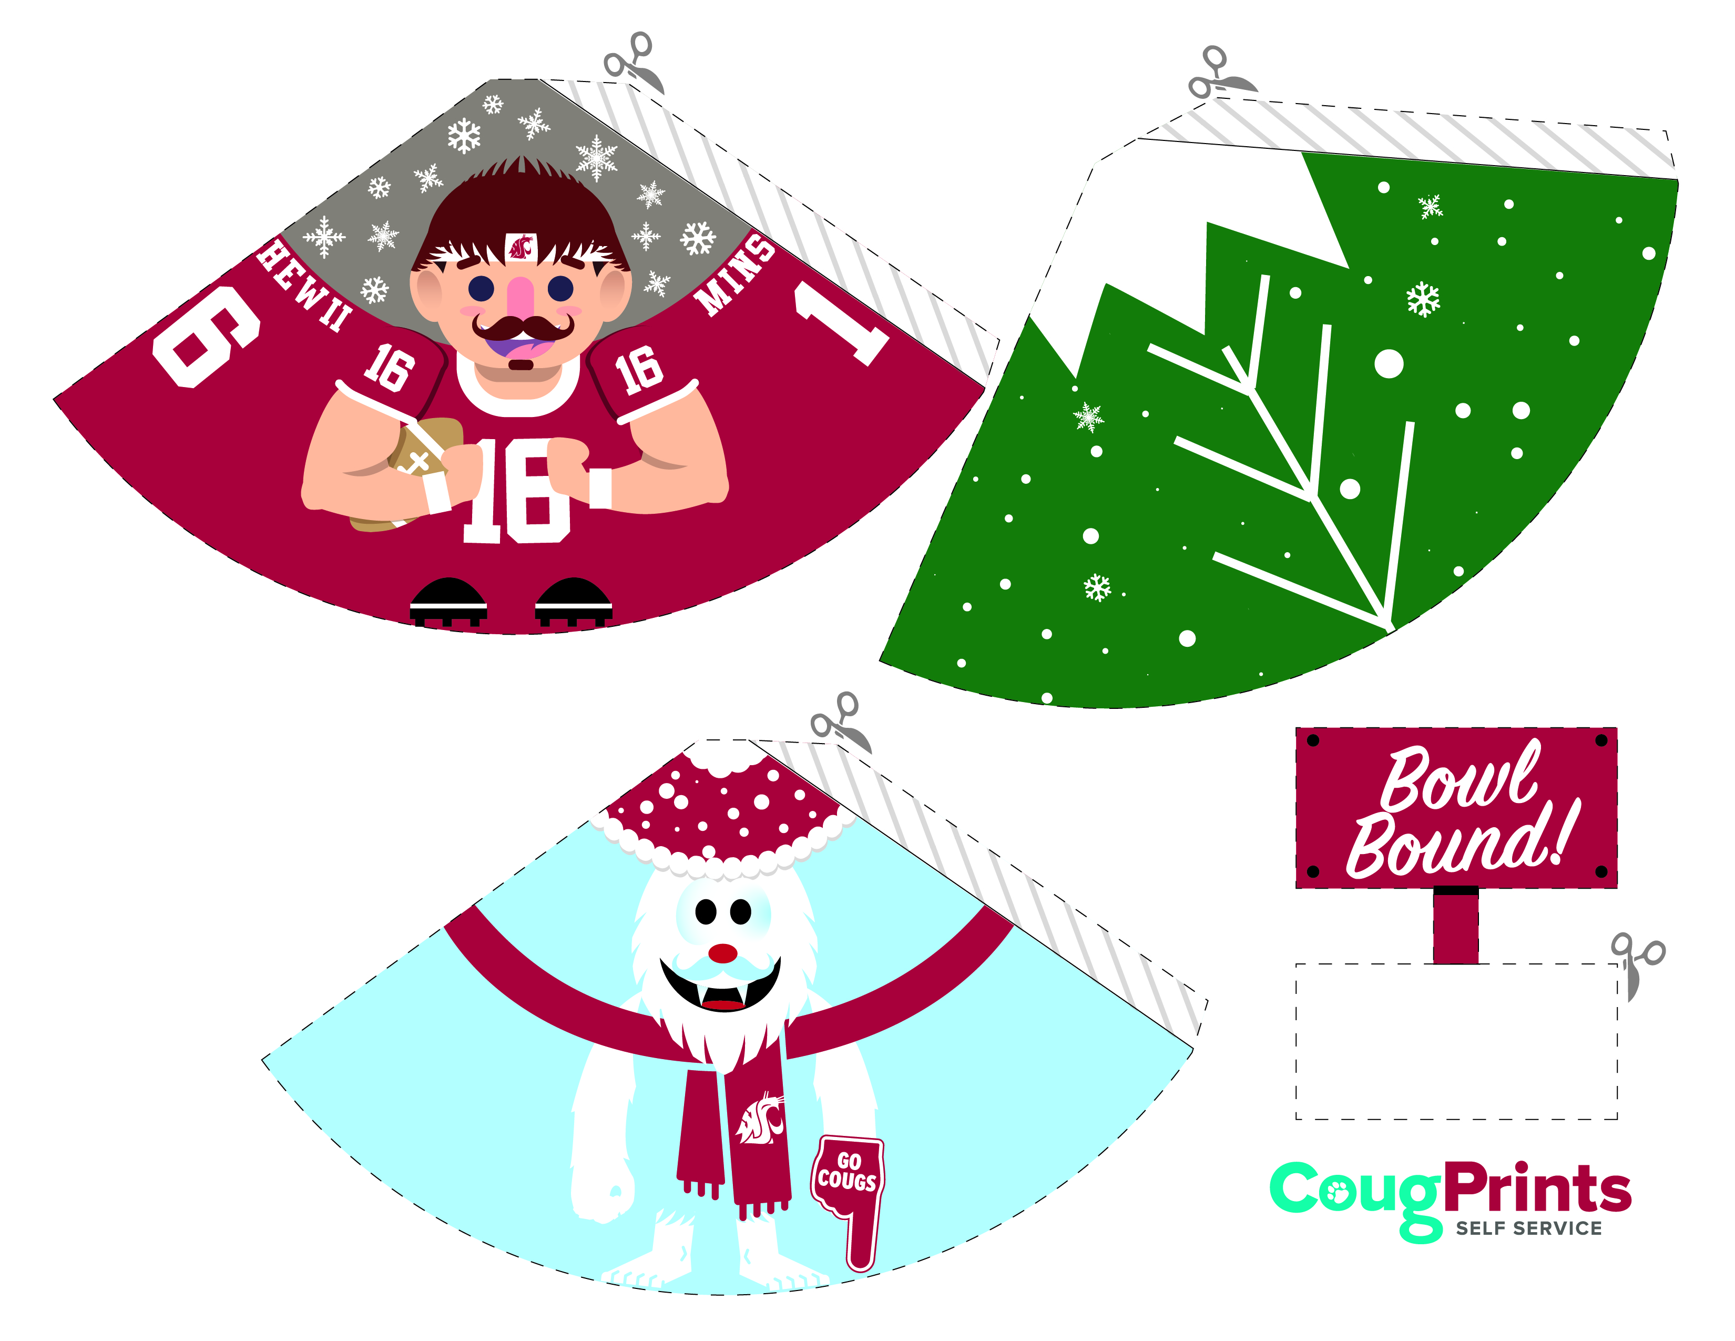

© Copyright Washington State University. For personal use only.

Some elements created by Freepik

11/18 160660 pb

**INSTRUCTIONS:** Cut along the dotted lines. Place a strip of double stick  
tape or glue along the gray flap.   
Bend each doll and attach the   
left edge to the gray flap to   
create a cone shape.

**Butch and Co. Paper Dolls**  
**YOU WILL NEED:**

Prints – two sheets of standard printer paper

Scissors

Glue or double stick tape

cougprints.wsu.edu