Vacuum Maintenance Procedure:
The Pumps must to be checked periodically to prevent them from breaking. There are two pumps, which require separate cleaning procedures. Consult the manuals for further instructions.
- Standard operating procedure for a mercury manometer
  - Obtain and fit a 500 mL vacuum Erlenmeyer flask with a tube penetrating a black septum (pictured below)
  - Connect the manometer to the inlet through the septum
    - This is to prevent mercury backflow from contaminating the lab
    - This flask should be segregated from any other use
  - Connect the inlet of the vacuum to the side arm
  - Label the flask properly
  - Make sure you’re reading the pressure correctly
- Labport rotovap pumps
  - Preventative measures: make sure to add ice to the pump bucket to increase the efficiency and longevity by running ice cold water through the coil. For volatile solvents e.g. DCM and Et₂O, use an ice bath to cool the collection flask.
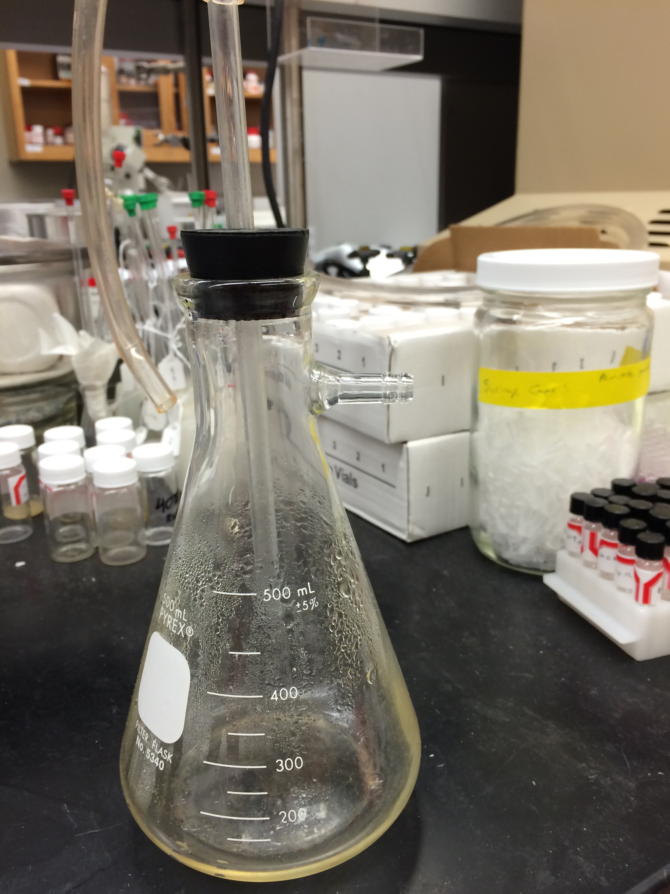
  - These pumps contain a Teflon coating on the inside, so they are more durable to solvents passing through them compared to the oil pumps. They must be washed by passing solvent through them. Take a 500mL vacuum filtration flask with a black septum, and set it up like this:
  - If the vacuums should be operating at around 20 Torr at the pump. If the vacuum is poorer than that, then a cleaning procedure is required.
    - Pour a cleaning solution such as acetone+0.5% conc. HCl, water+surfactant, etc. into the vacuum Erlenmeyer flask.
    - Connect the inlet to the tube penetrating the septum.
    - Submerge the glass tube into the cleaning solution
    - As the cleaning solution passes through the vacuum, pull the inlet tube out of the solution, and repeat the procedure until the liquid comes out clear
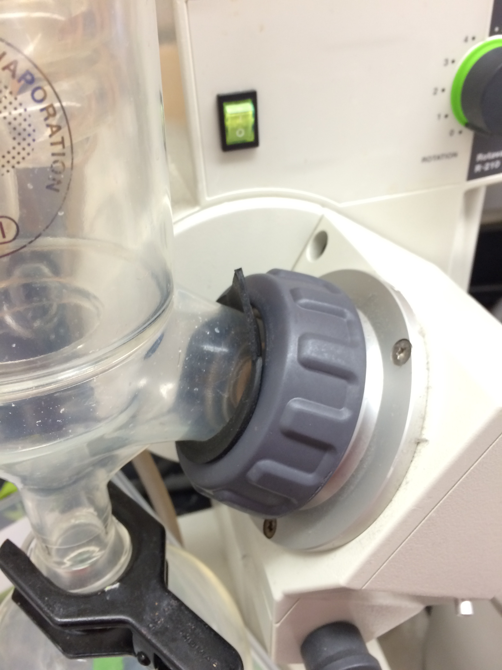
  - Measure the vacuum at the manifold with an empty flask attached, and measure the vacuum at the pump
    - Record both of these values in a vacuum log (depicted below)
      - If the rotovap is leaking vacuum, make sure the seals are clean, and setup correctly
  - It is not completely clear from the manual how to properly setup the interface of the rotovap. The black O-ring is supposed to go on the outside of the seal to prevent condensation from leaking into the motor.
- Oil pump maintenance
- Print out the log on the following page for use as a hard copy
  - Make sure that the correct oil is in the correct pump. There are different grades for the different pumps.
  - Measure the vacuum at the pump and at the Shlenck manifold every month.
    - Use the electronic manometer to measure the pressure below 1 Torr
    - If the vacuum too high, then change the oil
  - Wash the inside of the pump with a purchased surfactant mixture
    - Recommendations of use are listed on the bottle
  - Replace the oil with the correct oil, turn the pump on for 20-40 minutes, and repeat until the oil comes out the same color as the oil put in

Checked by  (Initials) | Date | Good? (Y/N) | Torr at pump | Torr at manifold

