CAAM Capital Scores Codebook

This codebook contains descriptions of each of the 15 worksheets in the CAAM capital scores workbook and the associated variables in each worksheet. The variable names and labels are provided in the following format:

Variable Name
Variable Label

The regions and divisions used in this workbook are defined by the US Census:

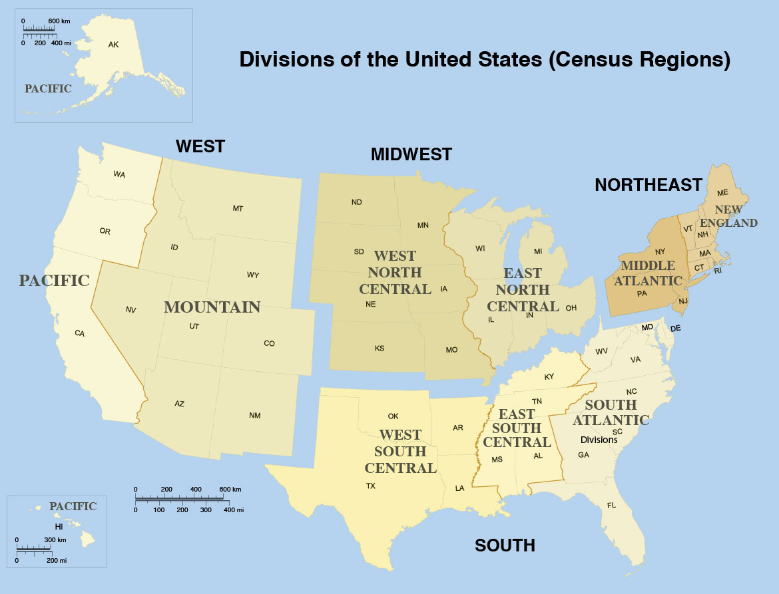
Source

Sheet 1: All Counties
Description: displays all capital scores included in the CAAM for all counties in the US, including scores normalized to the national average

FIPS
County FIPS code

County
County name

State
State name
StateAbb
State name abbreviation

CenReg
Census region
Source: US Census Bureau

CenDiv
Census division
Source: US Census Bureau

SocCap17
The social capital score for each county

SocCapZ
The social capital score for each county normalized to the national average

CulCap17
The cultural capital score for each county

CulCapZ
The cultural capital score for each county normalized to the national average

HumCap17
The human capital score for each county

HumCapZ
The human capital score for each county normalized to the national average

PolCap17
The political capital score for each county

PolCapZ
The political capital score for each county normalized to the national average

Pop2015
The estimated 2015 population of each county

CumulCap
The sum of all capital scores

CumulCapZ
The sum of all capital scores normalized to the national average
Sheet 2: All Counties (No AK, HI)
Description: displays all capital scores included in the CAAM for all counties in the US excluding Alaska and Hawaii, including scores normalized to the national average

FIPS
County FIPS code

County
County name

State
State name

StateAbb
State name abbreviation

CenReg
Census region
Source: US Census Bureau

CenDiv
Census division
Source: US Census Bureau

SocCap17
The social capital score for each county

SocCapZ
The social capital score for each county normalized to the national average

CulCap17
The cultural capital score for each county

CulCapZ
The cultural capital score for each county normalized to the national average

HumCap17
The human capital score for each county

HumCapZ
The human capital score for each county normalized to the national average

PolCap17
The political capital score for each county

PolCapZ
The political capital score for each county normalized to the national average

Pop2015
The estimated 2015 population of each county

CumulCap
The sum of all capital scores

CumulCapZ
The sum of all capital scores normalized to the national average
Sheet 3: R1-Northeast
Description: displays all capital scores included in the CAAM for all counties in Census Region 1 (Northeast), including scores normalized to the regional average

FIPS
County FIPS code

County
County name

State
State name

StateAbb
State name abbreviation

CenReg
Census region
Source: US Census Bureau

CenDiv
Census division
Source: US Census Bureau

SocCap17
The social capital score for each county

SocCapZ
The social capital score for each county normalized to the regional average

CulCap17
The cultural capital score for each county

CulCapZ
The cultural capital score for each county normalized to the regional average

HumCap17
The human capital score for each county

HumCapZ
The human capital score for each county normalized to the regional average

PolCap17
The political capital score for each county

PolCapZ
The political capital score for each county normalized to the regional average

Pop2015
The estimated 2015 population of each county

CumulCap
The sum of all capital scores

CumulCapZ
The sum of all capital scores normalized to the regional average

Sheet 4: R1D1-New England
Description: displays all capital scores included in the CAAM for all counties in Census Division 1 (New England), including scores normalized to the divisional average

FIPS
County FIPS code

County
County name

State
State name

StateAbb
State name abbreviation

CenReg
Census region
Source: US Census Bureau

CenDiv
Census division
Source: US Census Bureau

SocCap17
The social capital score for each county

SocCapZ
The social capital score for each county normalized to the divisional average

CulCap17
The cultural capital score for each county

CulCapZ
The cultural capital score for each county normalized to the divisional average

HumCap17
The human capital score for each county

HumCapZ
The human capital score for each county normalized to the divisional average

PolCap17
The political capital score for each county

PolCapZ
The political capital score for each county normalized to the divisional average

Pop2015
The estimated 2015 population of each county

CumulCap
The sum of all capital scores

CumulCapZ
The sum of all capital scores normalized to the divisional average

Sheet 5: R1D2-Middle Atlantic
Description: displays all capital scores included in the CAAM for all counties in Census Division 2 (Middle Atlantic), including scores normalized to the divisional average

FIPS
County FIPS code

County
County name

State
State name

StateAbb
State name abbreviation

CenReg
Census region
Source: US Census Bureau

CenDiv
Census division
Source: US Census Bureau

SocCap17
The social capital score for each county

SocCapZ
The social capital score for each county normalized to the divisional average

CulCap17
The cultural capital score for each county

CulCapZ
The cultural capital score for each county normalized to the divisional average

HumCap17
The human capital score for each county

HumCapZ
The human capital score for each county normalized to the divisional average

PolCap17
The political capital score for each county

PolCapZ
The political capital score for each county normalized to the divisional average

Pop2015
The estimated 2015 population of each county

CumulCap
The sum of all capital scores

CumulCapZ
The sum of all capital scores normalized to the divisional average

Sheet 6: R2-Midwest
Description: displays all capital scores included in the CAAM for all counties in Census Region 2 (Midwest), including scores normalized to the regional average

FIPS
County FIPS code

County
County name

State
State name

StateAbb
State name abbreviation

CenReg
Census region
Source: US Census Bureau

CenDiv
Census division
Source: US Census Bureau

SocCap17
The social capital score for each county

SocCapZ
The social capital score for each county normalized to the regional average

CulCap17
The cultural capital score for each county

CulCapZ
The cultural capital score for each county normalized to the regional average

HumCap17
The human capital score for each county

HumCapZ
The human capital score for each county normalized to the regional average

PolCap17
The political capital score for each county

PolCapZ
The political capital score for each county normalized to the regional average

Pop2015
The estimated 2015 population of each county

CumulCap
The sum of all capital scores

CumulCapZ
The sum of all capital scores normalized to the regional average

Sheet 7: R2D3-East North Central
Description: displays all capital scores included in the CAAM for all counties in Census Division 3 (East North Central), including scores normalized to the divisional average

FIPS
County FIPS code

County
County name

State
State name

StateAbb
State name abbreviation

CenReg
Census region
Source: US Census Bureau

CenDiv
Census division
Source: US Census Bureau

SocCap17
The social capital score for each county

SocCapZ
The social capital score for each county normalized to the divisional average

CulCap17
The cultural capital score for each county

CulCapZ
The cultural capital score for each county normalized to the divisional average

HumCap17
The human capital score for each county

HumCapZ
The human capital score for each county normalized to the divisional average

PolCap17
The political capital score for each county

PolCapZ
The political capital score for each county normalized to the divisional average

Pop2015
The estimated 2015 population of each county

CumulCap
The sum of all capital scores

CumulCapZ
The sum of all capital scores normalized to the divisional average

Sheet 8: R2D4-West North Central
Description: displays all capital scores included in the CAAM for all counties in Census Division 4 (West North Central), including scores normalized to the divisional average

FIPS
County FIPS code

County
County name

State
State name

StateAbb
State name abbreviation

CenReg
Census region
Source: US Census Bureau

CenDiv
Census division
Source: US Census Bureau

SocCap17
The social capital score for each county

SocCapZ
The social capital score for each county normalized to the divisional average

CulCap17
The cultural capital score for each county

CulCapZ
The cultural capital score for each county normalized to the divisional average

HumCap17
The human capital score for each county

HumCapZ
The human capital score for each county normalized to the divisional average

PolCap17
The political capital score for each county

PolCapZ
The political capital score for each county normalized to the divisional average

Pop2015
The estimated 2015 population of each county

CumulCap
The sum of all capital scores

CumulCapZ
The sum of all capital scores normalized to the divisional average

Sheet 9: R3-South
Description: displays all capital scores included in the CAAM for all counties in Census Region 3 (South), including scores normalized to the regional average

FIPS
County FIPS code

County
County name

State
State name

StateAbb
State name abbreviation

CenReg
Census region
Source: US Census Bureau

CenDiv
Census division
Source: US Census Bureau

SocCap17
The social capital score for each county

SocCapZ
The social capital score for each county normalized to the regional average

CulCap17
The cultural capital score for each county

CulCapZ
The cultural capital score for each county normalized to the regional average

HumCap17
The human capital score for each county

HumCapZ
The human capital score for each county normalized to the regional average

PolCap17
The political capital score for each county

PolCapZ
The political capital score for each county normalized to the regional average

Pop2015
The estimated 2015 population of each county

CumulCap
The sum of all capital scores

CumulCapZ
The sum of all capital scores normalized to the regional average

Sheet 10: R3D5-South Atlantic
Description: displays all capital scores included in the CAAM for all counties in Census Division 5 (South Atlantic), including scores normalized to the divisional average

FIPS
County FIPS code

County
County name

State
State name

StateAbb
State name abbreviation

CenReg
Census region
Source: US Census Bureau

CenDiv
Census division
Source: US Census Bureau

SocCap17
The social capital score for each county

SocCapZ
The social capital score for each county normalized to the divisional average

CulCap17
The cultural capital score for each county

CulCapZ
The cultural capital score for each county normalized to the divisional average

HumCap17
The human capital score for each county

HumCapZ
The human capital score for each county normalized to the divisional average

PolCap17
The political capital score for each county

PolCapZ
The political capital score for each county normalized to the divisional average

Pop2015
The estimated 2015 population of each county

CumulCap
The sum of all capital scores

CumulCapZ
The sum of all capital scores normalized to the divisional average

Sheet 11: R3D6-East South Central
Description: displays all capital scores included in the CAAM for all counties in Census Division 6 (East South Central), including scores normalized to the divisional average

FIPS
County FIPS code

County
County name

State
State name

StateAbb
State name abbreviation

CenReg
Census region
Source: US Census Bureau

CenDiv
Census division
Source: US Census Bureau

SocCap17
The social capital score for each county

SocCapZ
The social capital score for each county normalized to the divisional average

CulCap17
The cultural capital score for each county

CulCapZ
The cultural capital score for each county normalized to the divisional average

HumCap17
The human capital score for each county

HumCapZ
The human capital score for each county normalized to the divisional average

PolCap17
The political capital score for each county

PolCapZ
The political capital score for each county normalized to the divisional average

Pop2015
The estimated 2015 population of each county

CumulCap
The sum of all capital scores

CumulCapZ
The sum of all capital scores normalized to the divisional average

Sheet 12: R3D7-West South Central
Description: displays all capital scores included in the CAAM for all counties in Census Division 7 (West South Central), including scores normalized to the divisional average

FIPS
County FIPS code

County
County name

State
State name

StateAbb
State name abbreviation

CenReg
Census region
Source: US Census Bureau

CenDiv
Census division
Source: US Census Bureau

SocCap17
The social capital score for each county

SocCapZ
The social capital score for each county normalized to the divisional average

CulCap17
The cultural capital score for each county

CulCapZ
The cultural capital score for each county normalized to the divisional average

HumCap17
The human capital score for each county

HumCapZ
The human capital score for each county normalized to the divisional average

PolCap17
The political capital score for each county

PolCapZ
The political capital score for each county normalized to the divisional average

Pop2015
The estimated 2015 population of each county

CumulCap
The sum of all capital scores

CumulCapZ
The sum of all capital scores normalized to the divisional average

Sheet 13: R4-West
Description: displays all capital scores included in the CAAM for all counties in Census Region 4 (West), including scores normalized to the regional average

FIPS
County FIPS code

County
County name

State
State name

StateAbb
State name abbreviation

CenReg
Census region
Source: US Census Bureau

CenDiv
Census division
Source: US Census Bureau

SocCap17
The social capital score for each county

SocCapZ
The social capital score for each county normalized to the regional average

CulCap17
The cultural capital score for each county

CulCapZ
The cultural capital score for each county normalized to the regional average

HumCap17
The human capital score for each county

HumCapZ
The human capital score for each county normalized to the regional average

PolCap17
The political capital score for each county

PolCapZ
The political capital score for each county normalized to the regional average

Pop2015
The estimated 2015 population of each county

CumulCap
The sum of all capital scores

CumulCapZ
The sum of all capital scores normalized to the regional average

Sheet 14: R4-West (No AK, HI)
Description: displays all capital scores included in the CAAM for all counties in Census Region 4 (West) excluding Alaska and Hawaii, including scores normalized to the regional average

FIPS
County FIPS code

County
County name

State
State name

StateAbb
State name abbreviation

CenReg
Census region
Source: US Census Bureau

CenDiv
Census division
Source: US Census Bureau

SocCap17
The social capital score for each county

SocCapZ
The social capital score for each county normalized to the regional average

CulCap17
The cultural capital score for each county

CulCapZ
The cultural capital score for each county normalized to the regional average

HumCap17
The human capital score for each county

HumCapZ
The human capital score for each county normalized to the regional average

PolCap17
The political capital score for each county

PolCapZ
The political capital score for each county normalized to the regional average

Pop2015
The estimated 2015 population of each county

CumulCap
The sum of all capital scores

CumulCapZ
The sum of all capital scores normalized to the regional average

Sheet 15: R4D8-Mountain
Description: displays all capital scores included in the CAAM for all counties in Census Division 8 (Mountain), including scores normalized to the divisional average

FIPS
County FIPS code

County
County name

State
State name

StateAbb
State name abbreviation

CenReg
Census region
Source: US Census Bureau

CenDiv
Census division
Source: US Census Bureau

SocCap17
The social capital score for each county

SocCapZ
The social capital score for each county normalized to the divisional average

CulCap17
The cultural capital score for each county

CulCapZ
The cultural capital score for each county normalized to the divisional average

HumCap17
The human capital score for each county

HumCapZ
The human capital score for each county normalized to the divisional average

PolCap17
The political capital score for each county

PolCapZ
The political capital score for each county normalized to the divisional average

Pop2015
The estimated 2015 population of each county

CumulCap
The sum of all capital scores

CumulCapZ
The sum of all capital scores normalized to the divisional average

Sheet 16: R4D9-Pacific
Description: displays all capital scores included in the CAAM for all counties in Census Division 9 (Pacific), including scores normalized to the divisional average

FIPS
County FIPS code

County
County name

State
State name

StateAbb
State name abbreviation

CenReg
Census region
Source: US Census Bureau

CenDiv
Census division
Source: US Census Bureau

SocCap17
The social capital score for each county

SocCapZ
The social capital score for each county normalized to the divisional average

CulCap17
The cultural capital score for each county

CulCapZ
The cultural capital score for each county normalized to the divisional average

HumCap17
The human capital score for each county

HumCapZ
The human capital score for each county normalized to the divisional average

PolCap17
The political capital score for each county

PolCapZ
The political capital score for each county normalized to the divisional average

Pop2015
The estimated 2015 population of each county

CumulCap
The sum of all capital scores

CumulCapZ
The sum of all capital scores normalized to the divisional average

Sheet 17: R4D9-Pacific (No AK, HI)
Description: displays all capital scores included in the CAAM for all counties in Census Division 9 (Pacific) excluding Alaska and Hawaii, including scores normalized to the divisional average

FIPS
County FIPS code

County
County name

State
State name

StateAbb
State name abbreviation

CenReg
Census region
Source: US Census Bureau

CenDiv
Census division
Source: US Census Bureau

SocCap17
The social capital score for each county

SocCapZ
The social capital score for each county normalized to the divisional average

CulCap17
The cultural capital score for each county

CulCapZ
The cultural capital score for each county normalized to the divisional average

HumCap17
The human capital score for each county

HumCapZ
The human capital score for each county normalized to the divisional average

PolCap17
The political capital score for each county

PolCapZ
The political capital score for each county normalized to the divisional average

Pop2015
The estimated 2015 population of each county

CumulCap
The sum of all capital scores

CumulCapZ
The sum of all capital scores normalized to the divisional average

Sheet 18: PNW
Description: displays all capital scores included in the CAAM for all counties in the Pacific Northwest (Washington, Oregon, Montana, and Idaho), including scores normalized to the average of these four states

FIPS
County FIPS code

County
County name

State
State name

StateAbb
State name abbreviation

CenReg
Census region
Source: US Census Bureau

CenDiv
Census division
Source: US Census Bureau

SocCap17
The social capital score for each county

SocCapZ
The social capital score for each county normalized to the PNW average

CulCap17
The cultural capital score for each county

CulCapZ
The cultural capital score for each county normalized to the PNW average

HumCap17
The human capital score for each county

HumCapZ
The human capital score for each county normalized to the PNW average

PolCap17
The political capital score for each county

PolCapZ
The political capital score for each county normalized to the PNW average

Pop2015
The estimated 2015 population of each county

CumulCap
The sum of all capital scores

CumulCapZ
The sum of all capital scores normalized to the PNW average

