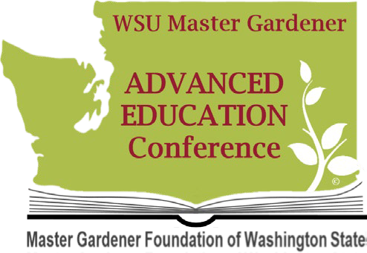
Sharing Success Proposal

50 Years and Counting

AEC 2023

County Program Coordinator: Volunteer First and Last Name: Volunteer Email Address: Display Title: Display Description:

Overview
This year’s Advanced Education Conference offerings focus on our Program Priorities. Educational Media proposals should illustrate how projects and programs, or an individual project or program addresses at least one of our Program Priorities. The selection committee will be looking for proposals that show an understanding of how to use the Priorities to plan, teach and evaluate programming.

Display Elements:
All displays must have an educational purpose, show a connection to our Program Priorities, be appropriately branded using WSU Extension’s logos and the WSU Extension Master Gardener Program spirit marks and graphics and contain the appropriate disclaimer statement. Be creative. Displays can be in the form of a poster, tri-fold, table display, diorama or other forms. Plan to reuse your display as a MG Speaker visual aid or as a themed information booth display.

Content:
There are three main points we want our communities to learn from us relative to the Program Priorities. The points start broad and become narrower. Review the Program Priority Toolkit and the associated presentation materials on the volunteer only section of our WSU Extension Master Gardener Website. If you create a poster on Local Food for example, the poster should depict how the program or project teaches our communities:
- about the benefits of local food on individual and community wellness.
- that we all have a role to play in local food systems.
- techniques for growing ones’ own food.
In addition, if you’ve evaluated the program or project using the questions in the Tool Kit, please include the results of the evaluation on your poster.

Branding and Disclaimers:
All displays must include current 2023 WSU Extension branding and appropriate disclaimer statements. At the very least displays must contain the WSU Extension logo associated with the county and this disclaimer statement: WSU Extension programs and employment are available to all without discrimination. Evidence of noncompliance may be reported through your local WSU Extension Office.
- Guidelines for Extension logo use (.pdf)
- Guidelines for secondary/spirit mark use (.pdf)
- Color and typography cheat sheet (.pdf)
- More information: Washington State University – WSU Brand Guidelines (wsu.edu)

Important Dates and Submission:
July 30, 2023: Deadline to submit proposals.
Email proposals to Jackie Sykes and Harmony Rutter jsykes@spokanecounty.org harmony.rutter@wsu.edu
August 15, 2023: Proposal Acceptance

Have questions? Email Harmony Rutter or Jackie Sykes

