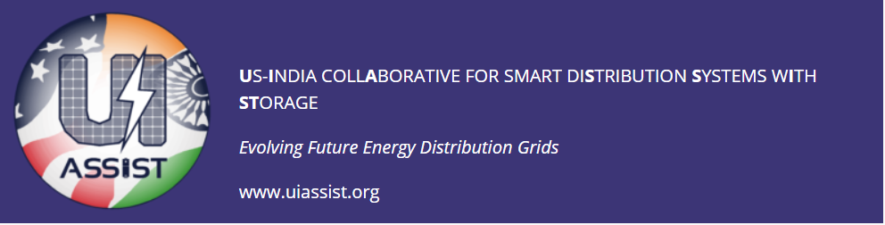

UI-ASSIST Virtual Review Workshop
Tuesday 21 July 2020

21:30- 22:00 IST | Welcome and Introductions of Funding Agencies and Advisory Boards  Speakers: Suresh Srivastava (IITK) and Noel Schulz (WSU)
22:00- 22:15 IST | DST  Speaker: Sanjai Bajpai
22:15- 22:30 IST | IUSSTF  Speaker: Nandini Kannan
22:30- 22:45 IST | DOE  Speaker: Merrill Smith
22:45- 23:00 IST | Theme 1 – Virtual Workshop Logistics  Speaker: Anurag Srivastava (WSU)
Wednesday 22 July 2020
07:00- 07:30 IST | Session #2: Theme Updates A Theme 9* - Field Demos  India Speaker: Suresh Srivastava(IITK) US Speaker: Anurag Srivastava (WSU)
07:30- 08:00 IST | Theme 8* - Lab Testing & Validation  India Speaker: Santanu Mishra (IITK) US Speaker: Anurag Srivastava (WSU
08:00- 08:30 IST | Theme 2* - Distribution Models & Benchmarks  India Speaker: Anju Meghwani (IITK) US Speaker: Noel Schulz (WSU)
21:30- 22:00 IST | Session #3: Theme Updates B Theme 3* - Storage  India Speaker: Alekhya Dutta (TERI) US Speaker: Noel Schulz (WSU)
22:00- 22:30 IST | Theme 4* - Microgrid & Active Distribution Systems  India Speaker: Santanu Mishra (IITK) US Speaker: Miroslav Begovic (TAMU)
22:30- 23:00 IST | Theme 6A* - DSO/Energy Management India Speakers: Abheejeet Mohapatra (IITK) and Krishnan Vekatraman (Synergy)
Thursday 23 July 2020
07:00- 07:30 IST | Session #4: Theme Updates C Theme 6B* - DSO/Energy Management  US Speakers: Anurag Srivastava (WSU)
07:30- 08:00 IST | Theme 7* - Market & Regulatory Issues  India Speaker: Abhijit Abhyankar (IITD) US Speaker: Anuradha Annaswamy (MIT)
08:00- 08:30 IST | Theme 5* - Cybersecurity  India Speaker: Ketan Rajawat (IITK) US Speaker: Anurag Srivastava (WSU)
21:30- 22:00 IST | Session #5: Theme Updates D Theme 10* - Impact Analysis & Policy  India Speaker: A K Saxena (TERI) US Speaker: Anjan Bose (WSU)
22:00- 22:30 IST | Theme 11* - Workforce & Training  India Speaker: Santanu Mishra (IITK) US Speaker: Noel Schulz (WSU)
22:30- 23:00 IST | Summary Discussions (DST/UISSTF/India Advisory Board Members Response)  Moderator: Noel Schulz (WSU)
Friday 24 July 2020
7:00- 7:30 IST | Session #6: Discussions & Next Steps Summary Discussions (DOE and Advisory Board Members Response)  Moderator: Noel Schulz (WSU)
7:30- 8:00 IST | General Discussions  Moderator: Anurag Srivastava (WSU)
8:00- 8:30 IST | Next Steps  Moderators: Suresh Srivastava (IITK) and Noel Schulz (WSU)

