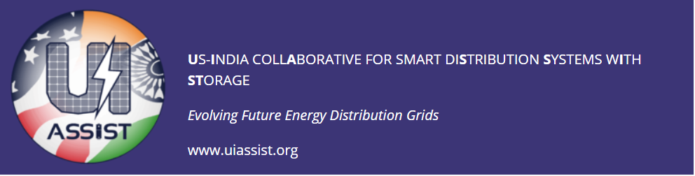

UI-ASSIST Virtual Review Workshop
Tuesday July 21, 2020

9:00-9:30 Pacific | Session #1: Kick off - Welcome and Introductions of Funding Agencies and Advisory Boards  Speakers: Suresh Srivastava (IITK) and Noel Schulz (WSU)
9:30-9:45 Pacific | DST  Speaker: Sanjai Bajpai
9:45-10:00 Pacific | IUSSTF  Speaker: Nandini Kannan
10:00-10:15 Pacific | DOE  Speaker: Merrill Smith
10:15-10:30 Pacific | Theme 1 – Virtual Workshop Logistics  Speaker: Anurag Srivastava (WSU)
18:30-19:00 Pacific | Session #2: Theme Updates A Theme 9* - Field Demos  India Speaker: Suresh Srivastava(IITK) US Speaker: Anurag Srivastava (WSU)
19:00-19:30 Pacific | Theme 8* - Lab Testing & Validation  India Speaker: Santanu Mishra (IITK) US Speaker: Anurag Srivastava (WSU)
19:30-20:00 Pacific | Theme 2* - Distribution Models & Benchmarks  India Speaker: Anju Meghwani (IITK) US Speaker: Noel Schulz (WSU)
Wednesday July 22, 2020
09:00-9:30 Pacific | Session #3: Theme Updates B Theme 3* - Storage  India Speaker: Alekhya Dutta (TERI) US Speaker: Noel Schulz (WSU)
09:30-10:00 Pacific | Theme 4* - Microgrid & Active Distribution Systems  India Speaker: Santanu Mishra (IITK) US Speaker: Miroslav Begovic (TAMU)
10:00-10:30 Pacific | Theme 6A* - DSO/Energy Management India Speakers: Abheejeet Mohapatra (IITK) and Krishnan Vekatraman (Synergy)
18:30-19:00 Pacific | Session #4: Theme Updates C Theme 6B* - DSO/Energy Management  US Speakers: Anurag Srivastava (WSU)
19:00-19:30 Pacific | Theme 7* - Market & Regulatory Issues  India Speaker: Abhijit Abhyankar (IITD) US Speaker: Anuradha Annaswamy (MIT)
19:30-20:00 Pacific | Theme 5* - Cybersecurity  India Speaker: Ketan Rajawat (IITK) US Speaker: Anurag Srivastava (WSU)
Thursday July 23, 2020
09:00-9:30 Pacific | Session #5: Theme Updates D Theme 10* - Impact Analysis & Policy  India Speaker: A K Saxena (TERI) US Speaker: Anjan Bose (WSU)
09:30-10:00 Pacific | Theme 11* - Workforce & Training  India Speaker: Santanu Mishra (IITK) US Speaker: Noel Schulz (WSU)
10:00-10:30 Pacific | Session #6: Discussions & Next Steps Summary Discussions (DST/UISSTF/India Advisory Board Members Response)  Moderator: Noel Schulz (WSU)
18:30-19:00 Pacific | Summary Discussions (DOE and Advisory Board Members Response)  Moderator: Noel Schulz (WSU)
19:00-19:30 Pacific | General Discussions  Moderator: Anurag Srivastava (WSU)
19:30-20:00 Pacific | Next Steps  Moderators: Suresh Srivastava (IITK) and Noel Schulz (WSU)

