UTC Project Information – National UTC TriDurLE
Project Title | Highway Pavement Condition Deterioration Modeling Considering Maintenance History
University | University of Mississippi (UM)
Principal Investigator | Waheed Uddin
PI Contact Information | Professor and Director, Center for Advanced Infrastructure Technology (CAIT)  Department of Civil Engineering  Carrier Hall 203B  The University of Mississippi  University, MS 38677-1848  Tel: 662-915- 5363 / 662-915- 1939  Email: cvuddin@olemiss.edu cvuddin@gmail.com
Funding Source(s) and Amount Provided (by each agency or organization) | TriDurLE UTC funding, Year 1: $53,914  UM cash cost share, Year 1: $53,914 (100% non-federal match)
Total Project Cost | Total year 1 UM project cost $107,828
Agency ID or Contract  Number | Grant Number 69A3551947137  Subaward No. 135461 G004189
Start and End Dates | UM Grant Subaward start date 7/1/2019 (July 1, 2019)  Subaward End date 9/30/2021 (September 30, 20121)  Year 1 Project Completion Planned Date 5/31/2021 (May 31, 2021)
Brief Description of Research Project | Highway infrastructure network assets for passenger mobility and freight transport are imperative to support the economy and society. The pavement part of a highway constitutes about 80 percent of the total construction and lifetime maintenance costs.  The primary objective is to develop enhanced mechanistic-empirical performance models for asphalt highway pavement condition deterioration progression considering major maintenance and rehabilitation history, climate regions, and intervention effects of natural hazards and extreme weather and climate change impacts. The computational modeling methodology will be implemented using the historical Long-Term Pavement Performance (LTPP) database from all climatic regions in the United States.  The developed models will be verified using reserved LTPP sections, validated using pavement condition data of selected non-LTPP highway sections in Mississippi and other climatic region states, and implemented in mechanistic-empirical design methods and pilot applications for pavement asset management.
Describe Implementation of Research Outcomes (or why not implemented)  Place Any Photos Here | Project Progress: The literature review and data extraction for asphalt pavement sections from the FHWA LTPP database are in progress. Because of the Coronavirus disease the university campus is physically closed. The research efforts and communication with the project staff and graduate students are being conducted by remote and virtual meetings using online zoom, emails, and cell phones.  Research effort started in May 2020 after the UM subaward was received. Therefore, the following research outcomes are not achieved.  The developed mechanistic-empirical models of pavement performance and models of 3D-FE structural responses will be implemented in mechanistic-empirical design methods and pilot applications for pavement asset management systems in collaboration with cooperating state DOTs.  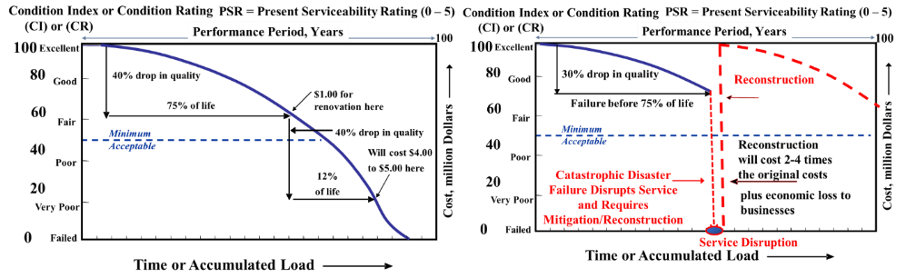  Highway pavement performance schematics: (left) Normal traffic and climate conditions; (right) Catastrophic disaster due to natural hazard and extreme weather events
Impacts/Benefits of Implementation (actual,  not anticipated) | Not applicable at this time.  Planned: The research products will be implemented in course contents of senior technical electives and graduate courses on highway pavements, infrastructure asset management, and pavement management system.
Web links  - Reports  - Project website | No reports. (Preparation for webinars on highway life cycle analysis will be pursued in the next quarter.)  https://olemiss.edu/projects/cait/

