Name(s):

Student Learning Objectives – Double Pipe Heat Exchanger
- Identify flow patterns, and inlets and outlets for hot and cold fluids for countercurrent flow.
- Identify the energy gains and losses for each fluid in the heat exchanger and how these relate to the energy balance.
- Perform calculations to determine the rate of heat transfer (heat duty).
- Understand the difference between flow area and heat transfer area.
- Identify geometric parameters such as the hydraulic diameter and cross sectional area for the annular side.
- Understand the difference between a heat transfer and energy balance temperature difference (ΔT).
- Determine the log mean temperature difference and explain why it is used.
- Explain the effect of flow rate and inlet/outlet temperatures on performance.

Before Assembling your LCDLM (Low-Cost Desktop Learning Module)
For a countercurrent heat exchanger with hot fluid on the tube side and cold fluid on the annular side:
- Draw the expected flow patterns on the LCDLM cartridge using dry erase markers.
- Copy the expected flow patterns on the schematic below.
- Identify the inlet and outlet of the hot and cold fluids on the LCDLM cartridge and add labels below

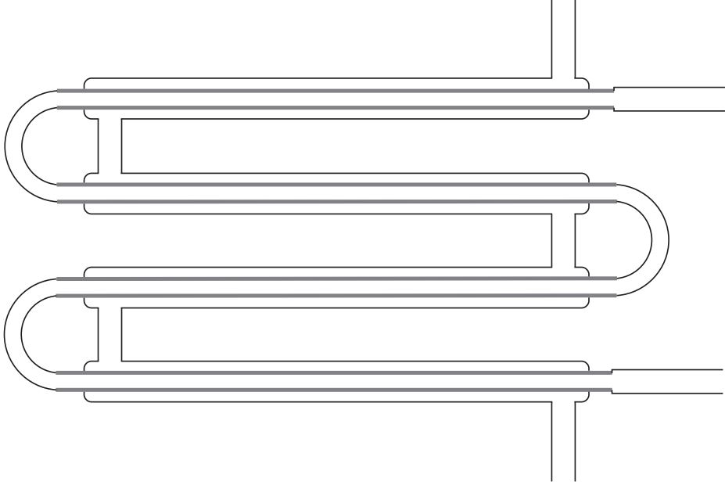

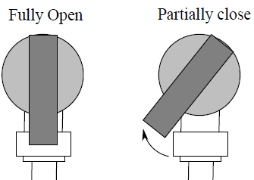
Experiment 1: Confirming Flow Patterns and Measuring Heat Transfer Rate
Fully Open Partially Closed
- Assemble your LCDLM per the video with both inlet valves fully open.
- Fill the tube side beaker with fresh hot water (red color) and annular side with fresh cold water (blue color).
- Record the inlet beaker cold water, then hot water temperatures below.
- Turn on both pumps simultaneously. When the hot and cold water reach the outlet beakers, start your phone timer.
- Turn off the pumps before the inlet beakers are empty and stop the timer.
- Record outlet beaker hot water, then cold water temperatures below.
- Record the hot and cold water outlet beaker volumes below.
- Make any corrections to the flow patterns hypothesized on page 1.

Table 1. Experimental data.
Tube Side (Hot) |  |  | Annular Side (Cold) |  |  | time
T_{in} | T_{out} | V (mL) | T_{in} | T_{out} | V (mL)

Heat Transfer Driving Mechanism and Log Mean Temperature Difference
- In the diagram below each line represents a temperature profile for one fluid along the length of a countercurrent exchanger. Label:
- Your experimental temperatures in the appropriate locations
- The temperature difference between the hot and cold fluid at both ends of the exchanger (locations A and B) and at a point midway through the exchanger (location C)
Temperature (°C)
Location in heat exchanger
T₁:
T₂:
T₃:
T₄:
A
B

C

- Which temperature difference (ΔT) drives heats transfer, T₁ – T₂; T₄ – T₃; or T_{hot} – T_{cold}?

- Based on your answer to (1B), is the driving potential for heat transfer constant throughout the exchanger? What does this tell you about the heat transfer rate throughout the exchanger?

- The predicted heat transfer rate (heat duty) of a heat exchanger is function of the logarithmic mean temperature difference, ${∆T}_{LMTD}$, defined below:

$\dot{Q}=f \left({∆T}_{LMTD}\right)$ ${∆T}_{LMTD}=\frac{{(∆T)}_{A}-{(∆T)}_{B}}{ln⁡(\frac{{\left(∆T\right)}_{A}}{{\left(∆T\right)}_{B}})}$

- How does ${∆T}_{LMTD}$ correct for what you described in question 3?

- Which temperatures from Table 1 are used to calculate${∆T}_{LMTD}$, e.g., what does ${∆T}_{A}$ mean, etc.?

Energy Balances in the Heat Exchanger
- Considering the hot fluid; indicate on the figure where thermal energy enters and leaves the system.
Hot Inlet

Hot Outlet

- The heat transfer rate (heat duty) can be calculated with an energy balance on the hot or cold fluid:

${\dot{Q}}_{H}= {\dot{m}}_{h}C_{p,h}∆T_{h}$ ${\dot{Q}}_{C}= {\dot{m}}_{c}C_{p,c}∆T_{c}$

- How does the energy balance account for the energy gains and losses you labeled in question 5?

- If the hot water (red) inside the heat exchanger is treated as the system (i.e., the mass flow rate and heat capacity of the hot water are used), which of your experimental temperatures are used to calculate$∆T_{h}$ in the energy balance? Why?

- Considering energy conservation, how should ${\dot{Q}}_{H}$and ${\dot{Q}}_{C}$compare? Why might they differ?

Experiment 2: Effect of Flowrate on Heat Transfer Rate
- Rearrange the LCDLM setup to recycle the hot and cold water as shown below. Ensure the hot water outlet tube is not submerged in the beaker
- Position the thermometer so it will reach into the hot water exit stream, near the end of the exit tube.
- Start flow for the hot and cold water (valves fully open). Note the temperature of the hot stream.
- Pinch the cold inlet tubing for ~5 sec to slow the cold flowrate. Note the temperature of the hot stream.
- Release the tube and note the temperature change after ~5 sec.
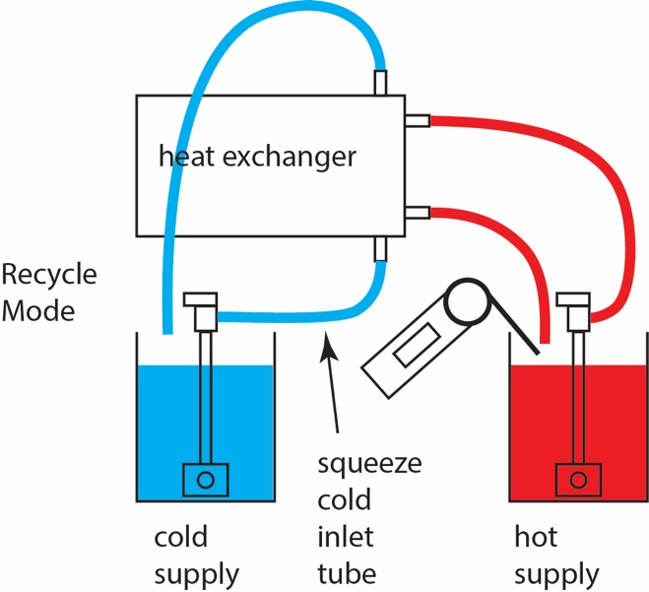
- Turn off the pumps.

- Describe the change in the temperature of the hot water flowing into the outlet beaker.

- Did slowing the cold water flow rate increase or decrease the heat transfer rate? Explain.

- Based on your knowledge of laminar and turbulent flow patterns, how does decreasing the velocity towards the laminar regime affect the heat transfer rate? Is heat more easily transferred from the hot to the cold fluid during laminar or turbulent flow? Why?

Heat Exchanger Geometry
- On the diagram of a cross section of the LCDLM below, label (use the expanded view if needed):
- The area for cold water flow
- The area for hot water flow
- The area for heat transfer for a single tube

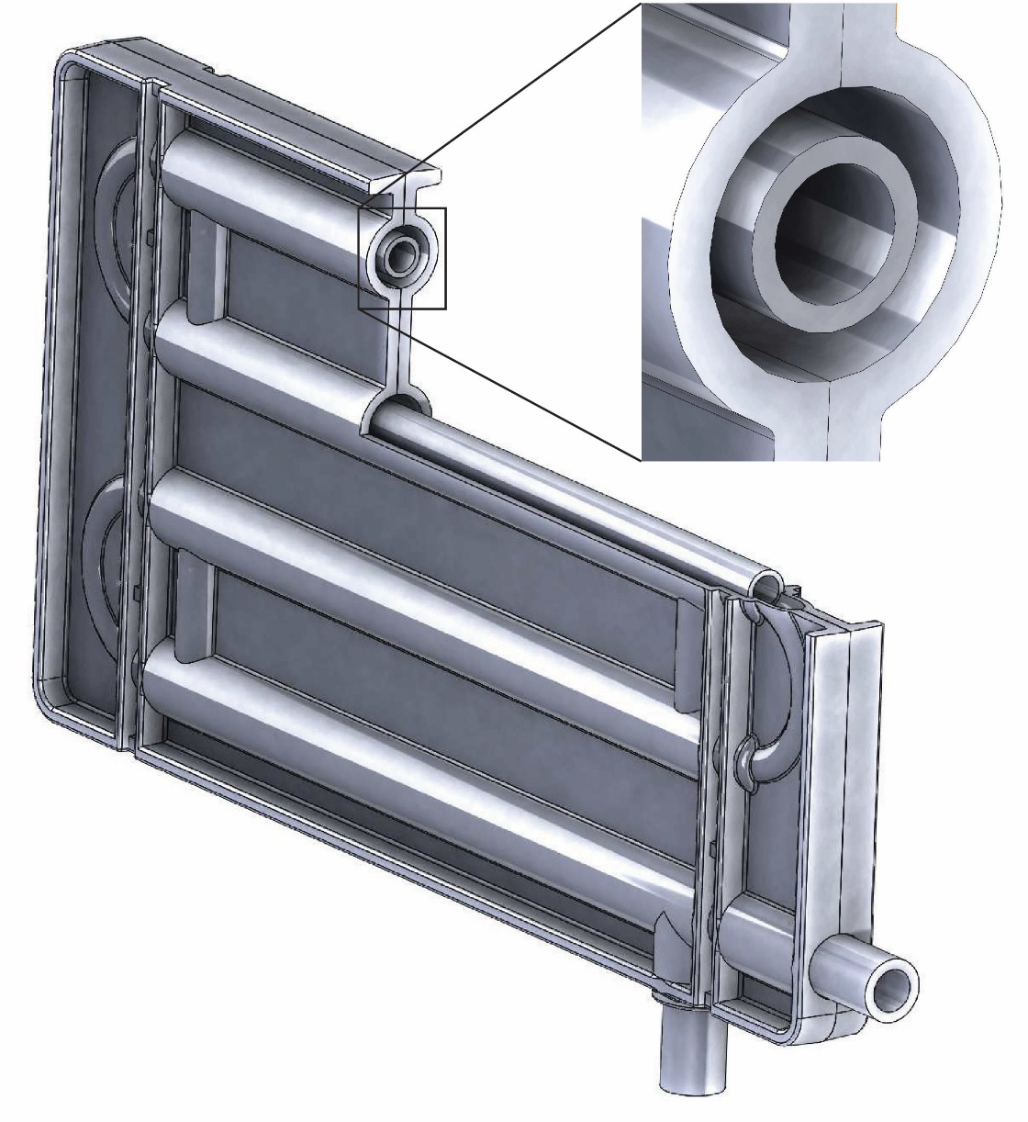
L
D_{t,o}
D_{annulus}
D_{t,i}

- Write a formula for each of the areas listed above.

$A_{C}:$Area for cold water flow =

$A_{H}:$Area for hot water flow =

$A_{O}$: Area for heat transfer =

- For each of the following, circle which area from above should be used to calculate the term:

  - The velocity of the hot fluid ($\overline{v}={\dot{V}}/A)$? $A_{C} A_{H} A_{o}$
  - The velocity of the cold fluid (($\overline{v}={\dot{V}}/A)$? $A_{C} A_{H} A_{o}$
  - The heat transfer rate ($\dot{Q}= U_{o}A∆T_{LM}$)? $A_{C} A_{H} A_{o}$

Homework Section: Complete on a separate sheet of paper

Reference information for Double Pipe Heat Exchanger LCDLM
- Tube length, $L=155 mm$
- Number of tubes, $N_{t}=4$
- Tube material, 304 stainless steel
- Tube dimensions: Outer diameter, $D_{t,o}=6.35 mm$, inner diameter, $D_{t,i}=4.37 mm$
- Annulus outer diameter, $D_{a}=9.53 mm$

Experimental Heat Transfer Rate
      - Calculate the heat transfer rate ($\dot{Q}$) using the data you collected in Table 1 and the energy balance equation below for both the annular and tube side. Is the amount of heat released by the hot fluid the same as the amount of heat received by the cold fluid? If not, what are possible reasons?

${\dot{Q}}_{C}={\dot{m}}_{C}C_{p,C}{∆T}_{C}$ ${\dot{Q}}_{H}={\dot{m}}_{H}C_{p,H}{∆T}_{H}$

Hydraulic Diameter of the Annular Side
  - Given the definition for the hydraulic diameter ($D_{h})$ below, show that for the concentric, circular annulus where cold water flows in the LCDLM, $D_{h}=\left(D_{a}-D_{t,o}\right)$

$$D_{h}=\frac{4∙A_{x}}{P_{w}}$$

$P_{w}$ = wetted perimeter where fluid contacts inner and outer walls of the annulus
$A_{x}$ = cross-sectional area for flow

Predicted Tube and Annular Heat Transfer Coefficients
  - Using correlations determine the individual heat-transfer coefficients for the tube-side, ($h_{i}$) and annular side ($h_{o}$) of the double pipe heat exchanger using your experimental flowrates. The individual heat transfer coefficients, h_{i} and h_{o,} can be determined by rearranging the Nusselt number (Nu or the dimensionless heat transfer coefficient), defined below. Note that the hydraulic diameter ($D_{h}=D_{a}-D_{t,o})$, is used for the annular side.
${Nu}_{i}= \frac{h_{i}D_{t,i}}{k}$ ${Nu}_{o}= \frac{h_{o}D_{h}}{k}$
To determine Nu you will need an empirical correlation defined below.
For laminar flow (up to Re $≅$ 2100), use the following correlation for the Nusselt number. Note, for laminar flow in the annulus the hydraulic diameter, $D_{h}$ (defined above), should be used in place of $D$:

$Nu=1.86{\left(Re∙Pr∙\frac{D}{L}\right)}^{0.33}$ $Re=\frac{ρ\overline{v}D}{μ}$

For turbulent or transitional flow (Re > 2100), use the following correlation for the Nusselt number:

$Nu=\frac{\left(\frac{f}{2}\right)Re∙Pr}{1+8.7{\left(\frac{f}{2}\right)}^{0.5}\left(Pr-1\right)}$ $f={\left(3.64∙ln⁡(Re)-3.28\right)}^{-2}$
where f = the friction factor.
For the tube side use the inside pipe diameter, D_{t,i}, to calculate the Reynolds number. For the annular side, use the hydraulic diameter, D_{h}. For both sides, fluid properties should be evaluated at the bulk temperature, defined below:

$$T_{b}=\frac{T_{in}+T_{out}}{2}$$

The fluid velocity may be calculated using your experimentally measured volumetric flowrate divided by the cross-sectional areas of the tube and annulus, shown respectively below:

$A_{tube}=\frac{π}{4}D_{t,i}^{2}$ $A_{annulus}=\frac{π}{4}(D_{a}^{2}-D_{t,o}^{2})$

Log Mean Temperature Difference
4. From your experimental data for countercurrent flow, compute the log mean temperature difference.

$$∆T_{LMTD}=\frac{\left(T_{h,in}-T_{c,out}\right)-(T_{h,out}-T_{c,in})}{ln⁡\left(\frac{T_{h,in}-T_{c,out}}{T_{h,out}-T_{c,in}}\right)}$$

Heat Transfer Resistances
- Compute the heat transfer resistances for the tube side, the tube wall, and the annular side using the heat transfer coefficients determined above.

$R_{tube}=\frac{1}{h_{i}A_{i}}$ $R_{wall}=\frac{ln\left(\frac{D_{t.o}}{D_{t.i}}\right)}{2π{LN_{t}k}_{wall}}$ $R_{annulus}=\frac{1}{h_{o}A_{o}}$

The inner ($A_{i})$and outer ($A_{o})$ surface areas for heat transfer are defined below:

$A_{o}=πD_{t,o}LN_{t}$ $A_{i}=πD_{t,i}LN_{t}$

- Compare the resistances. Is one of them controlling? Why or why not?

Overall Heat Transfer Coefficient and Predicted Heat Transfer Rate
- Compute the overall heat-transfer coefficient based on the sum of the individual resistances and from your experimental data, using the hot side heat transfer rate calculated in Question 1. How do the values compare?

$${\left(UA_{o}\right)}_{ theory}=\frac{1}{R_{tube}+R_{wall}+R_{annulus}}=\frac{1}{\left(\frac{1}{h_{i}A_{i}}\right)+\frac{ln\left(\frac{D_{t.o}}{D_{t.i}}\right)}{2π{LN_{t}k}_{wall}}+\left(\frac{1}{h_{o}A_{o}}\right)}$$

$${\left(UA_{o}\right)}_{ exp}= \frac{{\dot{Q}}_{H,expermental}}{∆T_{LMTD}}$$

- Using your experimental value for $∆T_{LMTD}$, compute the predicted heat transfer rate using $\dot{Q}={(UA_{o})}_{ theory}{∆T}_{LMTD}$ and compare it to the measured heat transfer rates calculated in Question 1 based on energy balances. Do the values agree? Explain and list possible reasons for any differences.

- Using the energy balance equation and the equation for the predicted heat transfer rate $\dot{Q}=U_{o}A_{o}∆T_{LMTD}$, consider and qualitatively explain how the heat transfer rate would change if:

        - You doubled the flowrate of the hot water.

        - You halved the temperature difference between the hot and cold water.

