OPERATING PROCEDURES
Spirit Lake-Toutle/Cowlitz River System Collaborative
Version 2 - December 9, 2021
These Operating Procedures accompany and expand on the concepts and commitments articulated in the 2022 Declaration of Cooperation for the Spirit Lake-Toutle/Cowlitz River System Collaborative (SLTCRC or “the collaborative”). Its purpose is to provide an organizational structure; roles and responsibilities for nongovernmental participants; and governance, meeting, and communications protocols for the group.
The SLTCRC Vision
The following vision statement represents a set of ideal conditions to guide the collaborative:
Healthy Ecosystems – Safe Communities – Healthy Economy
The SLTCRC Mission
The SLTCRC developed and agreed on the following Mission Statement in late 2021 and early 2022, to guide the first five years of the group’s efforts:
To share information, build understanding, and develop and coordinate management solutions to address sediment transport and flood protection in the Spirit Lake, Toutle/ Cowlitz River system while enhancing ecological benefits and serving the many needs of the communities within the system.
Ground Rules for the Collaborative
- Open discussion: Participants may express their views candidly, but without personal attacks. Time is shared because all participants are of equal importance.
- Transparency: Participants pledge to avoid surprises, keep open communication, and notify fellow collaborative parties when something might affect or impact them or their organization.
- Decisions and Consensus:
  - SLTCRC will not make decisions for any existing agency or organization, or that conflict with those party’s missions, mandates, jurisdictions, or projects. The collaborative can make decisions on topics such as whether to collectively seek funding to work together, adopt ground rules, express support for scientific or research efforts, develop and adopt a comprehensive sediment management plan, etc. Any decision of the SLTCRC does not necessarily reflect the mission or mandate of an individual agency.
  - SLTCRC decisions and recommendations will be consensus-based. For all decisions, consensus of all members is desired. Consensus can be achieved at any full SLTCRC meeting with at least 60% (e.g., 18 of 30) members (or their designated alternates). Members pledge to attend all meetings if possible., and scheduling of meetings will be as inclusive of all members as possible
  - Consensus Defined: The SLTCRC operates under the following definition of consensus: Consensus means that each member can say: (1) I was a respected member of the group that considered the decision; (2) my ideas (opinions, knowledge, concerns, beliefs, hopes) were listened to; (3) I listened to the ideas (opinions, knowledge, concerns, beliefs, hopes) of others; and (4) I can live with the decision of the group, even though I might have made a different decision had I acted alone or if my agency were the sole decision maker; or (5) I abstain from the decision since my agency uses a separate decision-making process.
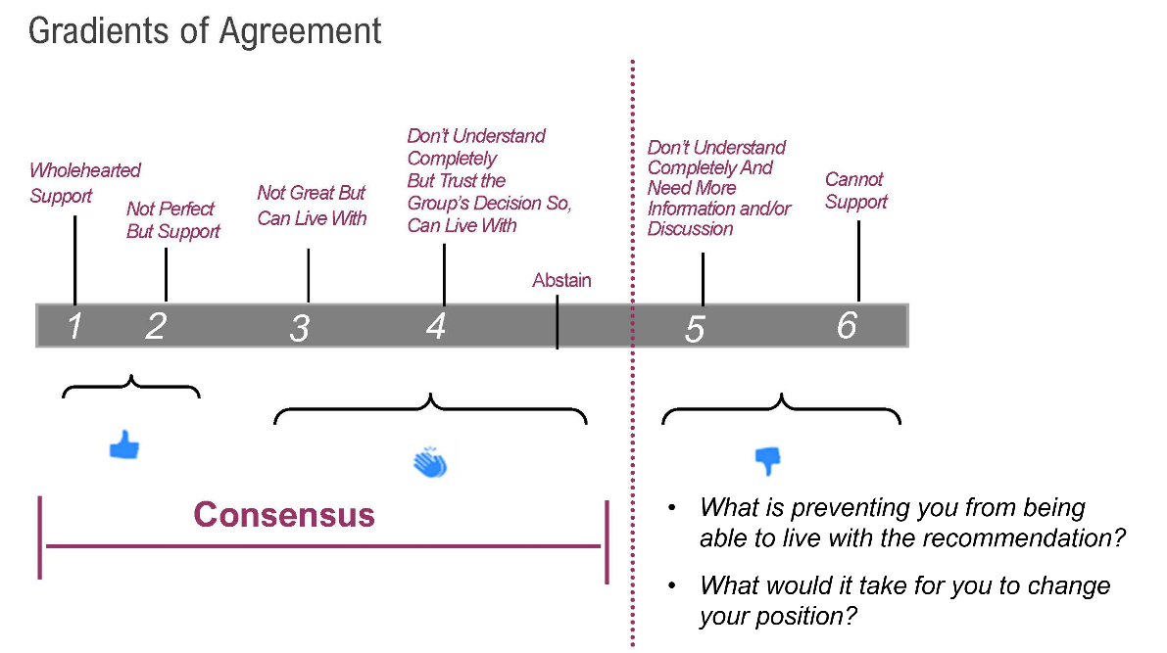
  - This consensus can be conveyed via a thumbs up (I support this option), thumbs sideways (I can live with this option for the good of the group and the process) or thumbs down (I cannot live with this option). If a member shows thumbs down, that member is expected to provide a proposal that legitimately attempts to achieve the interest of the constituency they represent and the interests of the other members. All members will seek solutions that allow those thumbs to go up or sideways.
NOTE: The consensus agreements do not involve a “vote.” Consensus describes a condition that a group can reach.
The group may opt to develop and adopt a decision matrix that would help qualify recommendations and base the decisions on a defined equal value.
Behavior in Meetings
- Be Constructive
  - State your piece: Be concise so all have a chance to speak
  - Overall: focus on mutual gains/solutions that work for ALL parties
- Virtual & In-Person Meetings
  - Keep yourself on mute unless speaking
  - Keep video on (as bandwidth & personal situations allow)
  - One primary representative (and one secondary representative) from each organization in speaking roles (unless technical or other needed support staff)
  - Raise your hand and/or wait to be recognized before speaking
- Be Respectful, and Honest
  - Respect everyone’s expertise and contribution; this is an important and complex discussion
  - Listen carefully so that you and ALL your colleagues can be heard
  - One voice at a time
  - Recognize and actively work to minimize power dynamics in a collaborative that includes vastly different stakeholders
  - Recognize: each party brings legitimate interests
- Show Leadership
  - Focus on the future and encourage one another to look forward
  - Look first for areas of agreement then use disagreement to build understanding
Meetings, Facilitation, and Communication:
- Over the long term, the Collaborative will meet at least quarterly (with exceptions as needed and agreed upon by participating members). Subcommittees and ad hoc workgroups will meet as agreed on by the full group.
- All Collaborative meetings are open to the public, and all interested parties are encouraged and welcome to participate within the ground rules for the meetings.
- Meeting agendas and materials related to any upcoming decisions of the SLTCRC will be issued one week in advance of the meeting in which the decision will occur, at least in draft and ideally in final decisional form.
- The SLTCRC will engage an impartial facilitator to moderate meetings, disseminate materials, maintain a contact list and website for the collaborative.
- Communications to and from the collaborative will go through the impartial facilitator unless otherwise agreed by the SLTCRC.
Member Roles and Commitments
All members and participants are expected to contribute as befits the parties’ missions, goals, resources, expertise, etc. Current membership is comprised of a wide group of government (local, state, federal), tribal nations, non-profits, private entities, and researchers. The list of membership is as follows:
Governments & Special Purpose Districts (signatories to Declaration of Cooperation)
WA Dept. of Ecology | WA Dept. of Natural Resources
Cowlitz Indian Tribe | Confederated Tribes & Bands of the Yakama Nation
U.S. Forest Service | WA Dept. of Fish and Wildlife
NOAA Fisheries | U.S. Army Corps of Engineers
U.S. Geological Survey | U.S. Federal Emergency Management Administration
Lower Columbia Fish Recovery Board | Cowlitz-Wahkiakum Council of Governments
City of Kelso | City of Castle Rock
City of Longview | Port of Longview
Cowlitz Conservation District | Consolidated Diking Improvement District #1
Cowlitz County | Cowlitz PUD
Lower Columbia Fisheries Enhancement Group | Cowlitz PUD
Non-Governmental Organizations and Interested/Affected Parties as of Late 2021 – Early 2022
Mount Saint Helens Institute | Cascade Forest Conservancy
Wildlands Network | Pinchot Partners
Academic Researchers (e.g., from Universities of Nottingham & Washington; Washington State University) | Eco-Park Resort
Catalyst Environmental Solutions | Pacific Northwest Waterways Association
Members of the Public
U.S. Congressional Delegation
Office of Senator Maria Cantwell | Office of Senator Patty Murray
Office of Representative Jaime Herrera-Beutler
Participation by Non-Governmental and Other Interested Parties:
Participation provides the collaborative opportunities to work with individuals and entities that have interests or are affected by management decisions in the system. Opportunities may exist to pursue grants and other funding opportunities that can further the goals of the collaborative.
- Entities will change over time.
- Participants will follow ground rules and operating protocols identified by the collaborative.
- These participants are expected to contribute in ways befitting their missions and resources (e.g., supplying information resources, entering mutually beneficial partnerships with fellow collaborative members).
- This group can also assist with broader public outreach and education on issues of importance to the collaborative.
- The SLTCRC may opt to develop and adopt a caucus structure, in which categories of nongovernmental participants can organize by interest area and participate in consensus decisions via one representative or, if they cannot attend, one alternate) for each caucus. Sample caucuses might include:
  - Environmental interests
  - Property owners
  - Local businesses
Facilitation
The role of the facilitator is as follows:
- Manage the meeting agenda
- Keep meeting minutes
- Keep website updated
- Facilitate communication within collaborative
Committees
The collaborative has the option of creating sub workgroups if determined by the collective. Members may choose to participate in the sub workgroups. The sub workgroups will provide regular updates to the full collaborative on their discussions.
Funding
It is anticipated that funding for the Collaborative will be provided by a combination of public and private sources. The methods to secure funding will be decided by the group and there is acknowledgement that federal agencies are not allowed to lobby for funding. Funding will be required for administrative and facilitation support.

Appendix A
Spirit Lake-Toutle/Cowlitz River System Collaborative
DRAFT WORK PLAN (Spring 2021-Summer 2022)
Indicators of Success for this phase:
  - Signed Declaration of Cooperation by all parties.
  - Develop and agree upon shared vision for the whole basin
  - Agree upon a set of common interests/values
  - Develop working list/database of agency authorities, roles and commitments, projects and timelines, legally binding agreements, existing metrics and what should be updated (e.g., flood protection levels)
  - Identify collective issues and risk concerns
  - Increased trust, stronger relationships, deeper understanding of each other’s needs, and agreement to act with awareness of others’ perspectives
  - Recognition by the U.S. Congressional delegation, Washington State Legislature, and Governor of the need for a successful, long-term collaborative group to comprehensively address the challenges associated with long-term sediment management in the system
  - Identify paths to continue collaborative group long-term
  - Prioritized list of actions to pursue that contributes to the long-term management of the system and the safety and economic wellbeing of downstream communities.
  - Pursue at least one action as a group during this phase of developing a collaborative.
  - Acquisition of operational funding to support the collaborative over a three-year period

