REQUIRED READING FOR ALL PERSONNEL WITH DODGEN RESEARCH FACILIY ACCESS
Facility Safety Procedures
NUCLEAR SCIENCE CENTER
Rev. 0.4, 10/2020
Washington State University
Dodgen Research Facility
TABLE OF CONTENTS

1 GENERAL 4
1.1 Purpose 4
1.2 Scope 4
1.3 Responsibilities 4
1.3.1 Directors 4
1.3.2 Laboratory Managers 5
1.3.3 Laboratory Workers 6
1.3.4 Visitors 7
1.4 Training 7
2 FACILITY DESCRIPTION 7
2.1 General 7
2.2 Break Room Areas 7
2.3 Machine Shop and Dock Areas 7
2.4 Reactor Radiochemistry Laboratory 7
2.5 Radioactive materials (machines) 8
3 FACILITY SAFETY RULES 8
3.1 Chemical Storage 8
3.2 Eyewash and Safety Shower 8
3.3 Fire Protection 8
3.4 Fume Hoods 9
3.5 Personal Protective Equipment (PPE) 9
3.6 Spill Kits 9
3.7 First-aid Kits 10
3.8 Radioactive Decontamination Kits 10
4 GENERAL LABORATORY RULES 10
4.1 The Two Person Rule 10
4.2 Eating and Drinking in the Laboratory 10
4.3 Distractions 10
4.4 Fiberglass Molded Lab Trays 10
4.5 Housekeeping 11
5 Standard Operating Procedure for Performing Laboratory Work with Chemicals 12
5.1 Selecting and Procuring Chemicals 12
5.2 Receiving and Accepting Shipments of Chemicals and Laboratory Supplies 12
6 Standard Operating Procedure for Performing Laboratory Work with Radioactive Materials 12
6.1 Selecting and Procuring Radioactive Materials 12
6.2 Receiving and Accepting Shipments Radioactive Materials 13
6.3 General Laboratory Practices on the Use of Radioactive Material Laboratories 13
6.4 Labeling Radioactive Materials 13
6.5 Storing Radioactive Materials 13
7 DEPARTMENTAL Equipment and Instruments 13
7.1 Computers 14
7.2 Instrumentation 14
8 STANDARD OPERATING PROCEDURE FOR Liquid Nitrogen and compressed gas cylinders 14
8.1 Receiving New Liquid Nitrogen (LN2) and Compressed Gas Cylinders 14
8.2 Procedure for Filling the LN2 Dewars for the Gamma Spectroscopy Systems 15
9 Electricity 17
10 Waste Management 18
10.1 Waste Minimization 18
10.2 Radioactive Material Trash Disposal 18
10.3 Non-Radioactive Trash Disposal 18
10.4 Disposal into the Sanitary Sewer 19
10.5 Disposal of Empty Containers 19
10.6 Disposal of Consumer Items 19
10.7 Management of Hazardous Waste 19
10.8 Recycling 19

GENERAL

Purpose
This document is to direct general use of all radioactive and non-radioactive material use labs present in the Dodgen Research Facility, managed by the Nuclear Science Center. It also covers policies and procedures of the Nuclear Science Center staff and department management for use of the laboratories, how to perform experiments, order chemicals, and perform laboratory housekeeping activities safely in the facility.
This document is a minimum set of requirements for operation of the NSC labs and facility. It may be used as a baseline to cover laboratory specific procedures and surveillance documentation.

Scope
Each laboratory in the Dodgen Research Facility has a red binder, Laboratory Safety Manual, which comprises the laboratory and facility safety program. Inside, the manual is divided into sections including Total Health and Safety Plan, Laboratory Standards, Facility Safety Procedures, Chemical Hygiene Plan, safety data sheets, and various surveillance forms. The Total Health and Safety Plan covers requirements for safely conducting work and identifying hazards at the facility. The Laboratory Standards document covers laboratory specific expectations, and this document covers procedures for common activities in the lab.
This Laboratory Safety Manual and all its sections, including this document, applies to all NSC employees, WSU students, contractors, and visitors utilizing the NSC laboratories located in the facility.

Responsibilities
Nuclear Science Center management has accountability for the laboratories contained in the Dodgen Research Facility. The management of the laboratories fall to the Reactor Operations and Research Division of the department for each lab type defined either based on use, for reactor operations, departmental research, outside research, or shared use. Teaching laboratories in the facility fall under research division management.
An outgoing laboratory manager shall turn over all relevant records and materials to an incoming laboratory manager or the Director.
The Nuclear Science Center responsible for managing and documenting all hazards associated with the activities in their designated space. Their responsibilities include:

Directors
- Ensuring a safety and responsible work environment.
- Designating a laboratory manager.
- Ensuring that all personnel who engage in laboratory operations have received documented and appropriate training.
- Performing document reviews at least once per year, unless activities change and ensuring that the plans are compatible with current laboratory operations. Additional review (and modification, if necessary) will occur before new experiments or new procedures are implemented if the experiments and/or procedures differ substantially from ongoing laboratory work, and/or before a new hazardous material, instrument, or procedure is brought to the laboratory.
- Ensuring that all personnel performing laboratory work have signed the List of Authorized Laboratory Personnel, placed in the LSM, which serves as evidence that the LSM have been read and understood by each individual performing laboratory work.

Laboratory Managers
Designation of a laboratory manager will be documented by a memorandum naming the individual. A copy of the memorandum will be kept on file in the laboratory safety binder for each laboratory.
The laboratory manager carries out duties that facilitate the day-to-day operations of the laboratories.
- Train, document, and maintain employee adherence to the Nuclear Science Center Laboratory Safety Manual, which includes:
  - NSC Total Health and Safety Plan
  - NSC Facility Safety Procedures
  - NSC Laboratory Standards (lab specific)
  - NSC Chemical Hygiene Plan (lab specific)
- Ensure completion of WSU required training including:
  - Safety Orientation
  - Sexual Harassment Training
  - Employee on-boarding training provided by WSU Human Resource Services
- Insuring that work proposed to be performed in the laboratory is approved and documented before initiation of the work.
- Performing and documenting any required laboratory surveillances. Additional surveillances will occur before new experiments or new procedures are implemented and/or before a new hazardous material, instrument, or procedure is brought into the laboratory.
- Ensuring the posting of appropriate signs intended for laboratory worker and visitor awareness of laboratory hazards and location of laboratory safety equipment. This includes, but is not limited to signs on doors, maps of the building, including location of eyewash stations, fire extinguishers, and evacuation routes, hazardous material storage, and hazardous waste storage.
- Ensuring that eyewash and safety showers are tested on a regular basis, and proper documentation of these tests are maintained.
- Screen for safety hazards and ensure that these screens are documented and reviewed annually. Hazard analyses will be reviewed and updated concurrently with any major changes in laboratory operations or upon introduction of new equipment or processes that could present previously unidentified hazards.
- Maintaining proper knowledge of the chemicals and instruments:
- Ensure that the radioactive material inventory (RAM inventory) in each NSC laboratory for which they manage is up to date and reported to the RSO if required.
- Ensure maintenance of a chemical inventory for each lab.
- Maintain current SDSs.
- Ensure that no hazardous substance is being used in the laboratory unless all requirements of the LSM are met, that proper documentation was completed prior to any use of any hazardous substances, and that management of hazardous wastes is in accordance with the LSM.
- Ensure the proper operation and use of all the laboratory instruments, that those instruments remain calibrated, and that the maintenance contracts are up to date.
- Conduct “check out” for laboratory workers upon termination of employment. The check out procedure will include:
- The laboratory worker has returned any WSU property that may have been in possession of the laboratory worker.
- The laboratory work area of the departing employee has been cleaned and organized, especially including identification of all samples and chemicals.
- The departing laboratory worker turns in all records, such as data and laboratory notebooks.
- Conduct laboratory personnel meetings.
Any of these duties may be delegated to laboratory personnel other than the laboratory manager by the laboratory manager.

Laboratory Workers
Laboratory workers include NSC personnel, contractors, and visitors performing laboratory work in the laboratory facilities. All laboratory workers must satisfy the following requirements:
- Read, understand, and comply with the Nuclear Science Center Total Health and Safety Plan.
- Become familiar with the NSC Chemical Hygiene Plan before using chemicals.
- Document laboratory work proposed to be performed in the laboratory and ensure its review and approval before initiation of the work. The document shall, in particular, demonstrate thoughtful planning to minimize the amount of hazardous waste produced.
- Refrain from unsafe operations.
- Inform laboratory manager of previously unidentified hazards.
- Escort guests during visits of the NSC laboratory facilities.

Visitors
A visitor is defined as anyone who is not routinely assigned by NSC management to perform laboratory work in the area being visited. One or more laboratory workers during their visit must escort visitors at all times.

Training
NSC Employees shall review and understand the Laboratory Safety Manual and its sections. The employee will review this information annually. All employees have a right to know and understand the physical and health hazards of chemicals in the work area, and the measures employees can take to protect themselves from these hazards. These methods include appropriate work practices, the use of engineered control devices (such as fume hoods or other ventilation equipment), emergency procedures, and the proper use of personal protective equipment.
All laboratory workers shall complete radiation safety training for radioactive materials and machines (if applicable), badging, and annual refresher training.

FACILITY DESCRIPTION

General
The Dodgen facility features a 1.0 MW TRIGA reactor, WSU Nuclear Science Center managed laboratories, an RSO office space, an RSO radioanalytical laboratory, offices, break rooms, janitorial closets and three bathrooms, a machine shop, and three loading and receiving docks. The LSM, including this document, applies to each part of the WSU Nuclear Science Center managed laboratories.

Break Room Areas
No laboratory work is to be performed in common areas (Rooms 150 and 250) or bathrooms (Rooms 4, 5 and 124). No chemicals shall be disposed of in the break room or janitorial room sinks (Rooms 122 and 105). Rooms 201A and 201B shall be free of radioactive material.

Machine Shop and Dock Areas
The machine shop has power tools and machines such as saws, drill press, air compressor, and a variety of hand tools. Paint and painting supplies are also stored in the machine shop for patchwork around the facility. There are two dock areas on the east side of the DRF (1st floor and 2nd floor) and one on the west side of DRF (Beam Room South).

Reactor Radiochemistry Laboratory
The reactor radiochemistry laboratory (Room 101), which is designed for chemistry experimental laboratory work as well as repackaging for radioactive samples that are being prepared to be shipped. Room 101 features chemical storage cabinets, 4 fume hoods, one oven, and one desiccator.

Radioactive materials (machines)
The XRD is located in Room 114. The instrument design prevents personnel from any exposure to instrument generated X-rays, however the completion of Radiation Worker Training (RSO Training) is required prior to using the instrument.

FACILITY SAFETY RULES
This section discusses safety-related equipment in both the NSC laboratories and the DRF.

Chemical Storage
For details on requirements on chemical storage, refer to Section 8.2.5: Storing Chemicals. A small subset of chemicals may be stored in the laboratory, including bulk solvents (e.g. acetone, DI water), however large quantities of chemicals are stored in the chemical inventory room 220.

Eyewash and Safety Shower
Facilities Services maintains eyewashes and safety showers are available in all NSC laboratories. The equipment shall be tested by laboratory workers on a weekly basis and documented in the Laboratory Safety Binder located in each lab. Signs are posted to indicate the location of the equipment.

Fire Protection
Facilities services in conjunction with the WSU Fire Marshall and the Pullman Fire Department maintain fire protection equipment and pull stations throughout the building. The following details the best practices for maintaining fire code compliance at the NSC.
- All hallways must have a maintained and clear path to the exit east end doors or the stairwell from every lab and office. The path must be a minimum of 48 inches in width with no obstructions.
- Circuit breaker panels must be free of obstruction out to 36 inches.
- Fire extinguishers and pull stations must not be covered and must be free of obstruction.
- Ceilings must be free of non-permanent installations and personal items to 24 inches below the ceiling.
- Waste pallets must be removed from the facility and off-site in a timely manner. Do not allow accumulation of pallets.
- Extension cords must be the minimum required to react from outlet to unit. Coiled extension cords can generate heat and create a fire hazard. Extension cords are not to be used as a substitute for a permanent power installation.
- All junction boxes must have covers on them unless temporary work is being performed.
- All extension cords, power cables, and surge protectors must be in good condition with no tears, rips, or degradation of the cord. Do not repair with electrical tape.
- All gas cylinders must be securely fastened to an anchor structure.
- Large containers (even empty ones) with flammable markings must be stored in flammable cabinets with not in use.
- All labs, offices, general areas, storage areas must be well kept and organized.

Fume Hoods
Fume hoods are located throughout the NSC laboratories. The following precautions are for operation and use of these fume hoods at the NSC.
- All fume hoods shall be tested and documented to follow the rules of the CHP and LSM. No fume hoods shall be used that do not meet these requirements.
- Personnel shall not disable the 18” sash stop which would diminish the airflow.
- The hood sash shall be lowered when not in use to achieve optimal containment.
- Personnel shall only introduce their arms and no other part of their body within the hood when carrying out laboratory work with open chemical containers.

Personal Protective Equipment (PPE)
REFER TO THE NSC TOTAL HEALTH AND SAFETY PLAN SECTION ON PPE
When working with radioactive material gloves shall be worn at all times. When gloves are put on, they shall be considered contaminated and should be disposed of in a radioactive trash box located in the lab where the work is being performed, or surveyed and disposed of as appropriate. Gloves shall NOT be worn outside of labs unless transporting radioactive material and the “One Glove Rule” shall be followed or a second individual without gloves shall help open doors and navigate around other obstacles.
The wearing of laboratory coats is recommended. Laboratory coats will be made available to every laboratory worker.

Spill Kits
Spill-control kits capable of absorbing hazardous spills are located in each lab throughout the facility. Section 9.8 provides guidance on the use of spill-control devices.

First-aid Kits
First-aid kits are located throughout the facility in Rooms 2, 100E, 101, 112A, 200E, and 201.

Radioactive Decontamination Kits
Decontamination kits are located in the Transformer Vault and Room 105.

GENERAL LABORATORY RULES

The Two Person Rule
Many people pass through the laboratory building frequently throughout the business day. Therefore, a single person may perform laboratory work alone during normal business hours, 8:00 a.m. to 5:00 p.m., Monday through Friday, excluding holidays, unless the laboratory worker is engaged in a hazardous task. Hazardous tasks of any kind may not be carried by a lone laboratory worker. Laboratory workers must consult with the laboratory manager if there is any uncertainty about whether a particular task is hazardous in order to determine appropriate mitigating actions.
Some types of non-laboratory work may be performed at any time by a lone worker in the laboratory building. Such non-laboratory work includes data processing on a computer, writing reports, reading and reviewing documents, and other types of non-laboratory work that are typically carried out in an office environment.

Eating and Drinking in the Laboratory
Eating, drinking, or storing food are strictly prohibited in the laboratory rooms. WSU is a tobacco-free campus.

Distractions
Every person in the facility shall ensure they are able to hear alarms and announcement on the public address system. This applies to music in labs and personal music players with earbuds.

Fiberglass Molded Lab Tray System
The NSC employs a tray system when working with RAM. Laboratory workers must use a fiberglass molded designated lab tray lined with absorbent lab paper whenever working with RAM. The use of RAM will be signified by the placement of a RAM sticker as seen in Figure 1.
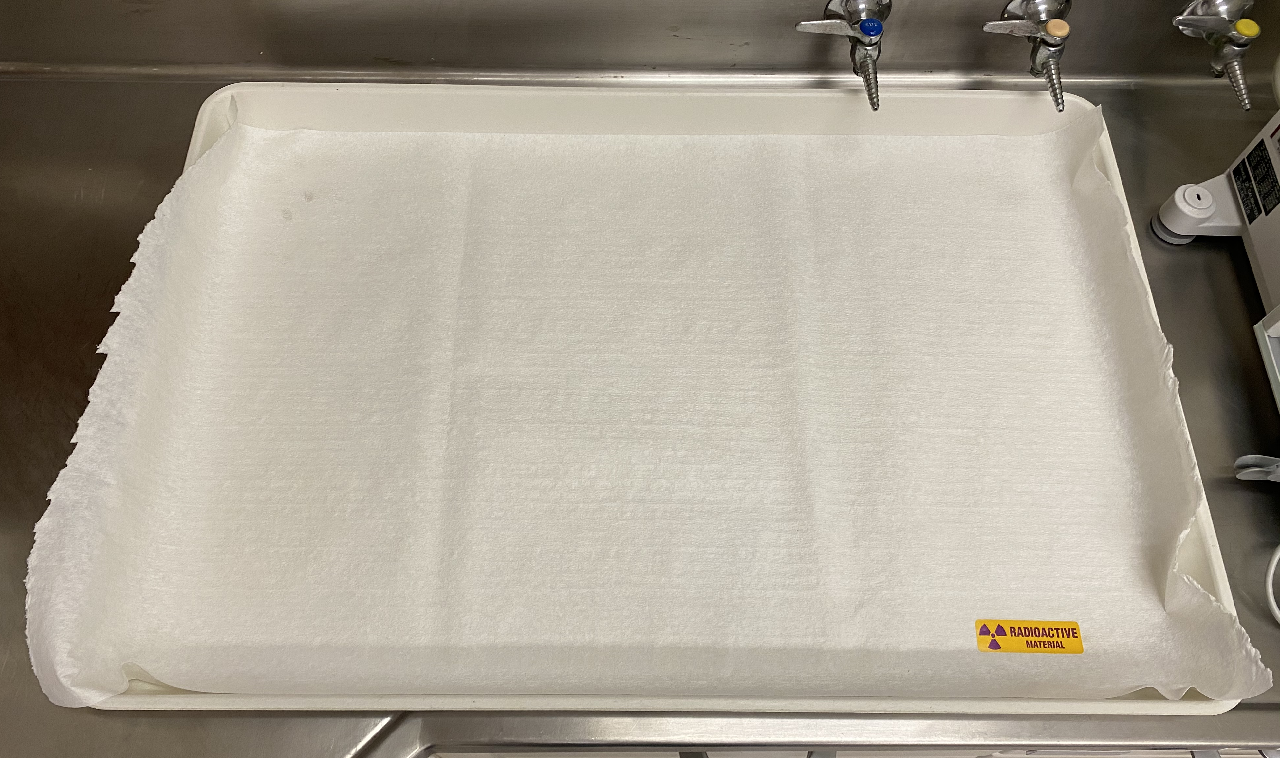
Figure 4-1. Lab tray system for use of radioactive materials.
The tray system is meant to minimize the spread of contamination when working with RAM. The replacement of absorbent lab paper between uses assists with tidiness and containment of material. When work is completed, tools, glassware, PPE, lab paper and lab tray shall be scanned out and disposed of properly and returned to their appropriate place.

Housekeeping
- Good housekeeping is a key to performing operations safely: Keep laboratory areas clean and uncluttered.
- Close containers, except when in use.
- Avoid excess material scattered on floor, benches, desks, or tables.
- Replace unused chemicals or equipment in proper cabinets or locations.
- Route wires, cables, hoses, straps, etc, to minimize tripping hazards.
- Bundle cables to phone, computers, instruments, and other electrical equipment.

Standard Operating Procedure for Performing Laboratory Work with Chemicals
READ AND UNDERSTAND THE NUCLEAR SCIENCE CENTER TOTAL HEALTH AND SAFETY PLAN, PARTICULARLY THE SECTIONS ON CHEMICAL SAFETY, CHEMICAL LABELING, AND PERSONAL PROTECTIVE EQUIPMENT.

Selecting and Procuring Chemicals
The chemicals shall be selected and procured in accordance with the NSC Chemical Hygiene Plan, and personnel shall:
- Attempt to substitute hazardous chemicals with less hazardous ones when possible.
- Minimize quantities to fit anticipated usage.
- Design procedures to use minimum quantities of hazardous materials.
- When in doubt, consult the laboratory manager before purchasing hazardous materials.
- Orders shall be performed by a laboratory manager or NSC budget authority.

Receiving and Accepting Shipments of Chemicals and Laboratory Supplies
- The shipment of chemicals and laboratory supplies will be received at the front desk of the NSC, in room 50.
- Packages containing chemicals and laboratory supplies shall be opened in the NSC laboratory facilities in the labs for which they are to be used.
- Upon opening packages, the receipt inspector shall inspect the shipment against the packing list, inspect the shipment for any damage or malfunctioning. If damage is observed, document damage and contact sales representative.
- The receipt inspector shall give packing lists to the NSC administrator, who will keep them on file.

Standard Operating Procedure for Performing Laboratory Work with Radioactive Materials
READ AND UNDERSTAND THE NUCLEAR SCIENCE CENTER TOTAL HEALTH AND SAFETY PLAN, PARTICULARLY THE SECTIONS ON CHEMICAL SAFETY, CHEMICAL LABELING, AND PERSONAL PROTECTIVE EQUIPMENT.

Selecting and Procuring Radioactive Materials
Procuring radioactive materials for use at the NSC labs is to be done in consultation with the WSU Radiation Safety Officer, NSC laboratory manager, and the authorized user.
Any procurement involving off site shipment of radioactive materials to an onsite lab at the Dodgen Building, transfer of RAM between labs within the facility, or transfer of radioactive material produced by the reactor to any non-reactor laboratory space will be performed after notification and approval of the transfer to the University RSO.

Receiving and Accepting Shipments Radioactive Materials
Receiving and acceptance of RAM shall be done in accordance with the SPPM.

General Laboratory Practices on the Use of Radioactive Material Laboratories
- Bring a GM detector into all RAM labs, regardless if you are working with radioactive materials.
- Use a GM detector or equivalent to frisk out of RAM labs, regardless if you are working with radioactive materials.
- Follow all general practices on the use of chemicals located in the LSM.
- Store used stock RAM in locked cabinets in labs or locked labs if the lab is sole use.
- The NSC employs a tray system when working with RAM. Use a RAM designated try whenever possible when working with these materials.
- Transfer of RAM from lab to lab within the DRF occurring through unrestricted areas must be double contained. Use vial holders, trays, and pails whenever possible. Minimization Minimize the chance occurrence of spill or tipping at all times through mechanical isolation.
- No gloves are to be worn in unrestricted areas, unless in an emergency. Maintain clean laboratory techniques in all RAM authorized labs.

Labeling Radioactive Materials
- RAM work areas must be designated with a RAM sticker that has the tri-foil symbol present.
- RAM must be labeled for each container that it is radioactive with a sticker containing the tri-foil symbol.

Storing Radioactive Materials
Storage of RAM shall be done in accordance with the SPPM.

DEPARTMENTAL Equipment and Instruments
All computers including general workstations, office workstations, laptops, and equipment workstations are property of the Department and the State of Washington. The use, modification, and maintenance of this equipment must be in accordance with the following sections.

Computers
This section covers hardware and software for all computers in the department, owned by the department.
- Any new computer purchases or old computer surplus will be done through NSC management and OR-IT.
- No modification of hardware or software will be made without prior approval by NSC management and WSU Office of Research IT (OR-IT). OR-IT will perform the modification.
- NSC employees are not permitted to modify or change operating systems, or add additional operating systems to departmental machines.
- No file storage is permitted on the local computer C:/ drive. Storage locations on Desktop and My Documents are permitted as these have maintained backups.
- File storage is maintained offsite by OR-IT. A local copy may be permitted utilizing a clean flash drive; however, the primary storage location will be on the OR-IT managed file server.
- NSC Reactor Operations will utilize the N:/ drive for all departmental and reactor records; NSC Research Division will use the M:/ drive for all departmental and research data.

Instrumentation
- Equipment and instruments shall be assembled, installed, used, and maintained in accordance with the manufacturer’s recommendations.
- At present, no offsite storage or network capabilities are enabled for instrumentation computers. Therefore, the collection and storage of the data from these computers are the responsibility of the laboratory managers and researcher that utilize the instrument.
- Personnel may modify the use or design of equipment or instruments with the approval the laboratory manager.
- All safety guidelines outlined in the equipment or instrument handbooks will be followed.

STANDARD OPERATING PROCEDURE FOR Liquid Nitrogen and compressed gas cylinders

Receiving New Liquid Nitrogen (LN2) and Compressed Gas Cylinders
- LN2 deliveries are made every Wednesday by WSU University Stores.
- Loading and unloading cylinders and dewars is to be performed on the first floor east end loading dock.
- Each Wednesday before 10:00 AM, bring empty LN2 cylinders to the east end loading dock by going through the gas bottle storage room to the outside door. DO NOT use the east end loading doors unless needed. Inform reactor operations if those east end hallway doors are required to be used.
- Any empty dewars placed outside in the docking area will be filled.
- At approximately 4:00 PM, retrieve the filled dewars and store inside the facility.
- Coordinate with WSU University Stores if any empty compressed gas cylinders are present in order to have them removed.

Procedure for Filling the LN2 Dewars for the Gamma Spectroscopy Systems
- LN2 deliveries are made every Wednesday by WSU University Stores. Ensure that the dewar in the storage closet has a sufficient amount of liquid nitrogen BEFORE filling the gamma spectroscopy dewar.
- Put on thermal gloves and goggles as a safety precaution. Liquid nitrogen is extremely cold and boils at -320 °F, contact with the liquid and/or vapor can cause injury. Handle with extreme care and avoid contact with bare skin, eyes, etc.
- Remove the filled dewars from the storage closet and position them such that the air tube (from the wall) and the filling tube (from the gamma spectroscopy dewar) can both reach it.
- Remove the lid from the filled dewar taken from the storage closet, and handle with care.
- Insert the cold finger pump (Figure 1) in to the filled dewar and tighten it.
  - Push the cold finger pump down into the dewar until it is snug.
  - Tighten the pump down until it is secure and loop the cord though the handle of the dewar so that the cold finger pump is attached to the dewar in order to ensure the pump will not become a projectile if it were to pop off the dewar. Caution: If the pump is loose then it can pop out of the dewar, violently, so ensure the pump is secure before connecting it to anything.
  - Be sure that that the pump valve is secure, if it is loose then liquid nitrogen will spew from the openings.
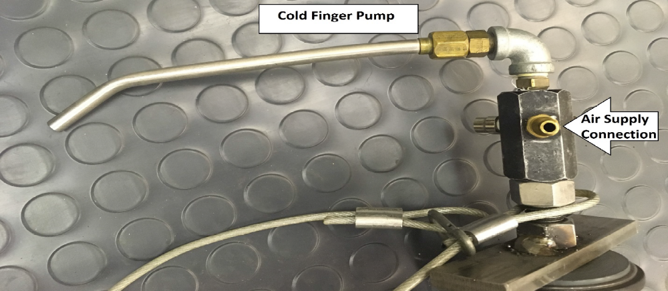
Figure 8-2. Cold finger dewar pump.

- Inspect all hoses before attaching them to the pump. Hoses should be free of major holes. If there are holes in the hoses then replace them, before attaching them to the pump.
- Attach the inlet hose that connects to the gamma spectroscopy dewar to the spout of the pump (See Figure 2). Ensure the fit is snug, if the connection is loose, the hose can pop off quickly.
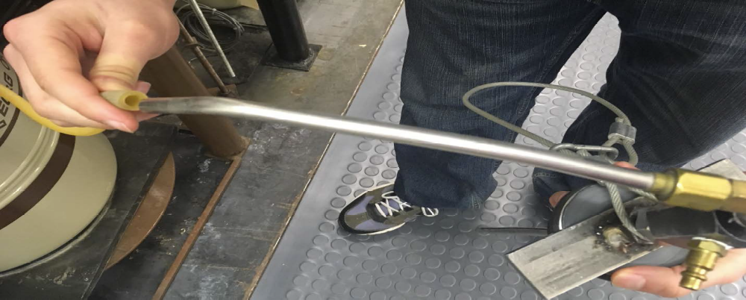
Figure 8-3. Hose and spout connection.

- Attach the air supply adapter to the copper connector on the cold finger pump (see Figure 3).
  - Push back the outer portion of the air supply adapter and place it over the copper connector on the cold finger pump.
  - When the adapter has fully surrounded the copper connector, push the outer portion forward to lock the adapter in place.
  - Air will begin to flow into the dewar once the adapter has been locked.
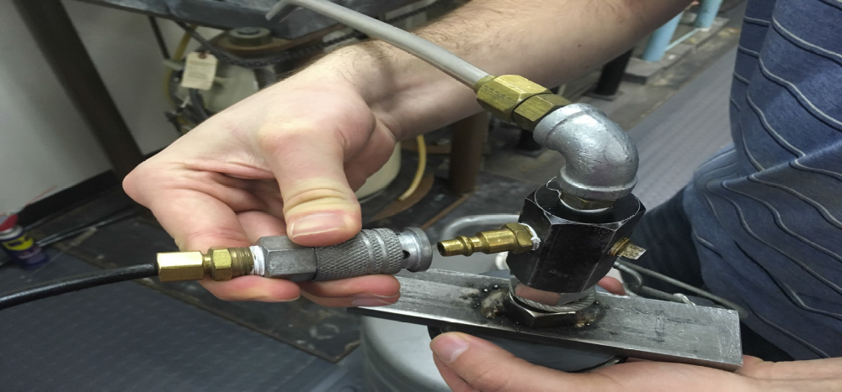
Figure 8-4. Air supply adapter to cold finger pump.

- Press down on the cold finger pump during the initial moments of filling, to ensure the pump does not pop off.
- Monitor the filling process until the gamma spectroscopy dewar is full. The exhaust hose will begin to release liquid nitrogen once the dewar is full.
- After the gamma spectroscopy dewar has been filled, remove the air supply adapter by pulling back on the outer portion of the adapter, and pulling it away from the cold finger pump.
Caution: Liquid nitrogen vapor will spew from the copper connector when removing the air supply adapter. Avoid contact with bare skin, eyes, etc.
- Allow the inlet hose to warm up before removing it from the cold finger pump.
- Remove the cold finger pump from the dewar.
Caution: The pump will be very cold, avoid contact with bare skin, eyes, etc.
- Replace the lid on the dewar.
- Safely store the dewar.

Electricity
NSC employees, contract associates, and student interns are strictly prohibited to perform any work on any of the laboratory building electrical systems. All laboratory building electrical system work will be done by WSU Facilities Services with licensed electricians.

Waste Management

Waste Minimization
All waste chemicals, including contained gases, liquids, and solids that are toxic, ignitable, corrosive, and/or reactive are to be handled as hazardous waste unless a waste profile has been completed to determine and demonstrate that they are not hazardous. To minimize the hazardous wastes generated by laboratory operations, personnel are encouraged to:
- Substitute less hazardous materials and chemicals for regulated hazardous ones whenever possible.
- Minimize the quantities of chemicals ordered to fit anticipated usage and minimize the volume of excess chemicals on hand.
- Modify processes to generate smaller quantities of hazardous waste, whenever possible.

Radioactive Material Trash Disposal
Radioactive trash is disposed of in 2 ft³ lined cardboard boxes or 55 gallon drums. These containers are distributed by the RSO on an as needed basis from the Dodgen Storage Building located behind the DRF.
All radioactive trash should be consolidated when available to a central radioactive trash box if space permits. Do not let boxes collect in laboratory spaces. Once a box is full:
- Close the bag lining with a zip tie,
- Seal the box with packing tape on all sides,
- Inform the laboratory manager that a rad box is full, and request a new one,
- Fill out the Rad Waste Disposal Pickup form for the box, and
- Schedule a rad waste pickup by filling out the online radioactive waste pickup form at http://www.rso.wsu.edu/radwastepickup.htm

Non-Radioactive Trash Disposal
Empty boxes, packing material, excess paper and other trash that does not fit in the standard trash cans or wastebaskets in the laboratory area shall be taken by the person generating the waste to the local dumpster for disposal.
Glassware, wire, and all other sharp objects shall not to be placed in trashcans or wastebaskets with the regular trash. Broken glass disposal cartons are available in the laboratory facilities for this purpose.
Waste containing flammable material shall not be disposed of in regular trash. Wipes or towels that had been wetted with alcohol (IPA) or acetone may be disposed of in regular trash, but only if they have been used until dry. Otherwise, these flammable wastes must be handled as hazardous waste.

Disposal into the Sanitary Sewer
Many of the liquid chemical wastes produced in the laboratory are not hazardous. However, per EHS regulations, laboratory workers are not authorized to determine which wastes may be disposed of in the sanitary sewer.

Disposal of Empty Containers
Cardboard containers are provided for glass containers and broken glass. Consult the LSM or contact EHS for questions regarding disposal of empty containers.

Disposal of Consumer Items
Consult the LSM or contact EHS for questions regarding disposal of consumer items.

Management of Hazardous Waste
Consult the LSM or contact EHS for questions regarding disposal of hazardous waste.

Recycling
Containers for collection of NSC work product are placed in several locations in on the second floor of the DRF. Corrugated cardboard is recycled in a bin outside of the first floor east doors of the DRF.
Battery recycling buckets are maintained in the front office (room 50) and reactor shop (room 201A) for used batteries. EHS processes the waste battery recycling buckets when notified.

