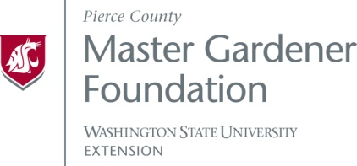
For Budget Year: 2022

Approval of funding requests is dependent on the Foundation’s available income. A follow-up report to the Foundation Board may be required mid-year.
Deadlines: Funding requests for 2022 are due April 1, 2022. The Grants Committee will review applications, then make a recommendation to the Board at their April 7, 2022, Board Meeting.
Submit completed electronic applications, including any attachments, to Tana Hasart at thasart2@msn.com. The maximum amount awarded for any approved grant will be $500. Notification of approved funding requests will be received from the MGFPC treasurer:
If you have questions about the application process, please contact Tana Hasart at the email address above.

Name of Program/Project: | SBCGG Grants | Total Amount Requested:
Briefly describe the purpose of this request:
Briefly describe how funds will be spent (attach detailed budget separately if additional space is needed):

Master Gardener Foundation of Pierce County ● 3602 Pacific Avenue Suite 200, Tacoma WA 98418-7920
Tel: 253-798-7180, 1-800-922-2456 Ext 7180 ● TDD 1-800-833-6388 ● MGFPBoard@gmail.com
Project Leader(s) who can authorize payments:
Name: | Telephone: | Email Address:

The WSU Extension Master Gardener Program has identified nine Washington State priorities: 1. Pollinators, 2. Local food, 3. Nearby nature, 4. Soil health, 5. Climate change, 6. Clean water, 7. Water conservation, 8. Plant biodiversity, and 9. Wildfire preparedness. Please identify which priorities your program/project supports and briefly describe how the priorities will be reflected in your work.

Other information that you want to provide about your project, if any:

