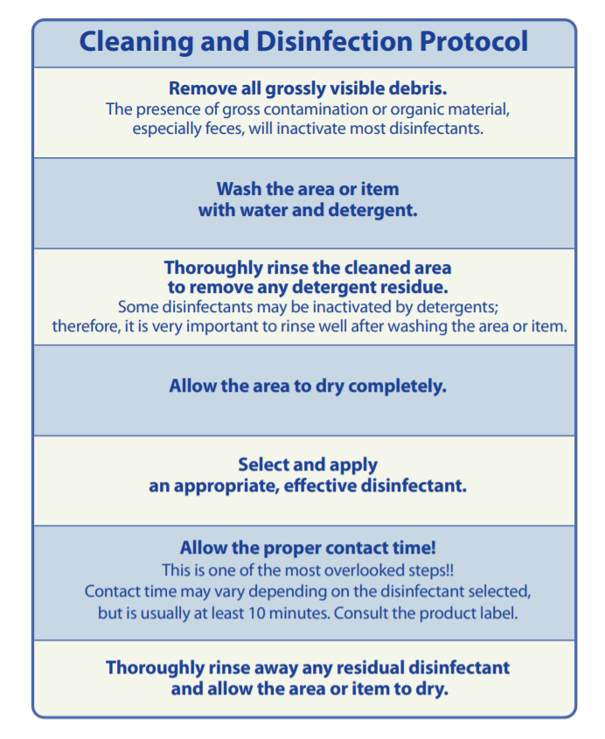
(
)
Dilution instructions for disinfectant:
Adapted from Center for Food Safety and Public Health, Iowa State University
www.cfsph.iastate.edu/Maddies_Textbook/Resources/CleaningDisinfection/SignCleaningDisinfectProtocol.pdf

