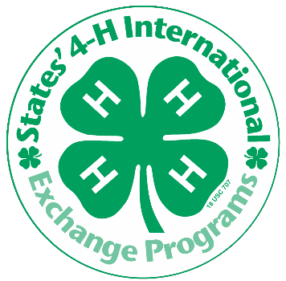
Washington 4-H International Exchange Program
Families Needed to Host Summer 2019!

HOST a delegate in your home this summer, earn credits for your child to travel abroad. No prior 4-H involvement required.

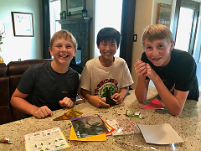
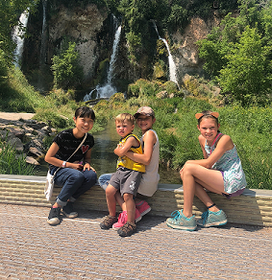
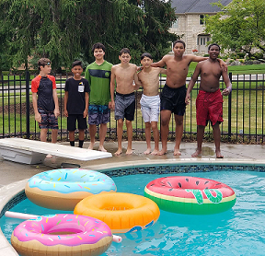

Host a Japanese Youth in Summer 2019 through Washington 4-H International Exchange
“It’s like having a sister I always wanted and a best friend”
-States’ 4-H Host Sibling

Open your home to an exchange student and open your lives to the world!

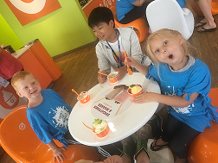
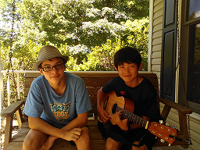
HOSTING PERIOD: July 26 to August 21

- Hosts are needed for youth ages 12-14
- Youth have a range of English language abilities, host families should be prepared to communicate imaginatively

HOST FAMILY REQUIREMENTS

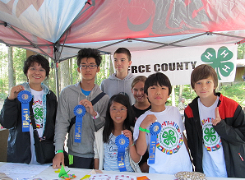
• Host families for BOYS are needed!
- Must have a child of the same gender and within 3 years of the
hosted youth.
• No special activities required. These kids want to experience American culture, make new friends, and improve their English.
- Prior 4-H participation is not required
- Host family receives credits if their child would like to travel abroad in the 4-H International Exchange Program.

Interested? To apply visit http://www.states4Hexchange.org/
Questions? Email Dianna.ullery@wsu.edu Phone: 360-867-2153

Please note: Host family selection is dependent on completion of an application and screening process as well as student availability and personality compatibility

