Clark County 4-H Program
Reporting 4-H Volunteer Hours

Why do volunteers need to report hours in this system?

We at WSU Extension could not have an educational impact in local communities without the work done by volunteers. For this we thank you very much! Why do we ask you to do even more for us and report the details of your work? Both WSU and the State of Washington look after the well-being of volunteers by requiring workers’ compensation insurance for every volunteer. This pays for medical treatment in the event that you are injured while working as a volunteer.

Washington State law requires that all volunteers working in support of WSU programs are covered by worker compensation insurance. The Washington State Department of Labor and Industry uses the dates and number of hours that volunteers work to determine the amount of insurance that must be purchased to adequately cover our volunteers. To be in compliance with state law, WSU Extension has developed an online tool to facilitate collection and analysis of volunteer contributions.

Accurate data is necessary to get insurance
Insurance is necessary to have volunteer programs

Accurate data is necessary to have volunteer programs

Please use the following site to report your monthly volunteer hours for the Clark County
4-H Youth Development program. This includes anything that you have done within your club, community service, fair events, club meetings and council meetings that you attend. Any preparing for meetings, etc. also counts.

Go to: http://ext.wsu.edu/Volunteers/logon.aspx and login.
- Your WSU Volunteer System username is the email you originally registered with Clark County 4-H.
- Your initial password is password! (all lower case and include the exclamation point). Once you log on you have the option to change your password.

If you have questions or cannot login, contact Kelli 360-397-6060 X 5730 or kellian.whidden@wsu.edu.

1

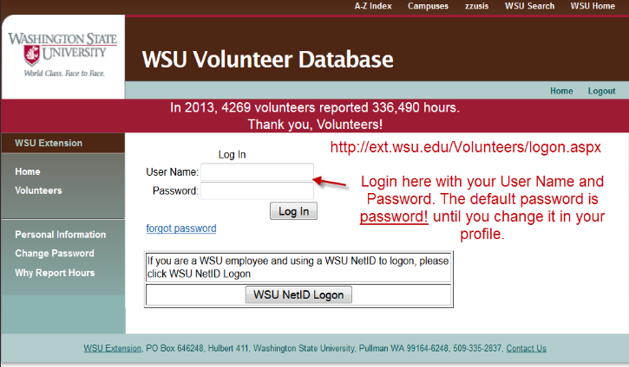
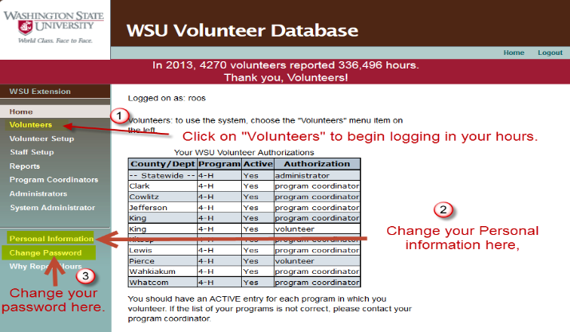
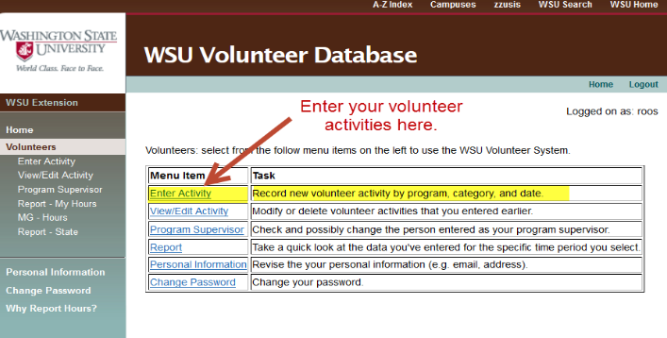
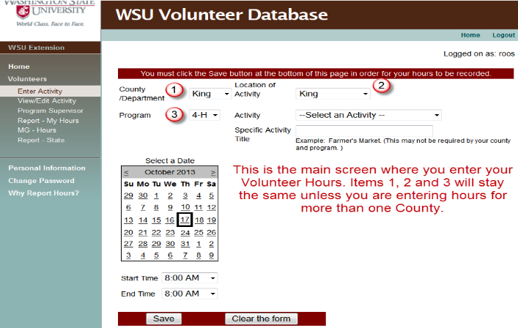
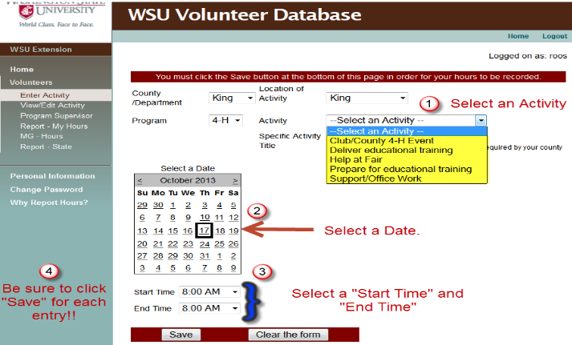
2
3
5
4

