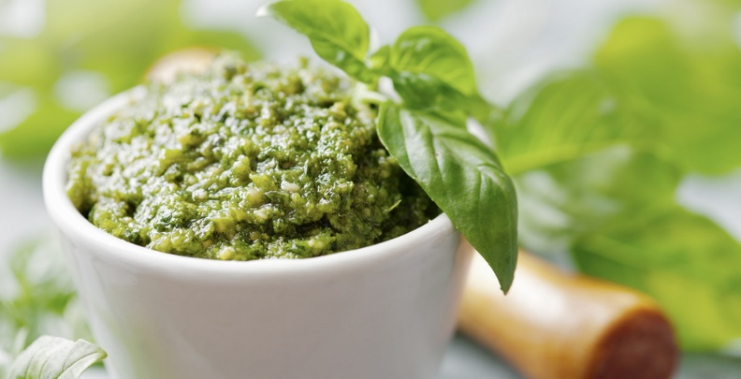
Oil Free Basil Pesto
Source: Chef Scotty
Yield: 1 cup

2 c basil leaves, packed tightly
½ c pine nuts, toasted
2 cloves garlic
2 tsp nutritional yeast
2 Tbl lemon juice

Procedure:
- Place all ingredients in a food processor and blend until desired consistency is achieved. If necessary, a small amount of water may be drizzled in to thin.

Chef Scotty's Notes:
A nice lighter version of pesto without all the oil. Use this right away or freeze in ice cube trays to store for later.

WSU Clark County Master Food Preservers
~ ~ ~
Food Preservation or Food Safety Questions?
Contact us via our Food Preservation & Safety Helpline
360-397-6060 ext. 5366 - Monday thru Friday

Companion recipe to The Columbian Market Fresh Article published on September 21, 2018.
For previous article recipes visit http://ext100.wsu.edu/clark/?p=8163

