SKAMANIA COUNTY 4-H
HORSE PROJECT
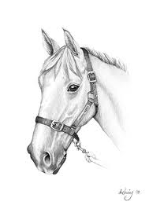
RECORD BOOK

Name_______________________________ Club__________________________
Birthdate____________ Grade Finished____ 4-H Age: JR___ INT___ SR___

