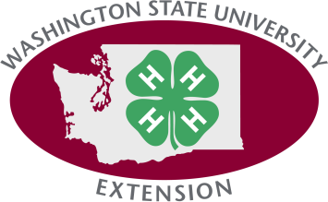
4-H Graduate Survey for ______________ Club
To the best of your knowledge, please answer the following questions for the end of the 4-H year 2018. This information will help us justify the value of the Washington State 4-H Program in our county.
Part I: How many of the former members of your 4-H club program were:
- “Graduates” or “Program Completers” in 2018: _________________ (total)That is, the total of those 4-Hers in your club completing the 4-H program by receiving a high school diploma or GED and/or reached the age 19 (too old to be a 4-Her) as of September 2016
Part II: Among your 4-H program completers, how many of them:
- Are now attending/enrolled in a post high school educational program*and are not working? _________________

- Are now attending/enrolled in a post high school educational program* and are working? _________________

- Have a full or part-time job and are not attending/enrolled in a post high school educational program? _________________

- Do not have a full or part-time job and are not attending/enrolled in a post high school educational program? _________________

- Have an unknown status (i.e., you just don’t know)? _________________

Thank you!

Due to the 4-H Office by December 1st.

*May include certificate programs, cosmetology/beauty school, military, vocational school, apprentice programs, community college, 4 year college or university, etc.

WSU Extension programs, employment, and volunteer service are available to all without discrimination. Concerns regarding potential discrimination may be reported through your local Extension office or directly to the WSU Office for Equal Opportunity, web: oeo.wsu.edu, email; oeo@wsu.edu, phone: 509-335-8288.

