Jefferson County 4-H Council
Requests and Reimbursements for
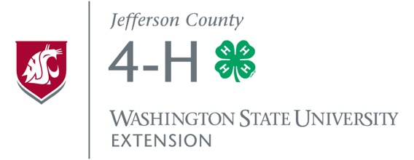
4-H Club/Group or Project Expenses

Name of 4-H Club/Group or Project (as it will appear on check):

Name and Address of Person/Club/Group to be Reimbursed:

Date | Expense Description | Reason for Expense | Amount
Total

I do hereby certify under penalty of perjury that the materials have been furnished, the services rendered, and/or the labor performed as described herein and that the claim is a just due and unpaid obligation against Jefferson County 4-H Council and that I am authorized to authenticate and certify said claim.
Signed:

4-H Club/Group Treasurer: Date:

____________________________________________________ __________________

4-H Club/Group Leader: Date:

____________________________________________________ __________________

PLEASE ATTACH ORIGINAL INVOICES and/or RECEIPTS
Please submit to:
Jefferson County 4-H Council
Treasurer
c/o 121 Oak Bay Rd.
Port Hadlock, WA 98339

To be completed by Jefferson County 4-H Council Treasurer:

Date Paid: _________________________________

Check #: __________________________________

