Gibbs Lake 4-H Challenge Course (GLCC)
GROUP REGISTRATION AND PRE-EVENT PROCESS
GROUP LEADER: KEEP A COPY OF THIS FORM/INSTRUCTIONS

STEP 1: Assess Your Group’s Interest & Readiness
Using the GLCC brochure and online information at http://extension.wsu.edu/jefferson/youth/gibbs_lake_challenge/, please take time to gauge the interest of potential participants. It is important that participants willingly choose to engage in any 4-H Challenge program.

STEP 2: Intake
Please fill out the following form and then contact the WSU Extension Jefferson County Director, Cliff Moore (360-379-5610 x202), to discuss these details and costs.

Name of group: | 4-H group?  Y___ N___
Group leader contact information
name, email, & phone#:
Dates interested in facilitated event at GLCC: (please list several options)
Preferred time and duration of event:
# of youth participants expected &  their age range: | Any enrolled 4-H member(s)?  #Y___ #N___
# of adult participants expected:  (please count only the adults who will actively participate on the Course) | Any enrolled 4-H leader(s)?²  #Y___ #N___
Are you requesting an on-site portable restroom? (Est. cost: $160)
Please mention any group and/or participant special needs for which planners may need to arrange accommodations:
Group’s goals/hopes for facilitated event at GLCC (e.g., peer-group teambuilding, adult-youth teambuilding, improved communication, etc.):

Other group information that you would like the event planners and facilitator(s) to know:

STEP 3: Coordinate with Participants and/or Parents/Guardians
- Email this link http://extension.wsu.edu/jefferson/youth/gibbs_lake_challenge/
  - Ask Participants and Parents/Guardians to read over the information on this page to familiarize themselves with the Course
  - Ask Participants and Parents/Guardians to download and complete:
    - The “GLCC Health & Authorization Form” – PARTICIPANTS WILL NOT BE ALLOWED TO PARTICIPATE ON THE COURSE WITHOUT THIS COMPLETED, SIGNED FORM
    - The “GLCC Personal Clothing & Equipment List”
- At least TWO weeks prior to your event, collect completed GLCC Health & Authorization Forms from EVERY PARTICIPANT
- Coordinate participants’ transportation and food needs

STEP 4: Final Details
- At least ONE week prior to your event, return all GLCC Health & Authorization Forms to the WSU Extension Office, in person or by mail: 121 Oak Bay Rd., Port Hadlock, WA 98339
- At least ONE week prior to your event, call WSU Extension 360-379-5610 x202 to review:
  - Participant numbers
  - Group arrival and departure times and general schedule
  - Special needs/accommodations
  - Group goals
  - Facilitators
  - Costs and payment
  - Any remaining questions

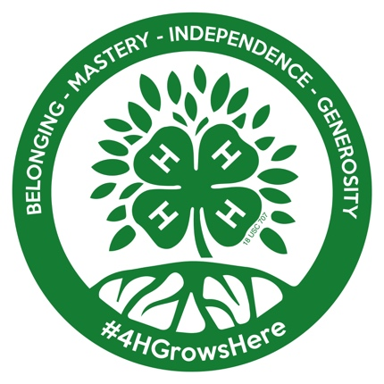

We look forward to seeing your group on the 4-H Challenge Course at Gibbs Lake Park!

To maximize the benefits of this experience, GLCC planners strongly recommend that you allow for at least 3.5-4 hours for your group’s first time on the Challenge Course.
WSU 4-H arranges for Special Event Insurance coverage for all youth and adults NOT enrolled in 4-H. These numbers help us do so.
A park restroom is located at Gibbs Lake main waterfront area, about a 5 min. walk from the Challenge Course. Groups requesting an on-site portable restroom will cover the rental cost; WSU Extension 4-H will arrange for this with Good Man Sanitation.
To view the WSU 4-H Reasonable Accommodations Policy, please scroll to the bottom of this page: http://extension.wsu.edu/jefferson/youth/.

