Jefferson County 4-H Council
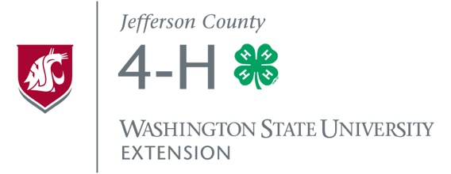
Travel & Training, Small Grants
APPLICATION FORM

The Jefferson County 4-H Council annually awards grants (up to $50) to 4-H youth and leaders who would like to gain greater understanding within their specific 4-H Projects and/or various aspects of positive youth development. These grants may be used for helping to cover the costs of trainings, travel, curricula, teen rallies, camps, or other 4-H-related educational experiences. 4-H youth and leaders who have helped to promote and/or raise funds for 4-H programs that benefit youth throughout our county (i.e., through the Jefferson County 4-H Council) are eligible to apply. All grant proposals must help further the “Essential Elements” (see http://jefferson.wsu.edu/youth) of 4-H.
Applications accepted on a rolling basis throughout the year; forms due the 15th of each month.

Current 4-H Year: October 1,_______-September 31,_______
Date of Application: _________________________________
Name(s) of Applicant(s): _________________________________________________________________________
Applicant(s) 4-H Club(s) or 4-H Affiliation(s): ________________________________________________________
Best Way to Contact Applicant(s):_________________________________________________________________

Please answer the following to the best of your ability. Please attach your Jefferson County 4-H Council Promotion/Fundraising Log(s), additional sheets, and/or other supporting information.

- Since last October 1, how did you help to promote and/or raise funds for Jefferson County
4-H? Please include activities, dates and hours served, and any other information that gives a sense of your involvement with 4-H Council fundraising and/or promotion.

- What is the grant amount that you are requesting? $____________

- Please describe how you would use the grant that you’re requesting:

- Please consider the four “4-H Essential Elements” listed below. Please describe how you would use the grant monies to live out each of these Elements – in your life and in the lives of others. (Use/attach additional sheets if needed.)
- BELONGING/INCLUSION

- INDEPENDENCE

- MASTERY

- GENEROSITY

- 4-H LEADER(S)
We will contact your 4-H Club and Project leader(s) as we make a decision on awarding you this grant:
Leader’s Name: __________________________________ Phone #: ______________________
Email: _____________________________________________________

Leader’s Name: __________________________________ Phone #: ______________________
Email: _____________________________________________________

Please return this completed application form to:
Jefferson County 4-H Coordinator
121 Oak Bay Rd., Port Hadlock, WA 98339
GRANT RECIPIENTS:
(1) Keep all receipts related to the grant.
(2) Within one month of having used the grant money, send a follow-up letter to Council (less than 1 page, to address above) reflecting again on how the grant-funded event/resources helped you to work on the 4-H Essential Elements listed in question #IV above. Include copies of your receipts in this letter. Thank you.

-This box to be completed by Jefferson County 4-H Council-
Date Application Received: _____________________ Date Application Reviewed: _________________________
Request Granted? YES or NO Amount: ______________________ Check #: ________________________
Comments:

Due Date of Follow-up Letter to Council: _______________________

