WELCOME to 4-H Afterschool Programs in Brinnon!

Dear Parents and Guardians:

We’re pleased that your youth will be spending time with us after school! Your youth will be taking part in a variety of high quality, experiential-learning activities that they may not encounter during the school day. Our gifted, well-vetted staff make every effort to create and maintain a safe environment in which youth can grow to their fullest potential. Please read, complete, sign, and return this cover letter and the attached Enrollment Form before your youth returns to the Afterschool Program. Thank you for entrusting your youth to our care and for your partnership in “making the best better” (the 4-H motto).

PARENT/GUARDIAN COMMITMENTS:
- Each day, I will pick up my youth as close to 5:20 p.m. as possible.
Parents/guardians are most welcome to join the class at 5:05 each day for closing activities. If you must pick up your youth early, please try to inform the staff ahead of time and/or please do so in an undisruptive way. Our staff will leave the campus promptly at 5:30 daily; if you are not able to pick up your youth by this time, you must make arrangements with another trusted adult to do so. On the back of this sheet, please list all other adults who may/may not pick up your youth. You may also indicate on the back if you authorize your children to get themselves home safely.
- I will make an effort to check in briefly with afterschool staff at least once each week.
Checking in with staff around dismissal time ensures that communication between home, school, and afterschool is as smooth as possible.
- I will contact the 4-H Coordinator, Tanya Barnett, if I have any questions or concerns that cannot be met through regular check-ins with after-school staff.
Tanya can be reached at: tanya.barnett@wsu.edu or (360) 379-5610 x208.
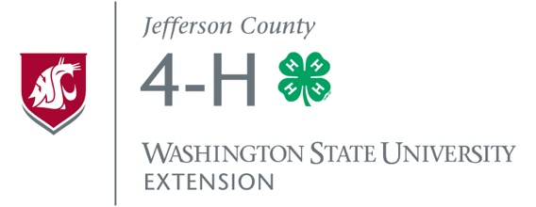
- I will be sure that my youth are in good health (e.g., NO contagious illnesses, fever-free for more than 24 hrs., etc.) when they attend the program and properly equipped for their afterschool experiences (e.g., water bottle, appropriate clothing – layers when necessary, NO electronic devices or weapons, etc.).
- I will respect and support afterschool staff and work with my youth to uphold the 4-H Youth Code of Conduct (on the attached Afterschool Program Enrollment Form, p. 1) as well as the rules and procedures outlined in the Brinnon School Student Handbook (https://www.bsd46.org/Page/113).

I have read these 4-H Afterschool Program Parent/Guardian Commitments and agree to them, signed:

_____________________________________ _______________________________ ___/__/___
(Parent/Guardian Name Printed) (Parent/Guardian Signature) (Date)

WSU Extension programs and employment are
available to all without discrimination.
Evidence of noncompliance may be reported
through your local Extension office.

Names & Ages of Your Youth Enrolling in 4-H Afterschool Programs

Youth Name | Age | Has parent/guardian permission to get to/from school on his/her own? (yes/no)

List of Approved Adults
Please list any adults you trust to pick up your youth:
Name | Relationship to Youth | Phone Number (cell preferred)

List of Restricted Adults
Please list any adults who may not pick up your youth:
Name

Please complete and return all forms to
The Afterschool Teacher or
Tanya Barnett, 4-H Coordinator
tanya.barnett@wsu.edu
121 Oak Bay Rd.
Port Hadlock, WA 98339
360-379-5610 x208

