4-H Volunteer Enrollment Process – NEW VOLUNTEERS

- Go to https://wa.4honline.com
- On the “Welcome” page, select “I need to set up a profile” and “family” as your role; click “create login” to continue to next page.
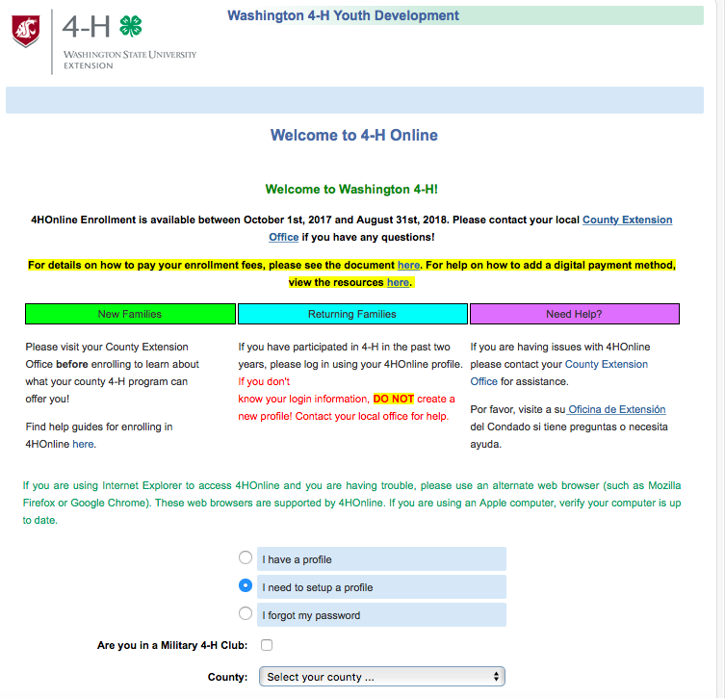
- On the next page, please fill in your information and click “continue” to continue to the next page
- On the next “Member List” page, go to “Add a New Family Member” and select “Adult” then “add member”
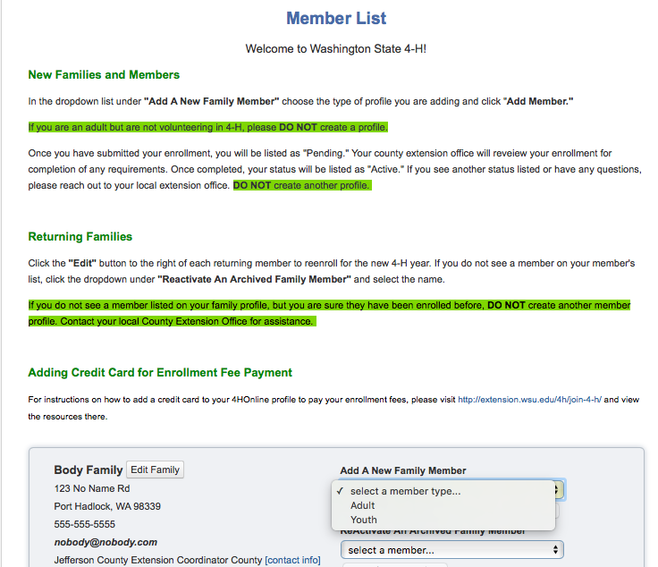
- Complete and click through Personal and Health Information pages
- When you reach the Participation page, add or delete club info. and volunteer info.; please ignore the “groups” tab
- Click through and complete all of the following pages (including $0 payment page) until you’re able to submit your enrollment

4-H Volunteer Enrollment Process – RETURNING VOLUNTEERS
- Go to https://wa.4honline.com
- On the “Welcome” page, select “I have a profile” and “family” as your role. (If you cannot remember your password, please select “I forgot my password”; then check your email for instructions to reset your password.) Click “Login” to continue to next page.
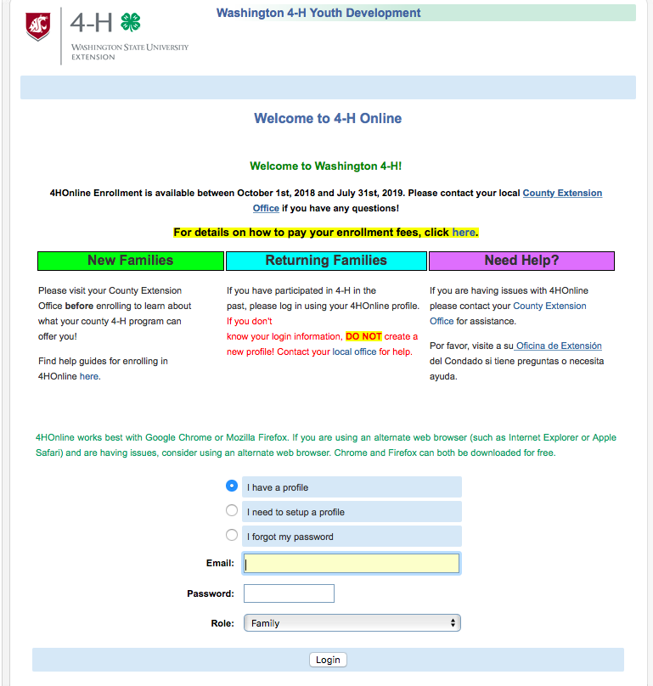
- On the next page, please fill in your information and click “Continue to Family” to continue to the next page.
- On the next “Member List” page, please find your name and click “Edit”; select your name and continue to read, complete, and click through all of the information, release, and health pages
- When you reach the “Participation” page, add or delete club info. and volunteer info.; please ignore the “groups” tab
- Click through and complete all of the following pages (including $0 Payment/Invoice page) until you’re able to submit your enrollment

