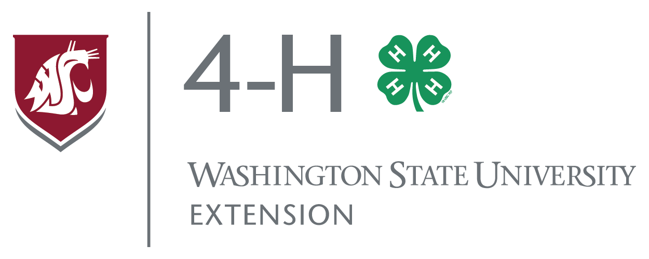

4-H Scholarship Request
Final Drive: Livestock Showmanship Clinic
Please complete the following form and submit to the 4-H Office by Feb 3rd

Youth Name: _______________________________________________________________
Youth Age:________ Youth Class: JR INT SR
4-H Club or FFA Chapter:_________________________ County:_____________________
Phone:_____________________________________ Email: _________________________
What species of livestock are you interested in? Cattle Hogs Sheep Goats

Why is 4-H important to you? __________________________________________________
__________________________________________________________________________
How do you hope this clinic will benefit you? _____________________________________
__________________________________________________________________________
How would this scholarship help you or your family? ______________________________
__________________________________________________________________________
How much scholarship funds are needed for this youth? $_________/$30.00 registration fee

Extension programs and employment are available to all without discrimination. Evidence of noncompliance may be reported through your local Extension office. Reasonable accommodations will be made for persons with disabilities and special needs who participate in 4-H events and programs. Contact Kate McCloskey at the Spokane 4-H Extension Office at 222 N. Havana, Spokane, (509-477-2165; kmccloskey@spokanecounty.org) at least two weeks prior to the event.

