Farm Name: ________________________________________ Year Updated: _________________
Farm Business Plan

_____________________________________________________
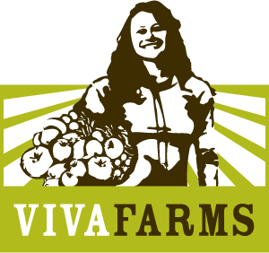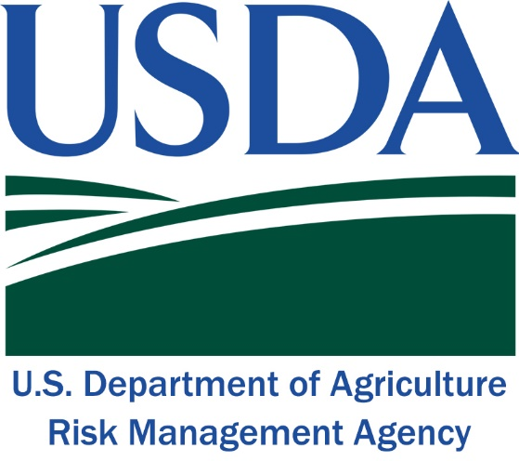

Contents
FARM BUSINESS PLAN 3
Business Name 3
Brief Description of Business 3
Business Mission 3
Business Goals 3
Funding Sources 4
Primary Sales Channels and Distribution Strategies 4
Description of Target Customer 4
Competitors 5
Marketing Strategy 5
Key Positions and Business Personnel 6
Permits, Licenses and Certifications 6
Additional Information 6
Product & Price List 7
FINANCIAL STATEMENT TEMPLATES 8
Budget 8
Actuals 9
Profit & Loss Statement (Annual Income & Expense) 11
Balance Sheet 12

FARM BUSINESS PLAN

Business Name

Brief Description of Business

Business Mission

Business Goals

Funding Sources
(e.g. Loans, Grants, Self-Financed)

Primary Sales Channels and Distribution Strategies
(e.g. CSA, farmers’ market, wholesale distributor, food hub, etc.)

Description of Target Customer
(e.g. wholesale buyers, coops, restaurants, end consumers, etc.)

Competitors

Marketing Strategy
What marketing outlets will you use to target and build your customer base (e.g. website, social media, paper fliers, events, newsletters, visits to the farm, etc.)?

Key Positions and Business Personnel
Position | Name | Experience

Permits, Licenses and Certifications
*List all current permits, licenses and certifications, as well as those that the business intends to obtain this year.

Additional Information

Product & Price List
Product | Sell-by Unit | Wholesale Price | Retail Price
Ex: Strawberries | Half flat | $13 | $18

FINANCIAL STATEMENT TEMPLATES

Budget
Instructions:
Use this Budget template to predict your income and expenses by each quarter of the year, in order to plan when major expenses will take place, when you will start making sales, and in order to plan your cash inflow and outflow.
*Note that in making your budget for the year, you should take into account your ending cash balance from the previous year, as well as any loan payments, the depreciation on any assets and estimated tax liability. These are more complex considerations that you can discuss with your accountant.
 | Q1  (Jan-Mar) | Q2  (Apr-Jun) | Q3  (Jul-Sep) | Q4  (Oct-Dec) | Total
INCOME
Wholesale
CSA
Farmers’ Markets/Farm Stands
Restaurants
Other
Total Income
OPERATING EXPENSES
Variable Costs
Car and Truck Expenses (mileage)
Contract Work
Feed
Fertilizer and Spray
Fuel
Seeds and Plants
Supplies and Packaging
Hired Labor
Fixed Costs
Insurance
Rent
Repairs and Maintenance
Storage
Telephone/Internet
Software (Accounting, POS, etc.)
Marketing
Other
Total Operating Expenses
Net Profit/Loss

Actuals
Instructions:
Use this Actuals template to compare your budget with what happened in reality. Take note of anything surprising. This will help you make a more accurate budget next year.

 | Q1  (Jan-Mar) | Q2  (Apr-Jun) | Q3  (Jul-Sep) | Q4  (Oct-Dec) | Total
INCOME
Wholesale
CSA
Farmers’ Markets/Farm Stands
Restaurants
Other
Total Income
OPERATING EXPENSES
Variable Costs
Car and Truck Expenses (mileage)
Contract Work
Feed
Fertilizer and Spray
Fuel
Seeds and Plants
Supplies and Packaging
Hired Labor
Fixed Costs
Insurance
Rent
Repairs and Maintenance
Storage
Telephone/Internet
Software (Accounting, POS, etc.)
Marketing
Other
Total Operating Expenses
Net Profit/Loss

Profit & Loss Statement (Annual Income & Expense)

Instructions:
You can complete a Profit & Loss Statement at any point throughout the year, and it will always express your income and expenses over a period of time. Complete this P&L on December 31st, and it should match the totals from your Actuals. This will give you a snapshot of your income and expenses for the entire year.

Start Date: January 1st End Date: December 31st
INCOME
Wholesale
CSA
Farmers’ Markets/Farm Stands
Restaurants
Other
Total Income
OPERATING EXPENSES
Variable Costs
Car and Truck Expenses (mileage)
Contract Work
Feed
Fertilizer and Spray
Fuel
Seeds and Plants
Supplies and Packaging
Hired Labor
Fixed Costs
Insurance
Rent
Repairs and Maintenance
Storage
Telephone/Internet
Software (Accounting, POS, etc.)
Marketing
Other
Total Operating Expenses
Net Profit/Loss

Balance Sheet

Instructions:
The Balance Sheet is a snapshot of your business at one point in time. It expresses everything you own and owe, and the “net worth” of your business. It is good to complete a Balance Sheet on the first and last day of every year, in order to show how the economic activity over a given period of time impacts your net worth.

 | Beginning Balance (January 1st) | Ending Balance (December 31st)
ASSETS
Current Assets
Farm Bank Account
Cash on Hand
Accounts Receivable
Inventory
Fixed Assets
Farm Land
Farm Equipment
Farm Vehicles
Farm Buildings
Other
Total Depreciation
Total Assets
LIABILITIES
Debt
Operating Loan Balance
Tractor/Equipment Loan Balance
Credit Card Loan Balance
Long Term Loan Balance
Payables
Total Debt
Equity
Owners Capital
Owners Draw
Net Income (or loss)
Total Equity
ASSETS = LIABILITIES (Debt + Equity)

Additional Information
____________________________________________________________________________________________________________

_________________________________________________

