Developing Practical Phosphorus and Potassium Tissue Test Recommendations and Utilizing Struvite in Modern Alfalfa Systems III
Norberg, S.¹, S. Fransen², J. Harrison³, D. Llewellyn⁴, and L. Whitefield⁵
¹Washington State University
WSU Franklin County Extension Office
404 W. Clark Street
Pasco, WA 99301
Phone: 509-545-3511
Fax: 509-545-2130
Email: s.norberg@wsu.edu

²WSU IAREC
24106 N. Bunn Rd.
Prosser, WA 99350-9687 USA
Phone: 509-786-9266
Fax: 509-786-9370
Email: fransen@wsu.edu

³Washington State University
2606 West Pioneer, Puyallup, WA 98371
Phone: 253-445-4638
Fax: 253-445-4569
e-mail: jhharrison@wsu.edu

⁴Washington State University Extension
ASLB 220
P.O. Box 646310
Pullman, WA 99164-6310
Phone: 509-335-8759
Fax : 509-335-1082
E-mail: don.llewellyn@wsu.edu

⁵ Washington State University
Livestock Nutrient Management Program
2606 W. Pioneer
Puyallup, WA 98371
Office: 253-445-4562
Fax: 253-445-4569

Abstract: (Limit 200-300 words)

Developing critical plant nutrient levels in-season improves recommendations and applications, saving producers time, expense and effort since many growers take samples for hay quality. Three experiments were designed as follows: 1) Phosphorus (P) Rate study with differing rates of P₂O₅ using monoammonium phosphate (MAP); including: 0, 30, 60, 120, 240 lb P₂O₅ acre⁻¹ on a low testing P soil <10 ppm (Olsen P method); 2) Potassium (K) Rate study with differing rates of K₂O using potassium sulfate: 0, 40, 80, 160, 240, 320 lb K₂O acre⁻¹ on an <100 ppm K soil (ammonium acetate method). 3) Struvite study (magnesium ammonium phosphate, MgNH₄PO₄ · 6 H₂O) application at 144 lbs. of P₂O₅ /acre in differing ratios of MAP:Struvite in alfalfa including: 100:0, 75:25, 50:50, 37.5:62.5, 25:75, 12.5: 87.5, 0:100 and an unfertilized check. The following is summation of three field years of results for alfalfa harvested at mid-bud stage for all cuttings in the same field. Increasing P rate from 0 to 240 lb P₂O₅ acre⁻¹ increased yield by 0.9, 1.5 and 1.6 tons acre⁻¹ in 2018, 2019, and 2020, respectively. Averaged over years, the whole plant tissue level at the economic optimum was 0.355 and 0.36% at mid-bud stage for 150 and $200 ton⁻¹ of hay, respectively. No potassium response was found in 2018 but yield increased 1.14- and 1.26-tons acre⁻¹ in 2019 and 2020 respectively. About 80% of yield response occurred in the first and second cuttings indicating that P and K need to be applied in the fall or early spring to get the largest yield response. Potassium content in alfalfa varied widely between years optimum K content for the two years but the optimum for $200 ton⁻¹ hay was 1.9 and 1.6% for 2019 and 2020, respectively. Replacing MAP with struvite used in this experiment proved successful without yield loss or reduction in P content of alfalfa.
Introduction:
Most inorganic phosphorus (P) fertilizers are derived from phosphate rock, where 98% of the reserves are in other countries; with the USA only holding 2% (Stewart, 2002; USGS, 2020). Dairy farms accumulate P through manure, and each farm has a unique need for P outlets and removal to reach a whole farm P nutrient balance (WA Dept. of Ecology). In contrast, alfalfa (Medicago sativa) producers need to reverse the trend of declining soil test P content to maintain high crop yield and quality. To compound the problem, just a few years ago the price of commercial P fertilizers soared to record high prices, and will likely do so again as reserves diminish and struggle to accommodate increasing demand. A viable solution is the adoption of technology to capture P from liquid manure in the form of ‘struvite’ (magnesium ammonium phosphate, MgNH₄PO₄ · 6 H₂O), a slow-release form of P based fertilizer. Currently, Pacific Northwest (PNW) struvite NPK fertilizer has an analysis of (6 – 29 – 0) including 16% magnesium. Struvite is easy to handle and transport due to low moisture content and sand-like texture.
With high P and K fertilizer costs it is important to apply required nutrients accurately. Current soil sampling guidelines are calibrated from one foot soil tests, yet alfalfa plants can remove potassium and other nutrients from deeper horizons creating disproportional inaccuracy between crop response and soil test results. Tissue testing provides the opportunity to direct nutrient decision making based on accurate critical levels for in-season recommendations that could include possible applications between cuttings or through fertigation. California scientists have developed the alfalfa tissue testing protocols; however, producers are not adopting them because the test uses the middle third of alfalfa at one-tenth bloom for P & K (Meyer et al., 2007). One-tenth bloom is over mature dairy quality hay for most PNW producers, making the California recommendation impractical. Alfalfa tissue testing has been proposed in New Mexico, which recommended a wide range from 2.0 to 3.5% K in the upper third of the plant at early bloom (Flynn et al., 1999). The current PNW alfalfa fertilizer guide states a critical K level of 2.0 to 2.5% for the whole plant at first bloom, but needs further refinement (Koenig et al., 1999). Research conducted in Israel suggests that K levels should remain above 2.5% at harvest for maximum alfalfa yield (Kafkafi et al., 1977). This research and others reveal P & K concentrations decline with crop maturity indicating the importance of the timing of tissue testing.
Fertilizer is the largest single expense in an irrigated alfalfa budget for western U.S growers. Even at modest rates, fertilizer can easily exceed over $216 per acre with P & K being the largest component (Norberg and Neibergs, 2014). More K is removed from the soil by alfalfa than any other nutrient (Koenig and Barnhill, 2006). Alfalfa can remove 8 lbs P₂O₅ and 54 lbs K₂O per ton of alfalfa produced (Koenig, et al., 2009), which for yields of 10 tons per acre attainable by excellent producers in the PNW, result in 80 lbs P₂O₅ and 540 lbs K₂O removed per acre per year. In these studies, we investigated using a harvest crop maturity of mid to late bud stage (typical harvest timing for first cutting in PNW) and collecting whole plant samples at the same time for quality analysis. We have emphasized first cutting because it’s the one most desired by the dairy industry and the most likely cutting to be nutrient limiting due to cold soils. We have also proposed to test all alfalfa cuttings to follow seasonal trends in nutrient uptake from high producing alfalfa stands. Struvite is a slow-release option to MAP and our hypothesis is that combining the two nutrient source would provide the best overall production and quality results.
This is the third year of this research funded by National Alfalfa and Forage Alliance and was conducted near Prosser, Washington on a low phosphorus testing soil 5.4 ppm (method: Olsen et al., 1954) for the phosphorus study and 79 ppm potassium soil (ammonium acetate method). We aimed to: 1) Develop and calibrate phosphorus (P₂O₅; Phosphorus Rate study) & potassium (K₂O; Potassium Rate study) nutrient recommendations for bud stage alfalfa using tissue testing for maximum profit, yield and direct comparison to current soil testing recommendations; 2) Compare efficacy of combinations of MAP and struvite (Struvite study) for fertilization of alfalfa; 3) Evaluate quality of hay samples at different P and K rates and tissue concentrations.
Materials and Methods:
We established three experiments, two at low P soil test field < 10 ppm P (“Phosphorus Rate” & “Struvite”), and one on a low K soil test field <100 ppm K (“Potassium Rate”). Studies were in a randomized complete block design with four replications at establishment of a spring stand of alfalfa and harvested three times in the spring establishment year, 2018. Nutrients were applied on the surface for the second year of the experiment on April 11, 2019. Alfalfa was harvested five times in 2019 and 2020. The experiments’ treatments and descriptions are listed below.
“Phosphorus Rate” – Studying the influence of P₂O₅ rates of MAP (0, 30, 60, 120, 240 lbs P₂O₅/acre) to develop/refine tissue testing recommendations for P.
“Potassium Rate” – Response of alfalfa to six differing rates of Potassium Sulfate (0, 40, 80, 160, 240, 320 lbs K₂O/acre) to develop/refine tissue testing recommendations for K.
“Struvite” – Alfalfa response to six mixtures of MAP:Struvite (0:0, 100:0, 75:25, 50:50, 37.5:62.5, 25:75, 12.5: 87.5, 0:100) to determine if any quick release P is needed from MAP to supplement the slower release of P in struvite for spring planted alfalfa.
Struvite and MAP was applied according to treatments desired with a Gandy drop spreader after calibration.
Tissue samples were analyzed for P and K by Inductively Coupled Plasma Atomic Emission Spectroscopy (ICP). Yield results were compared to P and K concentrations to determine critical values required for maximum yield and economic returns. Calibration of P and K shortages were compared to optimum rate at harvest along with P and K concentrations of tissue samples pulled to determine appropriate fertilizer recommendations for each cutting or averaged over cuttings if similar results were found.
To determine the maturity at harvest we used the maturity ratings of Mueller and Teuber (2007) where: “growth stage 2” is late vegetative stage when stem length is greater than 12 inches, no visible buds, flower or seed pods; “growth stage 3” is early bud when 1-2 nodes have visible buds and have no flowers or seed pods; and “growth stage 4” is late bud when ≥ 3 nodes have visible buds, with no flowers or seed pods. “Growth stage 5” is early Flower when one node has an open flower and no seed pods; and “growth stage 6” is late flower when ≥ 2 nodes have open flowers and no seed pods. The growth stage of ten stems was determined and then used to calculate the average for each plot.
Plots were 36 inches wide and 25 foot long and harvested with a flail harvester (Carter Manufacturing). Subsamples that were taken by hand from 5 feet of 1 row in each plot and weighed, dried and weighed again for harvest moisture and dry matter yield determination.
These experiments determined how P and K status affects feed quality and value as stated in objective 3. To accomplish this, whole plant samples were collected from each treatment plot at bud stage at each harvest. All harvested samples were dried in forced air ovens at 60^{о}C until no weight loss occurred. Samples were ground through a Wiley Mill (Thomas Scientific, Swedesboro, NJ) to 2 mm in length, then ground with Udy Cyclone Sample Mill (Udy Corporation, Fort Collins, CO) to 1 mm before scanning and prediction for DM, CP, ADF, aNDF, ash, starch, fat and TDN by FOSS 6500 Near Infrared Reflectance Spectroscopy (NIRS) using 10 percent of samples for wet lab validation by the methods of Shenk et al. (1989). Ground samples were utilized for both nutrient and forage quality analysis. Statistical analysis was run in SAS using Proc GLM.

Results and Discussion
Phosphorus Rate Experiment:
The field selected for this work had been in switchgrass for over 5 years with no fertility put back in the field and resulted in soil test of 8 ppm P (Olsen) and 101 ppm K (Ammonium Acetate). Visually the 0, 30, and 60 lb P₂O₅/acre plots had stunted growth going into the 2nd and 3rd spring of the 3-year study (Figure 3). No leaflet symptoms were present. Increasing P rate from 0 to 240 lb P₂O₅ acre⁻¹ increased yield by 0.9, 1.5, and 1.6 tons acre⁻¹ in 2018, 2019 and 2020, respectively (Figure 1.). In 2020, yield response to P was mostly in the first and second cuttings and averaged over rates made up 79% of the total increase in yield. Yield increases of treatments in the first cutting peaked at 120 lb P₂O₅ acre⁻¹ in 2018 and 2019 but in 2020 the 240 lb P₂O₅ acre⁻¹ was the highest yielding treatment. Since MAP was used in this study some nitrogen would be applied, however research has found that late season harvests are most likely to have a N response (Raun et al. 1999) and only 19% of the total yield increase in this experiment was from cuttings 3, 4 and 5.
Harvest dry matter yield increases due to applied N were only found in late-season harvests, consistent with late-season decreased N2-fixing capacity in alfalfa documented by others.
Gross income after fertilizer expenses were calculated using regression to determine optimum fertilizer rates for the study using two prices of hay $150 and $200 ton⁻¹ of hay and a P₂O₅ price of 0.538 lb⁻¹. Optimum economic P₂O₅ rates were 140, 150, and 150 lb P₂O₅ acre⁻¹ for $150 ton⁻¹ hay in 2018, 2019, and 2020 respectively. For $200 per ton hay, regression showed that 160 lb P₂O₅ acre⁻¹ maximized gross income after fertilizer costs for all three years. Averaged over years, the whole plant tissue level at the economic optimum was 0.355 and 0.36% at mid-bud stage for 150 and $200 ton⁻¹ of hay, respectively.
When using tissue testing and selecting a critical level, the stage of maturity and what part of the plant is being tested both factors must be considered nutrient. Our experimental results indicate the optimum level of P in the plant is higher than previously published (Meyer et al., 2008, Koenig et al., 2009). Our results indicate that even which cutting tested can affect the P tissue testing results (Figure 2). Koenig et al., 2009 recommends 0.2 - 0.25% P at first flower using the whole plant and Meyer et al., 2008 recommends 0.26 - 0.28% P for whole plant tissue at bud stage or early bud stage, respectively. In 2019, on our very low P soil with no P reached 0.26% at the second cutting (Figure 2). The impact of hay content P in this study was as large as $522 acre⁻¹ over the 3 years for $200 ton⁻¹ hay (Table1.). The optimal P content should be applicable of a wide range of locations, however economics will vary based on productivity of the field.
Interestingly, the soil level test levels continued to drop at all P rates (Table 2) except for the 120 and 240 P₂O₅ lb a⁻¹ rates in 2018 which only had 3 cuttings in the first year as it was a spring planting. Crops seasons 2019 and 2020 each had five cuttings.
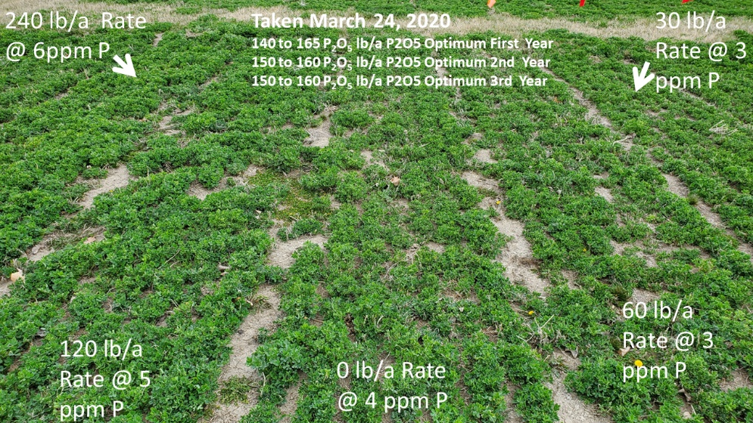
Figure 1. Field views in the Phosphorus Rate Study between the control and 240 lbs P₂O₅/acre treatment on March 24, 2020 at Prosser, WA prior to phosphorus fertilizer applications. Soils had a beginning Olson P concentration varying from 3 to 6 ppm.
Figure 2. Influence of phosphorus fertilizer rate on total yield in 2018-2020 at Prosser, WA.
Figure 3. Influence of rate of P2O5 fertilizer and cutting on phosphorus content (%) in 2019. Economic optimum phosphorus content by cutting is given when hay is $150 or $200 ton⁻¹.
Table 1. Hay phosphorus (P) content’s impact on dollars lost by misapplying P and amount of P to adjust next years rate. The optimal P content was found to be 0.355 and 0.36 % P for $150 and $200 per ton hay, respectively. Optimum P content was based on mid-bud stage hay harvested and averaged over three years (1998-2000) under irrigation near Prosser, WA.

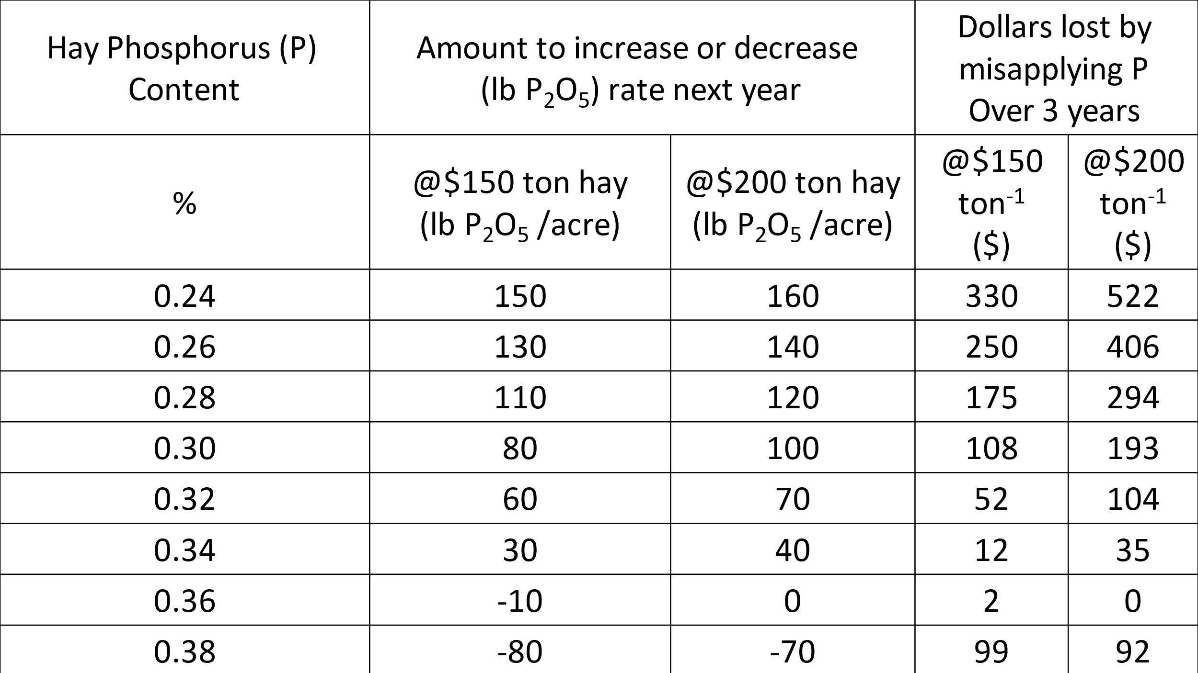

Table 2. Soil test values, application rates and removal rates of P2O5 for crop years 2018 to 2020 at Prosser, WA. Soil test in 2017 was taken just prior to the experiment.
P₂O₅ Rate  Applied | Total Applied in 3 Years | Total # of Removed in 3 Years | Fall Soil Test P 2017 | Fall Soil Test P  2018 | Fall Soil Test P  2019 | Fall Soil Test P  2020
(P₂O₅ lb a⁻¹) | (P₂O₅ lb a⁻¹) | (P₂O₅ lb a⁻¹) | (ppm) | (ppm) | (ppm) | (ppm)
0 | 0 | 228 | 8.4 | 4.5 | 4.3 | 5.5
30 | 90 | 265 | 8.6 | 6.0 | 5.8 | 4.8
60 | 180 | 293 | 7.9 | 5.5 | 4.0 | 3.3
120 | 360 | 382 | 7.6 | 7.8 | 6.3 | 6.0
240 | 720 | 455 | 9.1 | 9.7 | 8.3 | 7.5

Potassium Rate Experiment:
The first year of the potassium study (2018) alfalfa did not respond to potassium fertilizer. The study was planted in spring of 2018 so only 3 cuttings were harvested. Like the phosphorus study, the K level in 2018 soil was low at 101 ppm yet only a 0.18 ton acre⁻¹ increase occurred by increasing K rate from 0 to 320 lb K₂O acre⁻¹ (Figure 4.). Beginning soil test for sulfur was 13, 13, 17 ppm so any additional sulfur from potassium sulfate should have resulted in minor to no increases in yield in the experiment. In years two and three (2019 & 2020) the response to K was significant at 1.14 and 1.26 tons lb K₂O acre⁻¹. In 2020, except for the 40 lb K₂O acre⁻¹ rate, most of the yield increase (80%) occurred in the first and second cuttings. Virtually no yield increase occurred in the 3rd cutting, July 9th, compared to the control at any rates. Potassium rate that optimized economic return after fertilizer costs varied considerably from year to year. In 2018, the lack of yield response put the economic optimum at no application. However, in the following spring the control plots had significant visual potassium deficiency symptoms (Figure 5.). When hay prices are $150 ton⁻¹ optimum rates were 80 and 220 lb K₂O acre⁻¹ for 2019 and 2020, respectively. However in 2019, when hay prices are $200 ton⁻¹ the gross income after K fertilizer costs was similar across a wide range of K rates and was $1,847, $1,813, $1,944, $1,941, $1,905, $1,950 for 0, 40, 80, 160, 240, 320, lb K₂O acre⁻¹ rates, respectively. These results give a wide range of K rates for producers to choose but 320 lb acre⁻¹ rate was the maximum in 2019. In 2020, the optimum K rate was 240 lb K₂O acre⁻¹, but again a wide range of rates could be chosen with 160 and 320 lb K₂O acre⁻¹ rate being within $15 and $4 acre⁻¹ gross return after K application, respectively. Soil test K in commercial hay fields have been decreasing and this experiment was no different, even at the highest K rate, dropping from 93 ppm K at the beginning of the experiment to 78 ppm K after 3 years of alfalfa (Table 3.). At the 320 lb K₂O acre⁻¹ rate after converting K in plant tissue to lb K₂O acre⁻¹, 1,298 was removed in hay and only 960 applied leaving a 338 lb K₂O acre⁻¹ deficit. Further research needs to be conducted to differentiate probably causes of unpredictable K. Optimum potassium tissue concentration for $200/ton hay without quality consideration could range from 1.9 - 2.5 and 1.5 -1.6% in 2019 and 2020 respectively (Figure 5, Figure 6.). The year affect is significant (Figure 7.) Current recommendations are 1.2 – 1.5% K being adequate (Meyer et al., 2008) for baled mid-bud hay, and 2 – 2.5% for whole tops at first flower (Koenig et al., 2009). Under this low K testing field tissue testing may not be the best choice for even determining sufficiency. Although the percent K did not increase from the control the amount taken up by the crop did increase by 104, 158, and 46 lb K acre⁻¹ for 2018, 2019 and 2020 years, respectively. Why 2020 did not take up as much as in 2019 a good question, but it must be tied up in the soil due decreasing K soil tests and/or reduced alfalfa root ability in the third year. Interestingly the yield was higher in 2020 then 2019.
Figure 4. Influence of potassium fertilizer rate on total yield in 2018-2020 at Prosser, WA.
Table 3. Soil test values, application rates and removal rates of K₂O for crop years 2018 to 2020 at Prosser, WA. Soil test in spring of 2018 was taken just prior to the experiment.
K₂O Rate Applied | Spring Soil Test K 2018 | Spring Soil Test K 2019 | Spring Soil Test K 2020 | Fall Soil Test K  2020 | 2018 K₂O Removed | 2019 K₂O Removed | 2020 K₂O Removed
lb K₂O a⁻¹ | ------------------------ppm------------------------- |  |  |  | -------------lb K₂O acre⁻¹-----------
0 | 106.8 | 90.5 | 79.0 | 67.3 | 196.1 | 458.3 | 334.9
40 | 104.3 | 85.8 | 69.0 | 54.5 | 212.1 | 431.5 | 316.1
80 | 87.0 | 82.3 | 82.8 | 53.3 | 213.5 | 450.8 | 302.6
160 | 106.0 | 88.0 | 83.0 | 64.0 | 239.3 | 525.6 | 334.8
240 | 106.3 | 85.0 | 83.5 | 54.3 | 308.4 | 567.2 | 369.0
320 | 92.8 | 84.8 | 78.3 | 62.0 | 300.2 | 616.1 | 381.2

Figure 5. Potassium content of alfalfa as influenced by cutting and rate of K₂O acre⁻¹ in 2019 at Prosser, WA.

Figure 6. Potassium content of alfalfa as influenced by cutting and rate of K₂O acre⁻¹ in 2020 at Prosser, WA.
Figure 7. Potassium content of alfalfa as influenced by year and potassium rate applied to alfalfa near Prosser, WA from 2018-2020.
Struvite Study:
Results and Discussion
All treatments except the unfertilized check received different ratios of MAP:struvite equaling 100% of a constant rate (144 lbs P₂O₅/acre), as determined by the soil test. In 2020 the unfertilized check yielded as much as 0.6 ton DM per acre less than the highest yielding treatment showing the need for phosphorus in this experiment (data not shown). Since the 2020 results confirmed what occurred the previous two years of research, average alfalfa hay response for the three years is shown in Figures 10, 11, 12 and 13. Summed over years, replacing MAP (100:0) with struvite (0:100) did not reduced alfalfa yield (Figure 8.). The greatest numeric yield of 26.4 tons/acre was observed with 12.5% MAP (12.5:87.5) and 87.5% struvite at. Although not significant, increasing the percent struvite in the fertilizer, increased P content of forage and P uptake over the three years (Figure 9., Figure 10.). In contrast in first cutting however, average P content did not increase but remained constant to a slight decline. In the first cutting, approximately May 15th, 100% struvite had the lowest yield of the fertilized treatments showing there might be a slight benefit to 12.5% MAP to be mixed with the struvite for first cutting (Figure 11).
Also, the ratio of MAP:Struvite did not influence any nutrient quality parameters studied including: RFV, RFQ, protein, energy or fiber measurements.
Figure 8. As struvite portion of P fertilizer increased, total yield from the 3 years remained steady at the Irrigated Research and Extension Center near Prosser, WA in 2018-2020.
Figure 9. As struvite portion of P fertilizer increased, P content from the 3 years increased slightly at the Irrigated Research and Extension Center near Prosser, WA in 2018-2020.
Figure 10. As struvite portion of P fertilizer increased, total P uptake from the 3 years increased slightly at the Irrigated Research and Extension Center near Prosser, WA in 2018-2020.

Figure 11. As struvite portion of P fertilizer increased, first cutting P content and yield for three years remained level at the Irrigated Research and Extension Center near Prosser, WA in 2018-2020.

Management Recommendations/Conclusions From The Three Years:
- Alfalfa harvested at mid-bud stage and averaged over cuttings and years, the whole plant tissue level at the economic optimum was 0.355 and 0.36% P at mid-bud stage for 150 and $200 ton⁻¹ of hay, respectively. These results suggest a higher optimum concentration than previously reported. When tissue testing the stage of maturity and what part of the plant is being tested both must be considered when selecting a critical level.
- Phosphorus and potassium yield response is primarily in the first and second cuttings so applications should be made either in the fall or early spring.
- First- and second-year data show that struvite can be used alone or in combination with monoammonium phosphate (MAP) without a yield loss even on a soil averaging 8.1 ppm (Olsen method).
- Optimum potassium tissue concentration for $200/ton hay without quality consideration was 1.9 and 1.6% in 2019 and 2020 respectively.
Acknowledgements: Funding for this study was provided by the U.S. Alfalfa Farmer Research Initiative of the National Alfalfa & Forage Alliance.
References:
Flynn, R., S. Ball, R. Baker. 1999. Sampling for Plant Tissue Analysis. Guide A-123. New Mexico State University. http://aces.nmsu.edu/pubs/_a/a-123.html
Kafkafi, U., R. Gilat, D. Yoles, and Y. Noy. 1977. Studies on fertilization of field-grown irrigated alfalfa I. Effect of potassium source and time of application. Plant Soil 46:165–173. doi:10.1007/BF00693123
Koenig, R., C. Hurst, J. Barnhill, B. Kitchen, M. Winger, M. Johnson. 2011. Fertilizer Management for Alfalfa. Utah State University. AG-FG-01. All Archived Publications. Paper 7.
https://digitalcommons.usu.edu/extension_histall/7
Koenig, R.T. and J.V. Barnhill. 2006. Potassium Management in Alfalfa: A Summary of Eight Years of Research in an Arid Environment. In: Proceedings, 2006 Western Alfalfa and Forage Conference, December 11-13, 2006, Reno, Nevada. Published by: UC Cooperative Extension, Agronomy Research and Extension Center, Plant Sciences Department, University of California, Davis 95616.
Koenig, R.T., D. Horneck, T. Platt, P. Petersen, R. Stevens, S. Fransen, and B. Brown. 2009. Nutrient Management Guide for Dryland and Irrigated Alfalfa in the Inland Northwest. Pacific Northwest Extension Publication PNW0611.
Meyer, R.D., D.B. Marcum, S.B. Orloff, and J.L. Schmierer. 2007. IN: C.G. Summers and D.H. Putnam(eds.), Irrigated Alfalfa management for Mediterranean and Desert zone. Chapter 6. University of California agriculture and Natural Resources Publication 8289. See http://alfalfa.ucdaavis.edu/IrrigatedAlfalfa
Mueller, S.C., andL.R. Teuber. 2007. Alfalfa Growth and Development. IN: C.G. Summers and D.H. Putnam (eds.), Irrigated alfalfa management for Mediterranean and Desert zone. Chapter 3. University of California Agriculture and Natural Resources Publication 8289. See
St‐Pierre, N., and W. P. Weiss. 2011. IN: Proceedings, 2011 Western Alfalfa & Forage Conference, Las Vegas, NV, 11‐13 December, 2011. UC Cooperative Extension, Plant Sciences Department, University of California, Davis, CA 95616.
Olsen, S.R., C.V. Cole, F.S. Watanabe, and L.A. Dean. 1954. Estimation of available phosphorus in soils by extraction with sodium bicarbonate. U.S. Dep. Of Agric. Circ. 939.
Orloff, S., D. Putnam, C. DeBen, and A. Biscaro. 2012. Improved Methods for Nutrient Tissue Testing in Alfalfa. Final Report (Project #11-0469-SA) to Fertilizer and Research and Education Program.
Raun, W.R., G. V. Johnson, S. B. Phillips, W. E. Thomason, J. L. Dennis, and D. A. Cossey 1999. Alfalfa Yield Response to Nitrogen Applied After Each Cutting. n Soil Sci. Soc. Am. J. 63:1237–1243. DOI: 10.2136/sssaj1999.6351237x
Shenk, J.S., M.O. Westerhaus, and SM. Abrams. 1989. Protocol for NIRS calibration: monitoring analysis results and recalibration, p. 104-110. In: G.C. Marten, J.S. Shenk, and F.E. Barton (eds.), Near infrared reflectance spectroscopy (NIRS): forage quality analysis. USDA Agr. Handbook No. 643, (revised). U.S. Government Printing Office, Washington, D.C.
Stewart TRW. Inorganic phosphorus and potassium production and reserves. Better Crops. 2002; 86:6–10.
USGS 2020. Phosphate Rock Data Sheet - Mineral Commodity Summaries 2020 – Phosphate Rock https://pubs.usgs.gov/periodicals/mcs2020/mcs2020-phosphate.pdf
Acknowledgement – this research was funded by 3 grants from the National Alfalfa Forage Alliance (NAFA) checkoff program.
Keywords: Alfalfa, Phosphorus, Potassium, Struvite, Yield, Hay Quality

