Developing Practical Phosphorus and Potassium Tissue Test Recommendations and Utilizing Struvite in Modern Alfalfa Systems III
By Norberg, S., S. Fransen, J. Harrison, D. Llewellyn, and L. Whitefield
Rational and Objectives: 1) Develop and calibrate phosphorus (P₂O₅) & potassium (K₂O) nutrient recommendations for bud stage alfalfa using tissue testing for maximum profit, yield and direct comparison to current soil testing recommendations. 2) Compare efficacy of combinations of monoammonium phosphate (MAP) and struvite (magnesium ammonium phosphate, MgNH₄PO₄ · 6 H2O) for fertilization of alfalfa. 3) Evaluate quality of hay samples at different P₂O₅ and K₂O rates and tissue concentrations.
Study Description –

Plot Layout: Three alfalfa research studies (P Study, K Study, and Struvite Study) were grown near Prosser, WA in South Central WA in a low P & K testing soil from 2018-2020.
P Study: Differing rates of P₂O₅ using MAP; including: 0, 30, 60, 120, 240 lbs./acre.
K Study: Differing rates of K₂O using potassium sulfate: 0, 40, 80, 160, 240, 320 lbs. K₂O/acre
Struvite Study: Application of 144 lbs. of P₂O₅ /acre in differing ratios of MAP:Struvite in alfalfa including: 100:0, 75:25, 50:50, 37.5:62.5, 25:75, 12.5:87.5, 0:100 and an unfertilized check.
Analysis: Dry matter analyzed for yield, P or K content (ICP method), hay quality (NIRS method).

Results - P Study:
Table 1. Hay phosphorus (P) content’s impact on dollars lost by misapplying P and amount of P to adjust next years rate. The optimal P content was found to be 0.355 and 0.36 % P for $150 and $200 per ton hay, respectively. Optimum P content was based on mid-bud stage hay harvested and averaged over three years (1998-2000) under irrigation near Prosser, WA. The optimal P content should be applicable of a wide range of locations, however economics will vary based on productivity of the field. This field was harvested five times and yielded approximately 10 tons acre in years 2 and 3. Sixty-seven percent of the yield increase was in the first and second cuttings.
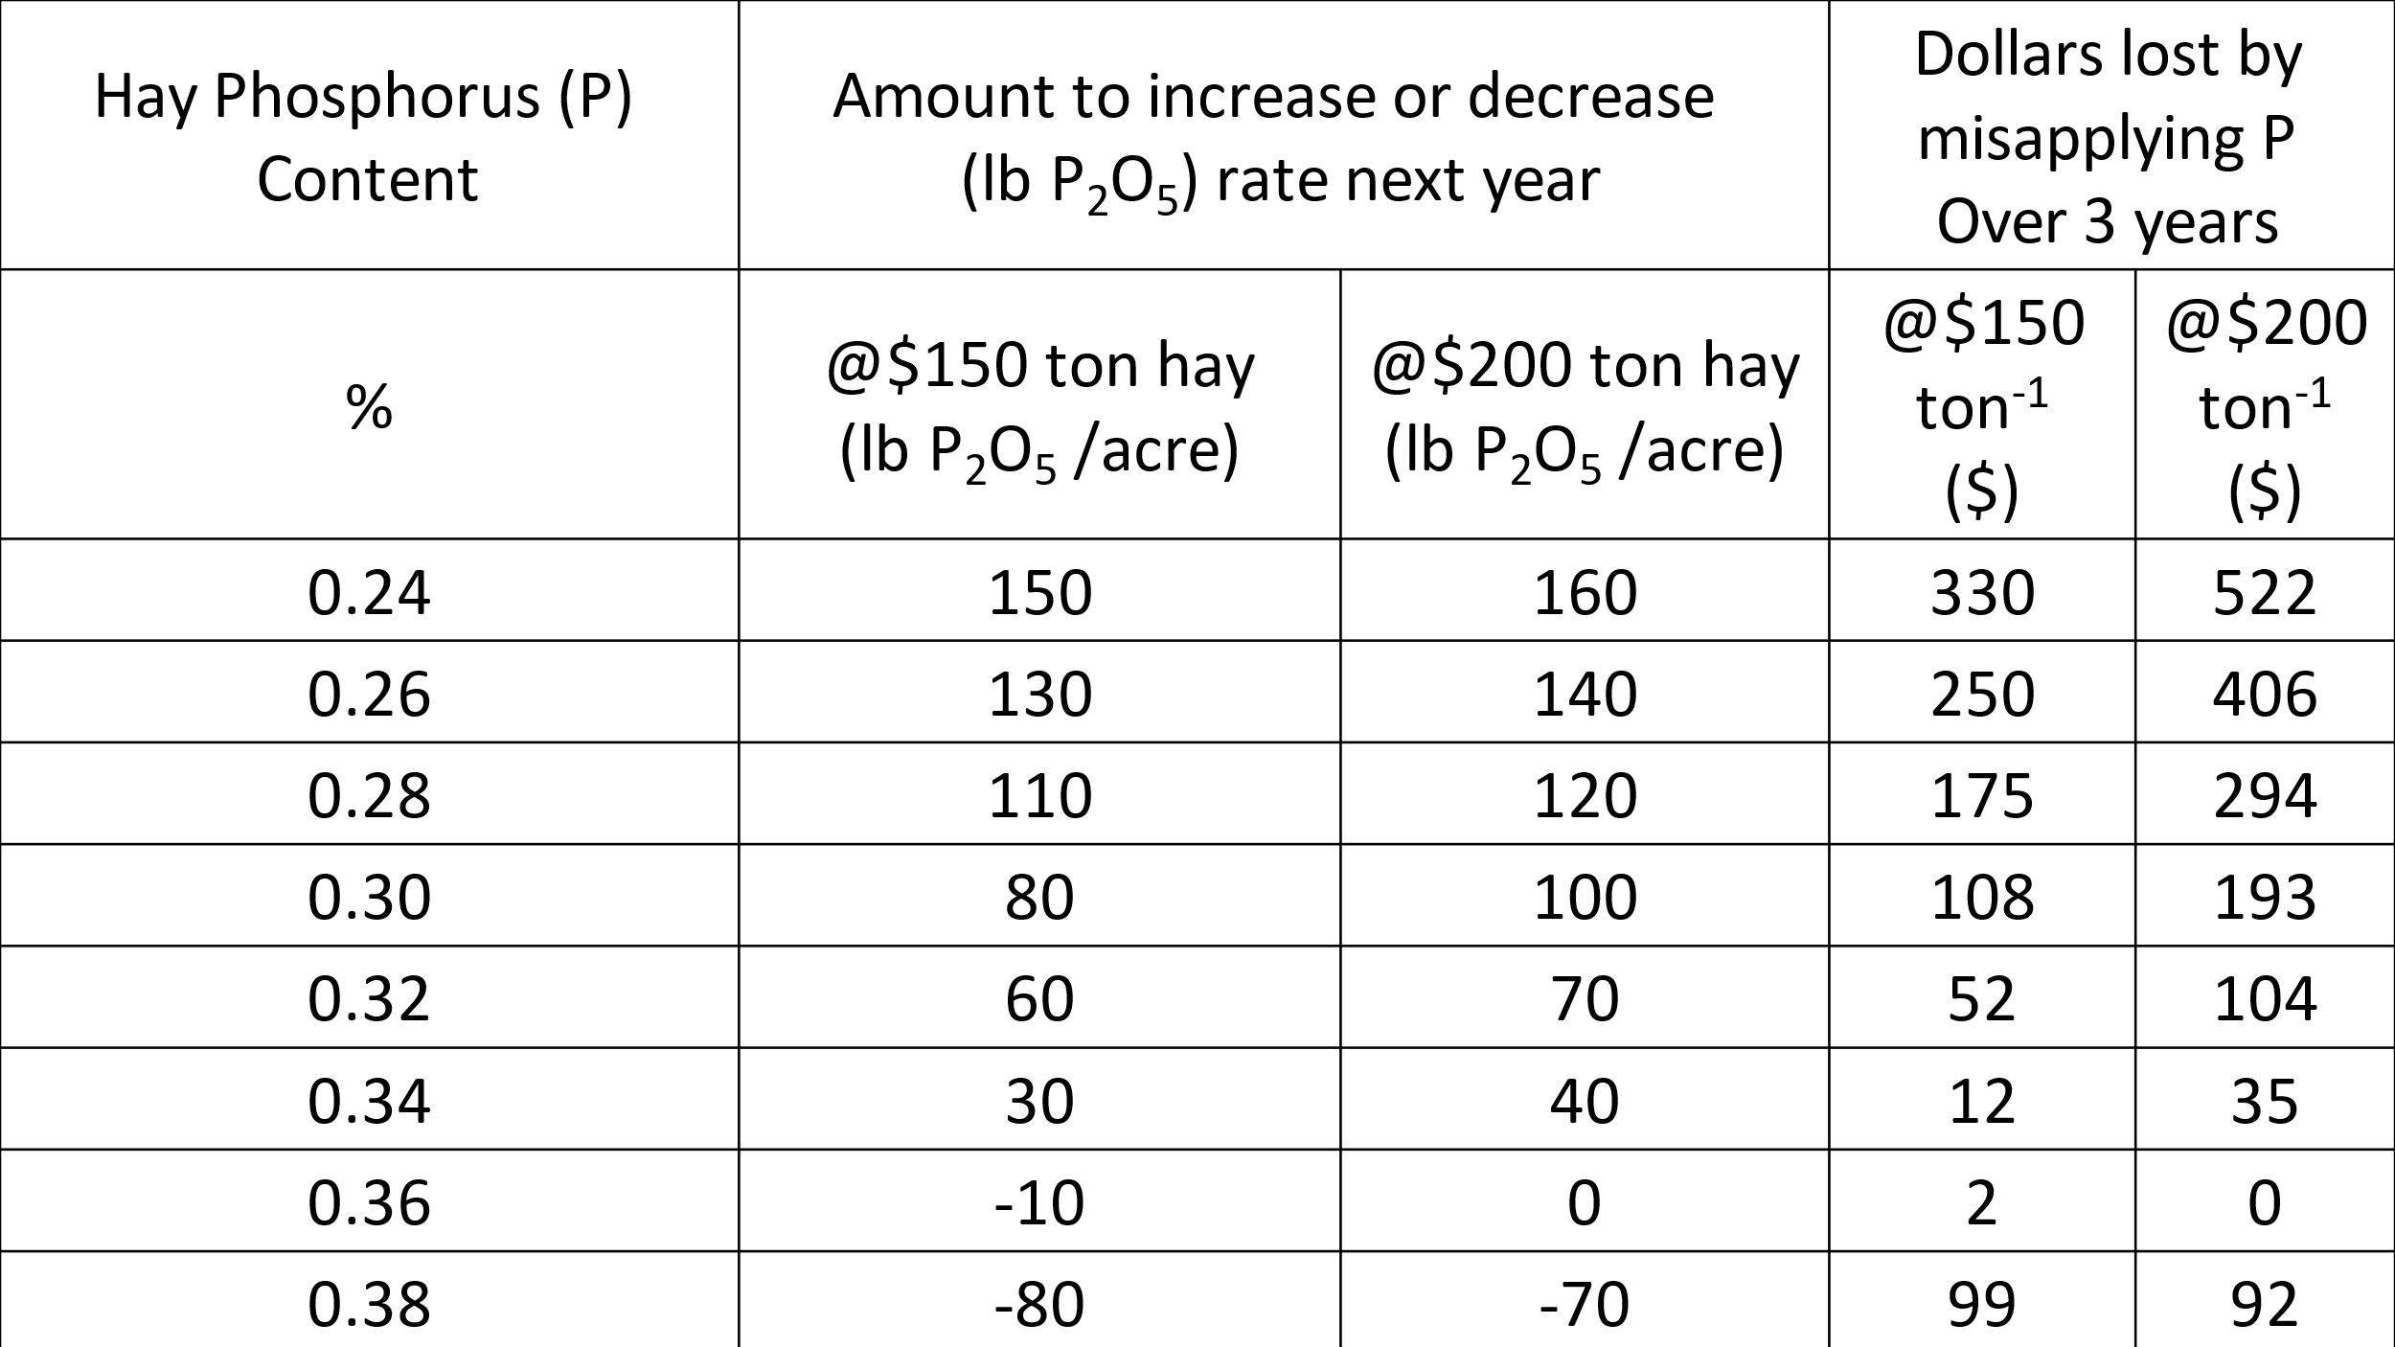
Results - K Study:
Figures 1a & 1b. Left figure shows yield increases occurred with applications of potassium sulfate in 2019 and 2020. No yield response was found in the year of spring establishment 2018. Potassium contents of the forage is shown in the figure on the right. In 2020, the third year of the experiment, application of K₂O failed to match the K forage content in the hay in the previous two years as both K accumulated was less and increased yield diluted K content. Optimum potassium tissue concentration for $200/ton hay without quality consideration was 1.9 and 1.6% in 2019 and 2020 respectively. In 2019, RFQ was increased from 182 to 255 by increasing rate to 320 lb/K₂O per acre. During the three years the 320 lb/acre treatment soil available K decreased in the soil from 92.8 ppm in spring of 2018 to 62 ppm in the fall of 2020, a 33% reduction from beginning to end of the experiment. A total of 960 lb/a K₂O was applied in three years, however 1,166 lb/a K₂O was removed in the hay.
Results - Struvite Study: Struvite:
Figure 2a. (left) and 2b (right). Total 3-year yields were similar when struvite percent of struvite increased when applied at same 144 lb P₂O₅/acre rate as MAP (monoammonium phosphate) (Figure 2a.). P content also similar P content when struvite portion of P₂O₅ was increased (Figure 2b.).

Management Recommendations/Conclusions:
- To maximize economic return, phosphorus content of alfalfa hay should be near 0.36% when harvested at mid-bud stage for hay harvested at 2 inches. This is higher than published elsewhere.
- The optimum K content for the two years was 1.9 and 1.6% for 2019 and 2020, respectively.
- Three years of data show that granular struvite can be used alone or in combination with MAP without a yield loss even on a soil averaging 8.1 ppm (Olsen P Method).

