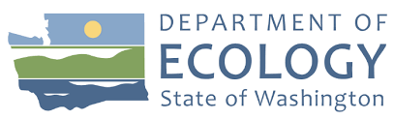
ON THE BEACH
  - clcp neWS, ISLAND COUNTY
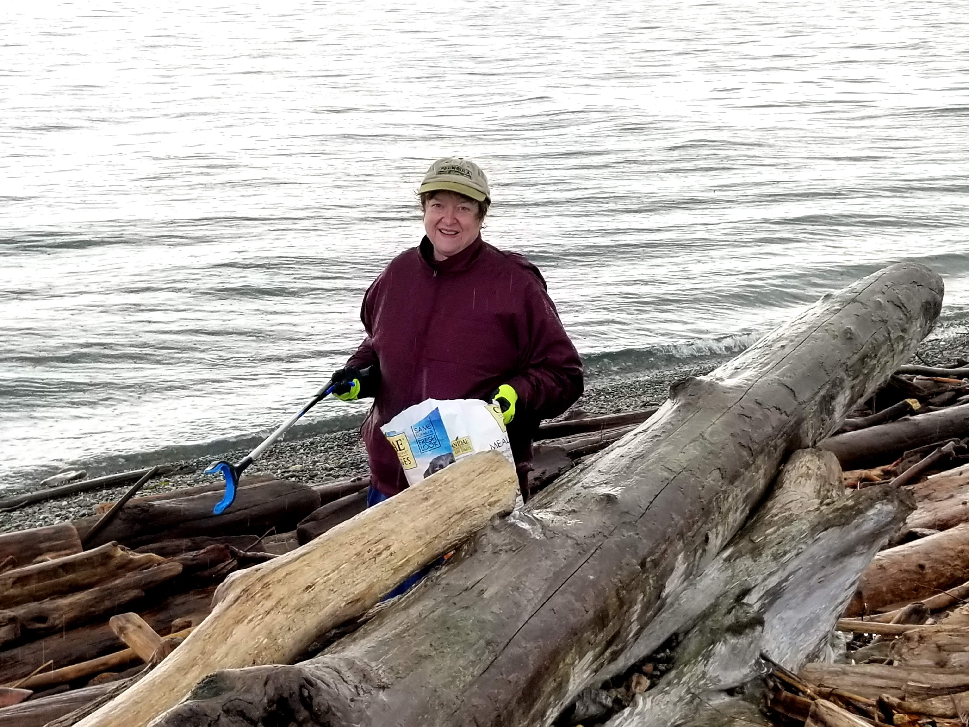
mdmAPPING Pg 2  fOLLOWING UP FROM ORCA RECOVERY DAY  MD Mapping is our project for the new year. Beginning with site one at Keystone, we will map the marine debris found for NOAA researchers. | sHOTGUN WADS pg 2  rECORDING DATA WITH SURFRIDER  Shotgun wads are everywhere! However, the company Surfrider out of San Francisco is doing something about it, and so are we! | SCHEDULE pg 3  UPCOMING CLEANUPS  Tides have definitely changed our cleanup times and dates. Throughout winter, you will notice afternoon time slots due specifically to the tides.
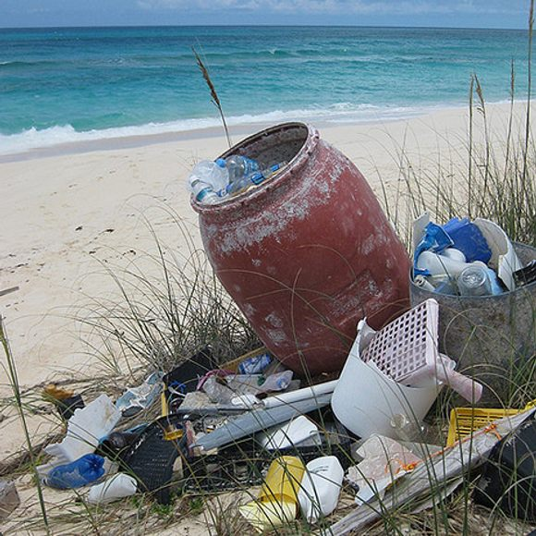 | Weekly beach clean-ups  These clean-ups are a fun, free, and easy way to give back to you community by keeping pollution from damaging marine organisms in and around Island County. It is easy to participate!
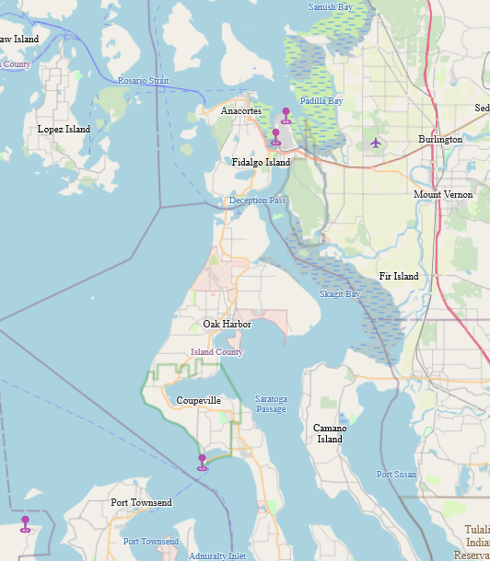 | Orca Recovery Day taught us many things about protecting and keeping the environment clean. The MD (marine debris) Mapping process we learned will be a valuable tool for us in 2023. For the first time, we will see our efforts in real-time.  Not only will this be exciting for us, but the research from this data collection and recording will help with plans and remediation efforts.  Weather permitting, we will map our next effort at Keystone Spit Beach on January 10th.
MD MAPPING, NOAA Marine Debris Mapping Project  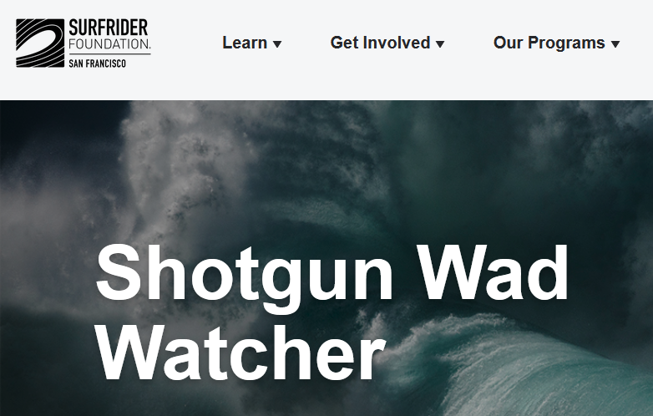 | https://sf.surfrider.org/programs/shotgun-wad-watcher  Anyone walking along the beach will almost inevitably find a shotgun wad. They are easily identifiable, and they are genuinely everywhere on our shores.  Surfrider is an organization based in San Francisco gathering data along coastlines where wads appear. The more data researchers have to work with, the greater chance of solving this crisis.  WSU Extension is teaming up with Surfrider to record the number of shotgun wads on our shores. At our cleanups, we are now separating and counting wads to report accurate data. It is another way to branch out and help make a difference!

Cleanup schedule

January 6th @ Dave Mackie/Maxwelton 2-4
January 10th @ Keystone Spit West 2-4
January 17th @ Double Bluff from 2-4
January 24th @ Ala Spit from 1-3
January 31st @ Keystone Spit East from 2-4

Purple Card Program
Our Purple Card Program helps those who have marine debris or have cleaned up marine debris and need to dispose of it. There is no charge for disposal of beach litter, all that is required is to sign up! Please see or contact Kacie Dominici for more details or answers to any questions you may have.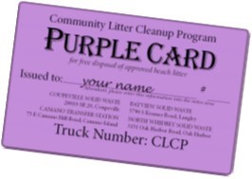
CLCP News is news for everyone! If you have an article or story related to beach cleanups or marine debris you would like to share, please send it in today!

A very special thank you to all of the volunteers who gave of their time in 2022. Your efforts are much apprecitated and the work, critical. 2023 will be a great year for CLCP and all of our volunteers.
Kindly,
Kacie

