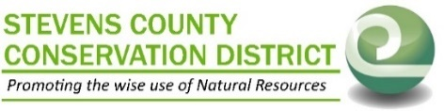
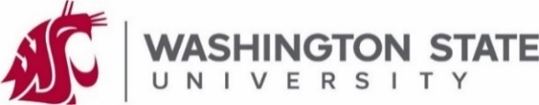
VETTER FARM NEWS July 2022 Edition #2

A Forest and Farm Education and Research Partnership
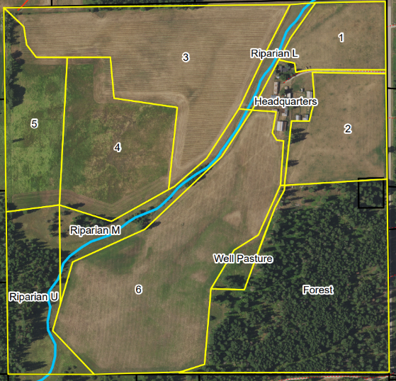
Background – 5281 Hattery-Owens Road
Stevens County Conservation District (SCCD) and WSU Stevens County Extension have developed a partnership to collaborate with the local community to establish a working-lands research, education, and demonstration working farm donated to WSU in the Clayton valley.
Current Projects
- Cover Crop demo trial - Field 1 and 2 planted to pea/oat forage mix with multiple seed bed preperation intensities and seeding rates. Sub-plots of a 30 species cover crop mix was included in the project area.
- Cattle – 14 cow calf pairs + bull are rotationally grazing the fields west of the forest and headquarters.
- Forest- Timber harvest starting soon to improve forest health and reduce wildfire risks.
- Stream on property has had the classification changed from Fish Bearing to Non Fish Bearing.
Upcoming Events
June 30th Open House at the farm – meet Stevens County Extension new Agriculture Education Cordinator, Weed board, and the Conservation District for a farm tour and field demonstrations.
Fall Farm Forest and Field Day on September 17th, 2022. We’ll have a forest tract and a field tract where we’ll run presentations from industry specialists regarding soils health, post fire management, forage species ID, and more!
Call or sign up on our website for reminders about our events, follow the QR code to the site.
We need your help!
We need your help to develop this farm to meet the needs of local landowners and farmers. SCCD is looking for:
- Advisory members to help with planning and outreach for programs and projects
- Farm equipment owners interested in custom farming or sharecropping parts of the farm
- Livestock owners in need of additional forage and willing to demonstrate pasture management practices
- Equipment and supplies donations—we’re happy to utilize your extra stuff that’s taking up space!
Contact: SCCD (509) 684-7579 or SCCD@stevenscountywa.gov
This newsletter is being sent to the landowners near the Vetter Farm and partners. If you are interested in receiving future communications, please email SCCD@stevenscountywa.gov or call (509) 684-7579 to be added to the list.
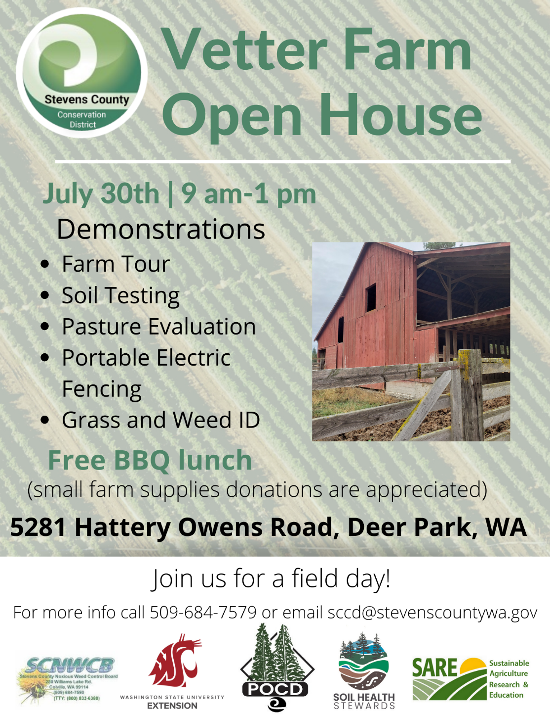
KLINGENBERG-VETTER FARM NEWS July 2022

NONPROFIT ORGANIZATION
U.S. POSTAGE PAID
COLVILLE, WA
PERMIT NO. 97
Stevens County Conservation District
232 Williams Lake Rd
Colville WA 99114

