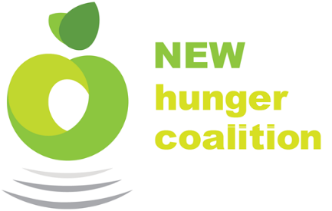
Farm to Food Pantry Program, Farmer Contract
Providence Northeast Washington Hunger Coalition
986 S. Main, Suite D
Colville WA, 99114

3/15/2018

Farmer_C --- Farmer_C_Farms
100 Farm to Market Rd
Farmington, WA 99101

Dear Farmer_C at Farmer_C_Farms
Please accept this letter as a contract to participate in Providence N.E.W. Hunger Coalition’s Farm to Food Pantry (F2FP) program. The Hunger Coalition commits to purchase $___ worth of produce from Farmer_C_Farms in the 2018 growing season. All prices and estimates of pounds related to this contract have been mutually agreed upon and are specified below. If this contract is acceptable and you commit to providing this produce in the 2018 growing season, please sign and return this contract.
Product | Price | Weight | Total Price
Acorn Squash – Note: Hunger Coalition volunteers will harvest | $0.60/Lb | 800 Lbs | $480
40 1-household CSA shares | $15 per share | Determined by Grower | $600
Produce items chosen by grower | Per 2018 price list | TBD | $500
 |  | Total: | $1580

Pick-up Information
The Providence N.E.W. Hunger Coalition will pick-up harvested product at locations agreed upon by both parties. The logistical agent and receiver of your produce will be the F2FP Program Coordinator, Coordinator_G. Please direct any inquiry or correspondence to the coordinator by email at F2FP_ProgramCoordinator@hungercoalition.org or by phone at 509-821-8040

We are very excited to be able to continue the F2FP program this year. Our partnership with Farmer_C_Farms is highly valued and greatly appreciated. Thank you for your participation in this program and do not hesitate to contact me with any questions.

Sincerely,

_____________________________________ _____________________________________
F2FP Program Coordinator Grower

