Class A Weeds: Non-native species whose distribution in Washington is still limited. Preventing new infestations and eradicating existing infestations are the highest priority. Eradication of all Class A plants is required by law.

Class B Weeds: Non-native species presently limited to portions of the State. Species are designated for required control in regions where they are not yet widespread. Preventing new infestations in these areas is a high priority. In regions where a Class B species is already abundant, control is decided at the local level, with containment as the primary goal. Please contact your County Noxious Weed Control Board to learn which species are designated for control in your area.

Class C Weeds: Noxious weeds that are typically widespread in WA or are of special interest to the state’s agricultural industry. The Class C status allows county weed boards to require control if locally desired, or they may choose to provide education or technical consultation.

Class A Weeds
Eradication is required
common crupina | Crupina vulgaris
cordgrass, common | Spartina anglica
cordgrass, dense-flowered | Spartina densiflora
cordgrass, saltmeadow | Spartina patens
cordgrass, smooth | Spartina alterniflora
dyer’s woad | Isatis tinctoria
eggleaf spurge | Euphorbia oblongata
false brome | Brachypodium sylvaticum
floating primrose-willow | Ludwigia peploides
flowering rush | Butomus umbellatus
French broom | Genista monspessulana
garlic mustard | Alliaria petiolata
giant hogweed | Heracleum mantegazzianum
goatsrue | Galega officinalis
hydrilla | Hydrilla verticillata
Johnsongrass | Sorghum halepense
knapweed, bighead | Centaurea macrocephala
knapweed, Vochin | Centaurea nigrescens
kudzu | Pueraria montana var. lobata
meadow clary | Salvia pratensis
oriental clematis | Clematis orientalis
purple starthistle | Centaurea calcitrapa
reed sweetgrass | Glyceria maxima
ricefield bulrush | Schoenoplectus mucronatus
sage, clary | Salvia sclarea
sage, Mediterranean | Salvia aethiopis
silverleaf nightshade | Solanum elaeagnifolium
small-flowered jewelweed | Impatiens parviflora
South American spongeplant | Limnobium laevigatum
Spanish broom | Spartium junceum
Syrian beancaper | Zygophyllum fabago
Texas blueweed | Helianthus ciliaris
thistle, Italian | Carduus pycnocephalus
thistle, milk | Silybum marianum
thistle, slenderflower | Carduus tenuiflorus
thistle, Turkish | Cardus cinereus
variable-leaf milfoil | Myriophyllum heterophyllum
wild four-o'clock | Mirabilis nyctaginea

Class B-designate Weeds
Control is required
blueweed | Echium vulgare
Brazilian elodea | Egeria densa
bugloss, annual | Lycopsis arvensis
bugloss, common | Anchusa officinalis
butterfly bush | Buddleja davidii
camelthorn | Alhagi maurorum
common fennel, (except bulbing fennel) | Foeniculum vulgare except F. vulgare var. azoricum)
common reed (nonnative genotypes only) | Phragmites australis
common tansy | Tanacetum vulgare
Dalmatian toadflax | Linaria dalmatica ssp. dalmatica
Eurasian watermilfoil | Myriophyllum spicatum
European coltsfoot | Tussilago farfara
fanwort | Cabomba caroliniana
gorse | Ulex europaeus
grass-leaved arrowhead | Sagittaria graminea
hairy willowherb | Epilobium hirsutum
hanging sedge | Carex pendula, Carex pendula subsp. pendula and Carex pendula subsp. agastachys
hawkweed, oxtongue | Picris hieracioides
hawkweed, orange | Hieracium aurantiacum
hawkweeds: All nonnative species and hybrids of the meadow subgenus | Hieracium, subgenus Pilosella
hawkweeds: All nonnative species and hybrids of the wall subgenus | Hieracium, subgenus Hieracium
herb-Robert | Geranium robertianum
hoary alyssum | Berteroa incana
houndstongue | Cynoglossum officinale
indigobush | Amorpha fruticosa
knapweed, black | Centaurea nigra
knapweed, brown | Centaurea jacea
knapweed, diffuse | Centaurea diffusa
knapweed, meadow | Centaurea x gerstlaueri
knapweed, Russian | Rhaponticum repens
knapweed, spotted | Centaurea stoebe
knotweed, Bohemian | Fallopia × bohemica
knotweed, giant | Fallopia sachalinensis
knotweed, Himalayan | Persicaria wallichii
knotweed, Japanese | Fallopia japonica
kochia | Kochia scoparia
lesser celandine | Ficaria verna
loosestrife, garden | Lysimachia vulgaris
loosestrife, purple | Lythrum salicaria
loosestrife, wand | Lythrum virgatum
Malta starthistle | Centaurea melitensis
parrotfeather | Myriophyllum aquaticum
perennial pepperweed | Lepidium latifolium
poison hemlock | Conium maculatum
policeman’s helmet | Impatiens glandulifera
puncturevine | Tribulus terrestris
Ravenna grass | Tripidium ravennae
rough chervil | Chaerophyllum temulum
rush skeletonweed | Chondrilla juncea
saltcedar | Tamarix ramosissima
Scotch broom | Cytisus scoparius
shiny geranium | Geranium lucidum
spurge flax | Thymelaea passerina
spurge laurel | Daphne laureola
spurge, leafy | Euphorbia esula
spurge, myrtle | Euphorbia myrsinites
sulfur cinquefoil | Potentilla recta
tansy ragwort | Jacobaea vulgaris
thistle, musk | Carduus nutans
thistle, plumeless | Carduus acanthoides
thistle, Scotch | Onopordum acanthium
velvetleaf | Abutilon theophrasti
water primrose | Ludwigia hexapetala
white bryony | Bryonia alba
wild basil | Clinopoduim vulgare
wild chervil | Anthriscus sylvestris
yellow archangel | Lamiastrum galeobdolon
yellow floating heart | Nymphoides peltata
yellow nutsedge | Cyperus esculentus
yellow starthistle | Centaurea solstitialis
Class B and C County Selects
RCW 17.10.090 allows Counties to select weeds from the B or the C list that must be controlled. Preventing spread is required.
gorse | Ulex europaeus
loosestrife, purple | Lythrum salicaria
loosestrife, wand | Lythrum virgatum
poison hemlock | Conium maculatum
tansy ragwort | Senecio jacobaea
yellow flag iris | Iris pseudacorus
knotweed, bohemian | Fallopia × bohemica
knotweed, giant | Fallopia sachalinense
knotweed, japanese | Fallopia japonica
Class B & C Weeds for education only, control encouraged but not required
Brazilian elodea | Egeria densa
common groundsel | Senecio vulgaris
common St. Johnswort | Hypericum perforatum
common teasel | Dipsacus fullonum
English hawthorn | Crataegus monogyna
English ivy - four cultivars only | Hedera helix ‘Baltica’, ‘Pittsburgh’, and ‘Star’, and H. hibernica ‘Hibernica’
Eurasian watermilfoil hybrid | Myriophyllum spicatum x Myriophyllum sibiricum
evergreen blackberry | Rubus laciniatus
field bindweed | Convolvulus arvensis
fragrant waterlily | Nymphaea odorata
herb Robert | Geranium robertianum
Himalayan blackberry | Rubus armeniacus
Italian arum | Arum italicum
jubata grass | Cortaderia jubata
knapweed, spotted | Centaurea stoebe
medusahead | Taeniatherum caput-medusae
nonnative cattail species and hybrids | Typha species
old man's beard | Clematis vitalba
pampas grass | Cortaderia selloana
perennial sowthistle | Sonchus arvensis
Ravenna grass | Tripidium ravennae
reed canarygrass | Phalaris arundinacea
Scotch broom | Cytisus scoparius
spotted jewelweed | Impatiens capensis
thistle, bull | Cirsium vulgare
thistle, Canada | Cirsium arvense
tree-of-heaven | Ailanthus altissima
yellow archangel | Lamiastrum galeobdolon
Plants of local concern – for education only, control encouraged but not required
yellow loosestrife | Lysimachia punctata
English holly | Ilex aquifolium

To Find Out More…
www.graysharbor.wsu.edu
Grays Harbor County Noxious Weed
34 Elma McCleary Rd, Elma WA 98541
360-482-2265
Facebook : Grays Harbor Noxious Weeds
Instagram: gh.plant.protector

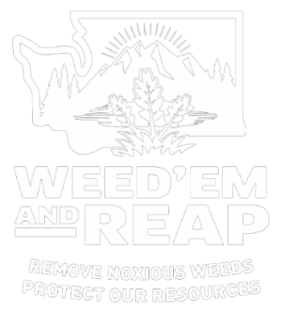

WA State Noxious Weed Control Board
P.O. Box 42560
Olympia, WA 98504-2560
(360) 725-5764

Email: noxiousweeds@agr.wa.gov
Website: http://www.nwcb.wa.gov

Or

WA State Department of Agriculture
(509) 249-6973

Grays Harbor Noxious Weed Board Coordinator
Kiley Smith
Kiley.smith2@wsu.edu

Grays Harbor County
2023
Noxious Weed List

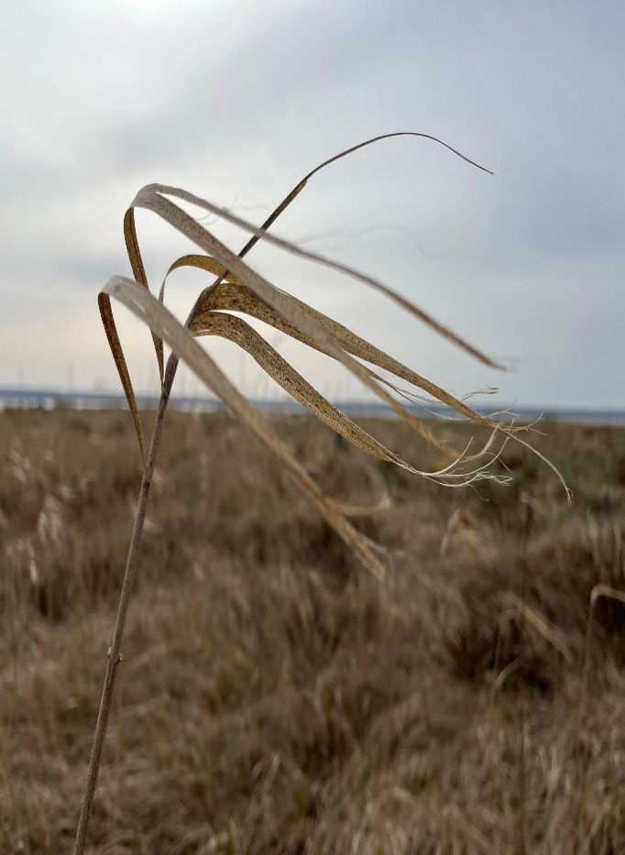

Common reed
Phragmites australis

