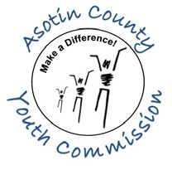
ASOTIN COUNTY YOUTH COMMISSION
Awards Nomination Form
Due Friday May 10, 2019

There are hundreds of hard-working volunteers in our communities. The ACYC wants to recognize their efforts at the 18th Annual Youth Awards Night on May 22, 2019 at the Clarkston High School Auditorium from 6:00 - 7:30 pm. Churches, schools and other organizations are invited to nominate youth, adults and organizations for awards by submitting this form. (Please be sure to complete ALL the fields so we may notify the nominee).

Who are you nominating: Youth Adult Organization

Name: Organization:

Complete Mailing Address:

Phone Number: Email:

For Youth Nominees, please include the following:
School Attended: Grade:

Who is nominating?

Name/Organization:
Position/Title:
Complete Mailing Address:
Phone Number: Email:

Will you be able to attend the awards recognition night event

Yes No

Please be specific when answering the following questions:

How has this youth contributed to our community?

Why should this person/organization be recognized?

Please include a picture of the person you are nominating. We will be using their picture as part of a PowerPoint presentation on Awards Night.

Please email this completed form to Mark Heitstuman at heitstuman@wsu.edu, or mail it to WSU Asotin County Extension, PO Box 9, Asotin, WA 99402, or fax it to 509-243-2018.

Email Guidelines:
In order to Email this form, you’ll need to save it onto your computer and then email it as an attachment. Please put ACYC in the subject line. Don’t forget to attach a picture!

