Report on 3-year Cherry Cultivar Trial Available
T.R. Alexander, J. King, E. Scheenstra, and C. Miles
WSU Northwestern Washington Research and Extension Center (NWREC), Mount Vernon, WA
See: https://extension.wsu.edu/maritimefruit/tree-fruit/cherry/ for the full report.

INTRODUCTION
From 2017-2019, a trial of 11 sweet cherry cultivars that had not previously been tested in the cool maritime climate of western Washington was conducted at the WSU Mount Vernon NWREC. The trial was established with scionwood received from the WSU Sweet Cherry Breeding Program (IAREC Prosser), grafted on Gisela 5 rootstock by Biringer Nursery. Three or four trees of each cultivar were initially planted. As of 2019, three years of data on nine of the 11 trial cultivars, and two years of data on four commercial standards (Bing, Lapins, Rainier, and White Gold) were collected for comparison. The trial included dark red, red, and yellow with red blush-skinned fruit, and both self-fertile and cross-pollination dependent cultivars. Skin color is an important harvest indicator for cherries, and in 2019 data were collected on fruit chlorophyll content using a non-destructive hand-held meter. Cherries were harvested by hand at fresh market maturity, that is, at least 16% soluble solids concentration (SSC; ºBrix) and 54/64 inch (21.5 mm) diameter (a combination of California and Washington State standards). Fruit quality analysis included fruit diameter, chlorophyll content, and soluble solids content.

RESULTS
Overall, after three seasons of observation, the cultivars Index, Selah and Tieton did not perform favorably in this region. These trees in this study exhibited stunted vegetative growth and poor yield since 2017. The cultivars Cowiche, Early Robin and Glacier in contrast performed best. Cvs. Cowiche and Glacier produced dark red, relatively large-sized, sweet fruit, with no cracking. ‘Glacier’ is advantageous to ‘Cowiche’ in that it is self-fertile, an important factor in a region with few cherry trees overall. ‘Early Robin’ produced a similar if not better yellow with red blush fruit than ‘Rainier’, exhibiting slightly sweeter fruit that are less prone to cracking. Although not observed in our study, in eastern Washington, ‘Early Robin’ has low fruit set and can produce ‘double fruit’, limiting its marketability.
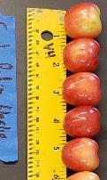

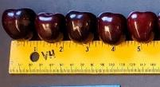

Early Robin (USP #13,951)
Glacier (PC7144-7, PP8051)
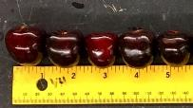
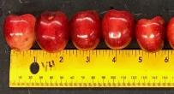

Figure 1. Photographs of representative fruit from 2 of the best performing cherry cultivars harvested at WSU NWREC in 2018 (top) and 2019 (bottom), lined up along a ruler for visualization of relative fruit diameter (mm) and color.

