S. Shrestha, M. Dolieslager, P. Kreider, E. Scheenstra, and C. Miles
WSU Mount Vernon NWREC
16650 State Route 536, Mount Vernon, WA 98273 http://vegetables.wsu.edu

Melon Variety Trial
INTRODUCTION
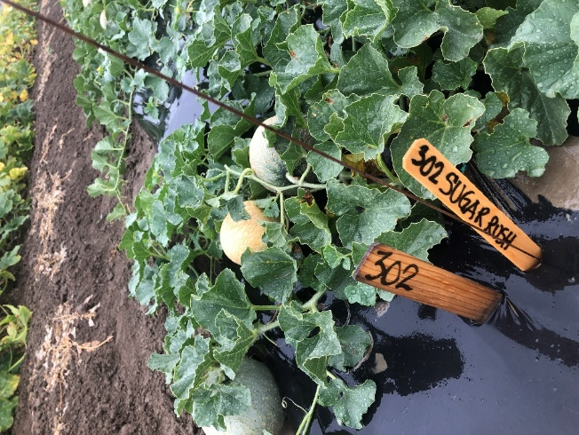
Melon (Cucumis melo) is a warm-season crop that is sensitive to temperature and thrives well in a hot, dry climate with mean daily temperature of 22-30℃. In 2019 we tested 10 different melon cultivars including 5 cantaloupe (Athena, Divergent, Goddess, Sugar Cube, and Sugar Rush), 4 honeydew (HD93, Orange Sugar, Pongo, and Snow Mass), and 1 ananas (San Juan), and we compared yield in a high tunnel and the adjacent open field. Seed was donated by Osborne Seed Company and Harris Seeds. The experimental design was a randomized complete block with 2 replications and 5 plants per plot, planted in a single row. In the high tunnel, rows were flat with no mulch and were spaced 1.8 m (6 feet) apart. In the open field, raised beds were formed and covered with black plastic mulch (1 mil thickness; Filmtech, Allentown, PA), and spacing was 3 m (10 ft.) center-to-center. We recorded number of days from transplanting to first harvest, and measured fruit yield and quality.

RESULTS
Days to first harvest were 92–105 in the field and 90–98 in the high tunnel, and the average was 98 days in the field and 94 days in the high tunnel. Total fruit weight and number per plant were generally two times greater for all varieties in the high tunnel than in the open field. Pongo had the greatest cumulative fruit weight in both the high tunnel and open field while Sugar Cube, a mini fruit variety, had the lowest cumulative fruit weight in the high tunnel and moderate fruit weight in the open field (Fig. 1). Orange Sugar and HD93 had moderate cumulative fruit weight in the high tunnel but were low in the open field. Weight per fruit ranged from 0.5–1.3 kg (1.1–2.9 lb) in the high tunnel and 0.2–1 kg (0.4–2.2 lb) in the open field. Fruit tended to be slightly larger both in weight and size in the high tunnel and overall average was 1 kg (2.1 lb) per fruit compared to 0.7 kg (1.7 lb) per fruit in the open field. The average fruit length was 12.5 cm (range 9.1–14.7 cm) in the high tunnel and 11.3 cm (range 9.2–13.4 cm) in the open field, while the average fruit width was 11.9 cm (range 9.6–13.7 cm) in the high tunnel and 8.1 cm (range 9.9–12.7 cm) in the open field. Athena had the largest fruit in the high tunnel. Sugar Cube and Orange Sugar had the smallest fruit in both the high tunnel and the open field. Fruit tended to be sweeter in the high tunnel and overall average was 12.4% soluble sugar compared to 10.6% in the open field. Sugar Rush (14.1% on average) had the highest soluble sugars while Athena (9.1% on average) had the lowest in both the high tunnel and the open field.

Figure 1. Total weight of fruit per plant of 10 melon cultivars grown in a high tunnel and the open field at WSU Mount Vernon NWREC.

