Week 5 November 2
Topic: Recycling Right and the Problem with Plastics
Facilitators/Speakers:
- Heather Teegarden, Sustainable Community Stewards Program Coordinator, SnoCo
- Sarah Bergquist, Waste Wise Program Coordinator – Island County
- Jerilyn Ritzman, Waste Wise Program Coordinator – Camano Island
Agenda
600-603 | Welcome/Check-in/Introduction to Week 5
603-608 | “What’s Your Why?”
608-613 | Review week 4–Nature’s Bounty
613-645 | Food Waste Audit Reflection
645-715 | It’s Not All Garbage – Proper Recycling
715-725 | Break/ Grab an item
725-735 | Recycling Right Activity
735-815 | The Problem(s) with Plastic
815-829 | Household Waste Audit
830 | Closing Checkout
Learning Goals
- I can learn about and be inspired by my classmates.
- I can adapt and change actions going forward, based on assessment of my current practices.
- I can share my experience with others to encourage action.
- I can identify the three main rules of recycling that apply everywhere.
- I know where to look to learn what is recyclable in my area.
- I can understand the meaning of the numbers in the chasing arrows on packaging.
- I can identify many of the problems with how our society uses plastic.
- I can make a plan for a personal waste audit.
- I can summarize my learning.

Notes:
What do I expect to discover in my household waste audit? ___________________________________
___________________________________________________________________________________
What are the 3 main rules of recycling, applicable anywhere? _____________, _________, & ______.
_____% of plastic is recycled in the United States. The amount that is effectively recycled is closer to _____%

My biggest takeaway is:

Action items/Deliverables:
- Complete and submit Gisela Dumm’s Graduate Degree Project Documents (please!)
- Complete and submit “What your why” (slide, photo, word doc) - 2 weeks left to participate!
- 4-day Household waste audit (report out Tuesday, 11/9)
  - What you learned
  - What practices are you going to change?
  - How can you communicate your new food waste reduction knowledge to others?

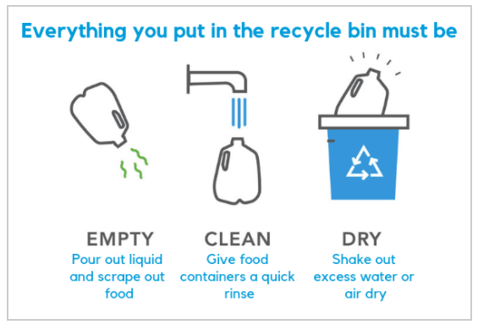

Resources:

The Story of Plastic (2020)— Emmy award winning documentary. Available for free on YouTube until November 30th.
Plastic Wars (full film) | Frontline Have efforts to solve the plastic pollution problem made it worse? Go inside the battle over plastics, recycling and what’s at stake.

Microfiber Pollution – Shore Stewards Newsletter written by Jerilyn

Plastic in Our Lives: How to Be an Informed Consumer, Dr. Mahmoud Adbel-Monem, retired WSU
  - Session Recording on YouTube
  - PDF of Presentation

Stemming the Tide on Plastic: Can Washington Lead the Way? Heather Trim, Zero Waste Washington
  - Session recording on YouTube

Household Waste Audit Directions
(short and sweet) https://earth911.com/home-garden/conducting-home-waste-audit-part-1/
(more informative) https://www.conserve-energy-future.com/how-to-conduct-a-household-waste-audit.php
Rob Greenfeild Trash Suit https://youtu.be/9vCstrZ7ilk

Waste Management Cascade Recycling Center
Cascade Recycling Center - Waste Management Northwest - Washington, Oregon, Idaho (wmnorthwest.com)

Island County Recycling:
Solid Waste Recycle (islandcountywa.gov)

Snohomish County Recycling:
Recycling | Snohomish County, WA - Official Website (snohomishcountywa.gov)

Snohomish County Recycling Guides:
- Waste Management: Snohomish County, including Unincorporated Snohomish County (South of the Stillaquamish River) Brier, Lynnwood (East of Hwy. 99)and Gold Bar Washington - Recycling Service - Waste Management Northwest (wmnorthwest.com)
- Republic Services Recycling: SnohomishR2Y1.pdf (republicservices.com)
- City of Everett: Rubatino-Recycle-2018.pdf (secureservercdn.net)
- Recology: Sorting Guides | Recology Cleanscapes | Bothell
King County Solid Waste:
- Recycling - Garbage & recycling services - King County Solid Waste Division - King County

WSU Island County Extension:
- Main page: WSU Extension, Island County | Washington State University

- Waste Wise Program: Waste Wise | WSU Extension, Island County | Washington State University

- Waste Wise Program Training page: Training Page – Fall 2021 | WSU Extension, Island County | Washington State University

WSU Snohomish County Extension sites:
- Main page: Snohomish County | Washington State University (wsu.edu)

- Sustainable Community Stewards Program: Sustainable Community Stewards Outreach Program | Snohomish County | Washington State University (wsu.edu)

- Training Files/References: 2021 Snohomish County Sustainable Community Stewards & Waste Warrior Training Resources | Snohomish County | Washington State University (wsu.edu)

