Tuesday News – July 12, 2022

CONTENTS

FEATURES

- You’re Invited to Zoom: Learn How to Enter Exhibits at the Washington State 4-H Fair! >NEW!<
- 4-H International Exchange Program Update – One Boy Still Needs a Host Family! >UPDATED!<
- Washington 4-H State Livestock Judging Contest Recap
- It’s Time For 4-H Hall of Fame and State Recognition Award Nominations!
- Washington Pork Producers Summer 2022 Newsletter Is Here!
- Washington State Veterinarian Releases Letter Addressing Avian Influenza and Fairs Recommendations
- AVIAN INFLUENZA UPDATES: Articles and Links
- 4-H Ambassadors Present the 4-H Youth of the Month for June
- Two Decades Working With Youth Provides Background For New Interim 4-H Director
- State Equine Presentations Date Has Been Set; Event Will Be Virtual
- Small Equine to Be Offered at 2022 4-H state Fair
- Wahkiakum and Naselle Robotics Teams Place 2nd and 3rd In International Contest
- Washington State 4-H Dairy Judging Contest Set For July 19th

COVID-19 RESOURCES

- 4-H COVID-19 HEALTH AND SAFETY PROTOCOLS - UPDATED MARCH 12, 2022
- A Reminder: COVID-19 Resources Available from WSU Extension
- WASHINGTON STATE RESOURCE GUIDE FOR PARENTS AND CAREGIVERS: Caring for Your Family During COVID-19

Features

You’re Invited to Zoom: Learn How to Enter Exhibits at the Washington State 4-H Fair!

We are inviting 4-H faculty, staff, 4-H volunteers (State 4-H Fair coordinators), 4-H Superintendents, and 4-H families to join us for this Zoom workshop. We have invited State 4-H Fair Superintendents and Board Members to help answer questions.

We will be covering:
4-H Still-life entries= green cards /and entry tags
Animal entries = blue cards
Information on contests and activities, virtual and in-person
Camping
Tickets/Passes
Where the 4-H Office is located on the fairgrounds.

You are invited to a Zoom meeting!
When: July 19, 2022 at 7:00 PM Pacific Time (US and Canada)

Register in advance for this meeting:
https://wsu.zoom.us/meeting/register/tJwvdO2vqDMiGtfwWpmUDrmL8dooRFhyyxmG

After registering, you will receive a confirmation email containing information about joining the meeting.

4-H International Exchange Program Update – One Boy Still Needs a Host Family!

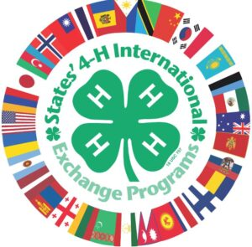

One family still needed to host a boy – delegates are arriving in just over a week!

To start an application to host for the summer inbound program, visit https://www.states4hexchange.org/apply/host/

— Families need a youth in the home within three years of age and of the same gender as the visitor.

— You do not need to be affiliated with 4-H to participate.
— The goal of this exchange is a cultural experience and English immersion, not tourism and site seeing. The delegates want to stay with a family and experience your life with you.

Kizuki, age 15 – Kizuki enjoys the outdoors, reading books, animals and watching TV (mystery, suspense and detective dramas). He is considerate of others, loves to laugh, and is cheerful, serious and honest. He enjoys soccer, baseball and badminton. Kizuki likes gummy candy, playing soccer or baseball in the park, playing card games (especially Pokémon and Uno) and shopping. He wants to learn more about culture and be a member of his host family.

Here’s a clipping from Kizuki’s application:

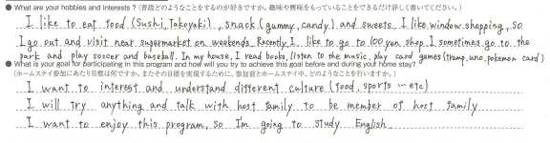
For more information, email Carolyn Russo at carolyn.russo@wsu.edu

Carolyn Russo
Grant County 4-H Program Coordinator
WSU Grant County Extension
1525 E. Wheeler Rd.
Moses Lake, WA 98837
509-754-2011, Ext. 4309

Washington 4-H State Livestock Judging Contest Recap

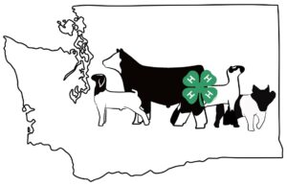

The Washington 4-H State Livestock Judging contest took place on Saturday, June 25th, with over 110 attendees including participants, parents and volunteers. The event was a success as a result of the many hands that pulled it together. Seven Junior, twenty-five Intermediate, and thirty Senior participants competed in eight evaluations and classes with: four sets of reasons (class 1, 2, 3 and 4) for Seniors, two sets of reasons (class 1 and 2) and two sets of questions (class 3 and 4) for Intermediates, and one set of reasons (class 3) and one set of questions (class 1) for Juniors.

Congratulations to Adams-Ritzville, Asotin and Grant for winning travel rights to the BIG three contests (NAILE in Louisville, KY, American Royal in Kansas City, MO, and the Western National Roundup in Denver, CO). The teams’ decision regarding which contest they choose to participate in will be shared in a future update. A shout-out to the High Individuals, Landon Williams (Adams County), Jaycee Cox (Columbia County) and Alyssa Williams (Adams-Ritzville) for their efforts in the Junior, Intermediate and Senior contests, respectively. Overall contest summaries, the top team placings and the high individuals overall for each of the three divisions can be found by clicking HERE.

A big thank you goes out to my colleagues and volunteers, our sponsors for the event, and most importantly to the Grant County Fairgrounds and Staff – their in-kind donations of staff and facilities made this event possible.
Alert your teams and prospective teams of the opportunity to participate in the 2023 Washington 4-H State Livestock Judging contest at the Grant County Fairgrounds next June! Exact dates will follow in a future update – stay tuned!

Paul Kuber, Ph.D.
Associate Professor, State 4-H Agri-Science Specialist

It’s Time For 4-H Hall of Fame and State Recognition Award Nominations!

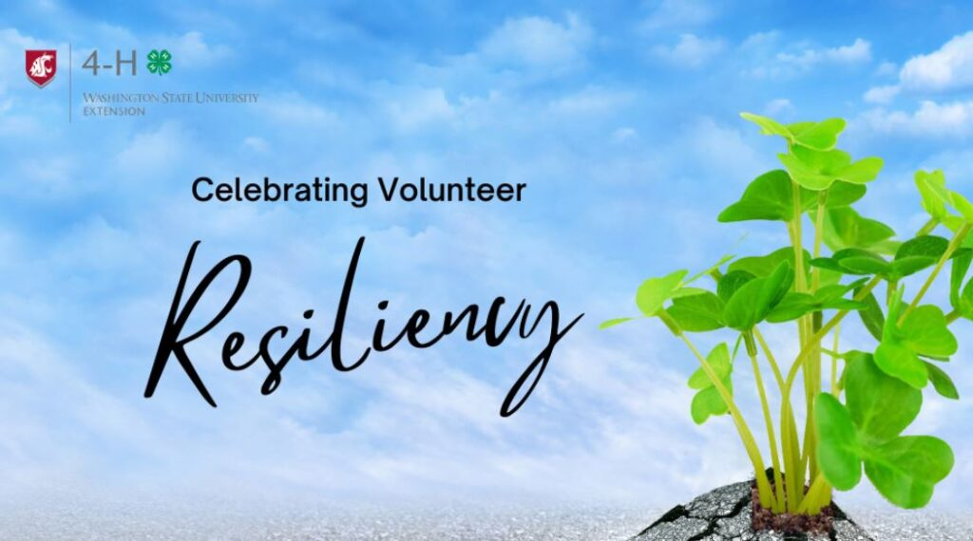

Our volunteers are outstanding! To let them know we think so, and to acknowledge their contributions to the Washington 4-H Program, the time to nominate them for a state award is NOW! All state award nominations are due by August 1 to Tony Dell at adell@wsu.edu. The deadline for the Hall of Fame nominations has been extended to August 1! You will find all nomination forms, including criteria for nomination, at: https://extension.wsu.edu/4h/for-volunteers/wastate-volunteer-recognition/.

Also, remember to honor that volunteer and teen from your county as Outstanding Volunteer and Outstanding Teen of the Year. These forms are due no later than October 1; a picture of your honoree(s) is required by the same date – October 1. If a volunteer/teen does not have a picture submitted, we’ll use a clover logo in its place for the recognition slide show.

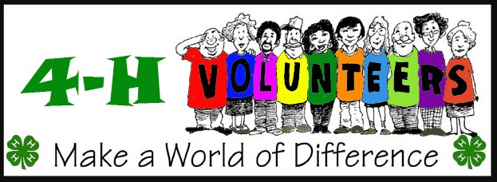

Washington Pork Producers Summer 2022 Newsletter Is Here!

The Summer 2022 edition of the Washington State Pork Producers Newsletter has just been released! Sarah Smith, Extension Regional Animal Sciences Specialist from the WSU Grant/Adams Extension Office, does a great job of providing up-to-date swine information two to three times per year. Included in this issue is information about 4-H/Swine Biosecurity Recommendations, Youth for the Quality Care of Animals information, the impact of high feed costs on youth swine projects, and preventing sunburn in pigs.

To download the newsletter, click HERE!

There are lots of youths participating in swine projects in the State of Washington. Please share this information widely throughout our 4-H community!

Washington State Veterinarian Releases Letter Addressing Avian Influenza and Fairs Recommendations

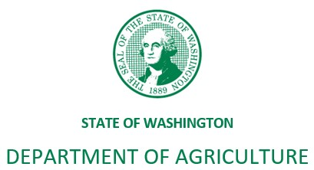

The WSDA strongly recommends temporarily suspending poultry shows, exhibitions, or swap meets until 30 days after the last detection of HPAI in the state. Commingling birds from many farms is extremely high-risk for disease transmission and has potential to create a superspreader event.

Read and download the complete letter HERE

AVIAN INFLUENZA UPDATES
Articles and Links

All About Avian Influenza

If you have poultry or know someone who does, please read through this material and use the links as needed. Currently, the surveillance areas are for 10 kilometers/about 6.2 miles and for 30 days from the point of origin, current information at https://agr.wa.gov/departments/animals-livestock-and-pets/avian-health/avian-influenza/bird-flu-2022, you can see when and where there are confirmed cases around the state. This first one is the updated WSDA website it has the daily update and a brand-new interactive quarantine area map. There is also a new map showing all of the positive locations in the U.S. As of May 17th, at 10 AM there are eight confirmed positive backyard flocks (small flocks), in eight different counties in the State of WA.

Fairs will make their own decisions but remember it is still early for most fairs to make a call on hosting poultry shows at county/community fairs and the surveillance is for 30 days. At this time, this is not a quarantine other than for the properties that have been depopulated.

Currently, migrations of wild waterfowl are the major mode/vector/fomite that is spreading Avian Influenza. However, attention to bio-security practices should be enhanced so that we (people) and our modes of transportation as well as other animals do not become fomites. There is MUCH more information below and many links to help answer your questions and a link to watch a recorded broadcast via YouTube with our WA State Veterinarian Dr. Amber Itle from 5/12/22.

Pam Watson, WSU Lewis County Extension 4-H and Poultry

Avian Influenza in Washington State – What all bird owners should know and think about …

Avian Influenza is in Washington State and since birds use a flyway and don’t stick to the freeways it should be considered everywhere.
Be extra careful during wild bird migration seasons (spring and fall) particularly wild waterfowl, to protect your flock from infectious diseases. Where possible keep birds inside or undercover and check coops, pens, and poultry houses regularly for areas that allow wild birds to perch, nest, or interact with domesticated fowl. Learn more about biosecurity at: bit.ly/DefendtheFlock-Resources (available in several languages).

Please report any unusual or high rates of illness or death in your flocks: WSDA Sick Bird Hotline at 1-800-606-3056.

For food safety questions, call WSDA Food Safety Program at 1-360-902-1876
Contact the Washington Department of Fish and Wildlife to report sick or dead wild birds Report Wildlife Observations (arcgis.com)

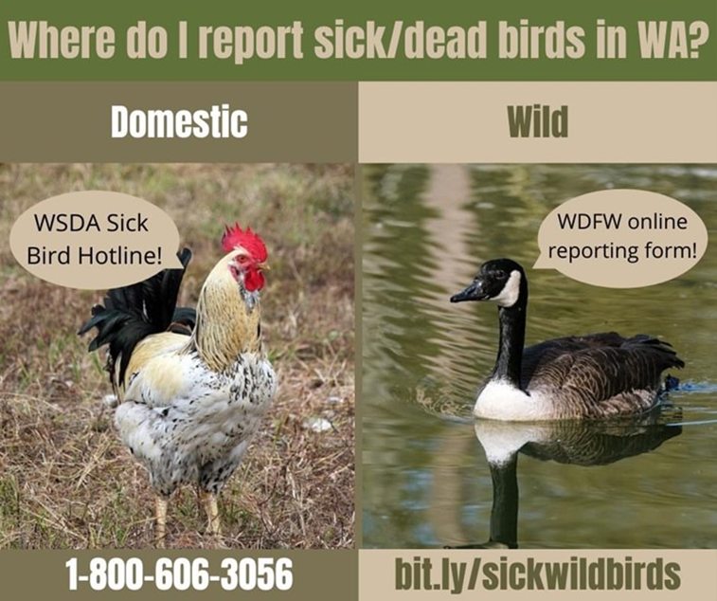

AVIAN INFLUENZA – HOW POULTRY OWNERS CAN PROTECT THEIR FLOCK

Below is a recording of a 2021 WSDA webinar on highly pathogenic avian influenza (HPAI) and steps poultry owners can take to protect their birds from this disease. In this webinar you will learn:
- What HPAI is and signs to look for in your flock
- How the global conditions are similar to the 2014/2015 outbreak of HPAI that reached Washington
- What effective biosecurity means and practical steps you can take to protect your flock
- Where to find additional resources about biosecurity
- When and how to report bird health issues, including suspected avian influenza
You can watch the avian influenza webinar on YouTube.

Pam Watson, M.Ed.
WSU Lewis County Extension
4-H Youth Development Agent, WSU Faculty

May 13, 2022 | Contact: State Veterinarian (360) 902-1878

Quick Links to HPAI Information in Washington
Dr. Amber Itle, Washington State Veterinarian

Good morning! With an all-hands-on-deck response effort at WSDA to contain HPAI, I’m having trouble getting these emails out to you all in a timely way. Please regularly check these resources for up-to-date information. You can join our WSDA bird flu Facebook group, watch pre-recorded you tube videos, monitor our bird flu website and check our WSDA new release website for information about detections in new counties, as well as any guidance about shows and fairs. Please distribute widely. Don’t hesitate to reach out if you have questions or concerns. Responses may be delayed, but we will get back to you as soon as we can.

Washington Bird Flu Updates 2022 | Facebook
WA State Veterinarian Bird Flu Q and A
WSDA News Releases–
2022 Washington Bird Flu Detections
2022 Confirmations of Highly Pathogenic Avian Influenza in Commercial and Backyard Flocks
2022 Detections of Highly Pathogenic Avian Influenza in Wild Birds

State 4-H Ambassadors Present the 4-H Youth of the
Month for June!

The Washington State 4-H Ambassadors recognize the 4-H Youth of the Month honoree for June, Stella Marshall of Skagit County! The Ambassadors are proud to highlight 4-H youth monthly throughout the year!

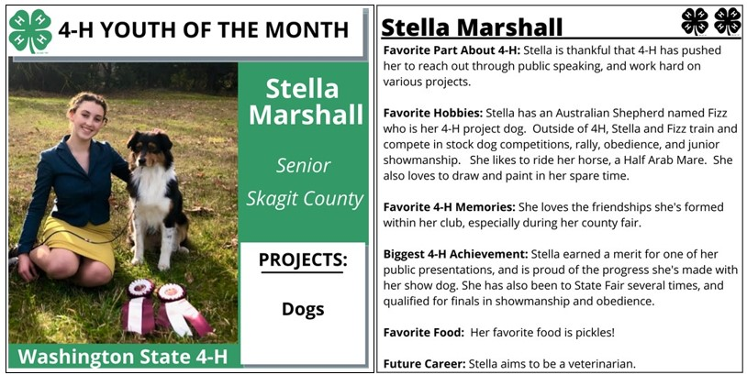

Two Decades Working With Youth Provides Background For New Interim 4-H Director

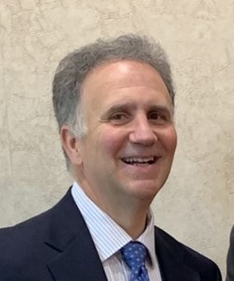
Mark Heitstuman

This feature originally appeared in WSU Insider on June 2, 2022.

Mark Heitstuman has spent over 20 years in Washington State University Extension, helping youths with livestock education, STEM programs, organizing youth camps, and more. He’s worked directly with 4-H students and volunteers as part of his job.

That experience will help Heitstuman as he steps into a new role as interim director of Washington State 4-H starting June 1st.

“4-H is really welcoming to all youth. We can and do make a difference in the lives of young people,” Heitstuman said. “That starts with strong leaders that provide mentorship and help develop skills for students.”

The WSU alum wears many hats in WSU Extension: livestock and community development regional extension specialist, director of Extension for Asotin and Garfield counties, and interim director of Whitman County. He’ll give up the last position as he steps into the statewide 4-H role.

“Mark has a great deal of leadership experience and has worked with 4-H as part of WSU Extension for his entire career here,” said Vicki McCracken, associate dean and director of WSU Extension. “I’m looking forward to working more closely with him over the next year as he leads and guides our dedicated 4-H students, volunteers, faculty, and staff.”

4-H is delivered in Washington by WSU Extension. It’s part of a network of hundreds of land-grant universities serving more than 6 million children through 4-H, nationwide.

Heitstuman has three primary goals for the next year in 4-H:
- Stabilize student enrollment in the organization and increase the number of volunteer leaders for programs around the state.
- Work with 4-H faculty and staff to see what they’re working on and how the state-level organization can help and support them.
- Recruit and retain quality 4-H coordinators, who do much of the day-to-day work with parents and youth in the organization.

“4-H is a powerful force for good around Washington, and there are numerous studies that show the value in 4-H programming,” Heitstuman said. “But to continue the impactful programs we have, we need stability in faculty, staff, and volunteers. That’s how we help and support as many youths as we possibly can.”
A native and resident of Uniontown, Wash., Heitstuman said the call from McCracken asking to take on the interim 4-H director role took him by surprise. But he’s confident he’ll make positive progress on his goals for leading the state organization.

“I can work with a variety of different types of people and have broad experience in programs, especially for youths,” Heitstuman said. “I understand and value the role 4-H plays in helping young people around the state and the nation. I’m looking forward to the challenge of helping this vital organization succeed.”
Heitstuman takes over as interim director from Nancy Deringer, who is currently serving as interim associate dean for Student Success and Academic Programming for WSU’s College of Agricultural, Human, and Natural Resource Sciences.

State Equine Presentations Date Has Been Set; Event Will Be Virtual

The Washington State 4-H Equine presentations, as part of the Washington State 4-H Fair, will once again be a “virtual” contest. It will be held on Sunday, September 11th within the time frame of 10 am to 5 pm. Please connect with your county 4-H staff person with regard to the registration form for this contest for State Fair. The registration form is WS4HF/1.06 and your county 4-H staff person is aware of the usual state fair registration process for state fair events and activities. Your county 4-H staff person must complete the WS4HF/1.06 to verify eligibility for this state contest.

Contest rules are in process, and will be posted soon on the State 4-H Webpage’s Horse page: https://extension.wsu.edu/4h/projects/animal-science/companion-performance/horse/. Please keep in mind – the Equine presentations are part of the National Eastern 4-H Horse Roundup and are not the usual public presentations. The rules have strict time limits and must be focused on the equine industry. So please be familiar with the rules that that will be posted to the state website.

For contest information, education or helpful hints, registration details and eligibility contact Jennifer Leach, 4-H Equine Specialist and State Equine presentation coordinator at jleach@wsu.edu.

Small Equine to Be Offered at 2022 4-H State Fair

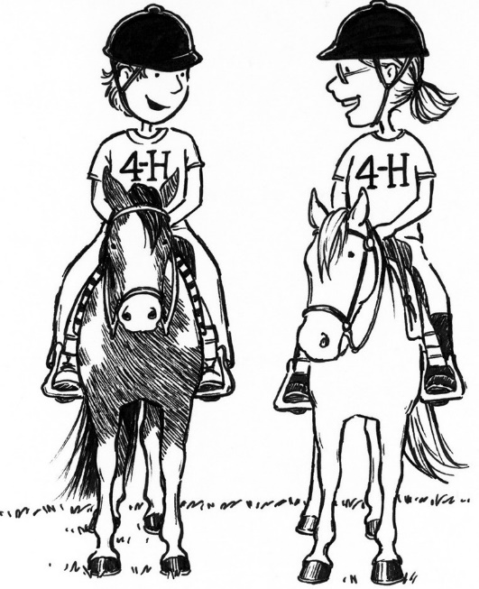

New this year for our 4-H horse members with small equines are show rules for those counties who are interested in expanding their equine program. The Small Equine program was approved at the State Council meeting in October 2019. And yes…we are now getting them out. A thank you to the “ad hoc” Small Equine Committee of Connie Medeiros, Pat Pehling, Kim Lansing, Laura Shackley; Shelby Gossett, and Hannah Kruchek. Small equine will be offered this year at State Fair. If you have questions about Small Equine—please reach out to Connie at her email address of mythicalmeadows@gmail.com. Connie is also the State Fair Small Equine and Harness Driving Superintendent. More information will soon be coming regarding the details of the Small Equine classes being offered at the 2022 4-H State Fair.

Small Equine Show Rules are now posted on the State 4-H Webpage! Click HERE to download them!

Submitted by Jennifer Leach, 4-H Equine Specialist (.25FTE)

Wahkiakum and Naselle Robotics Teams Place 2nd and 3rd In International Contest

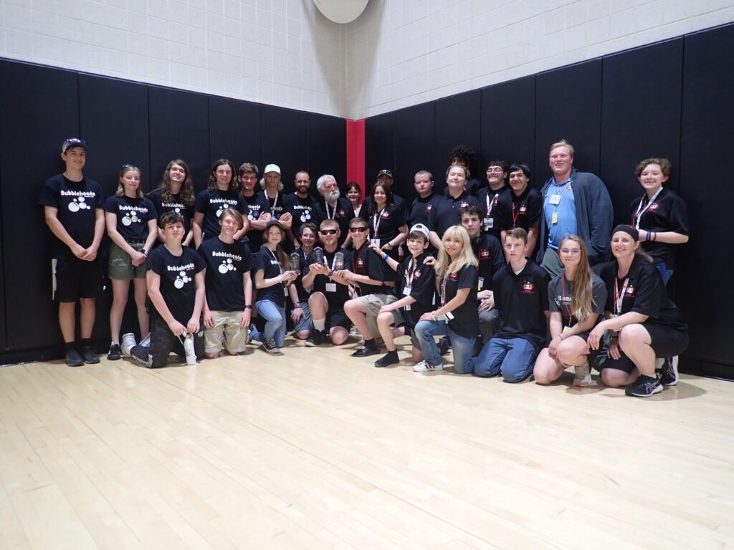

Naselle and Wahkiakum Robotics Teams

Wahkiakum County 4-H and Naselle and Wahkiakum School Districts robotics teams participated in the International SeaPerch Robotics Contest in Annapolis, Maryland, with the final competition taking place on Saturday, June 4th. 137 teams entered the contest from all over the world, participating in three divisions. The Wahkiakum and Naselle Teams competed in the Open Division, presumed to be the most difficult division of the three.

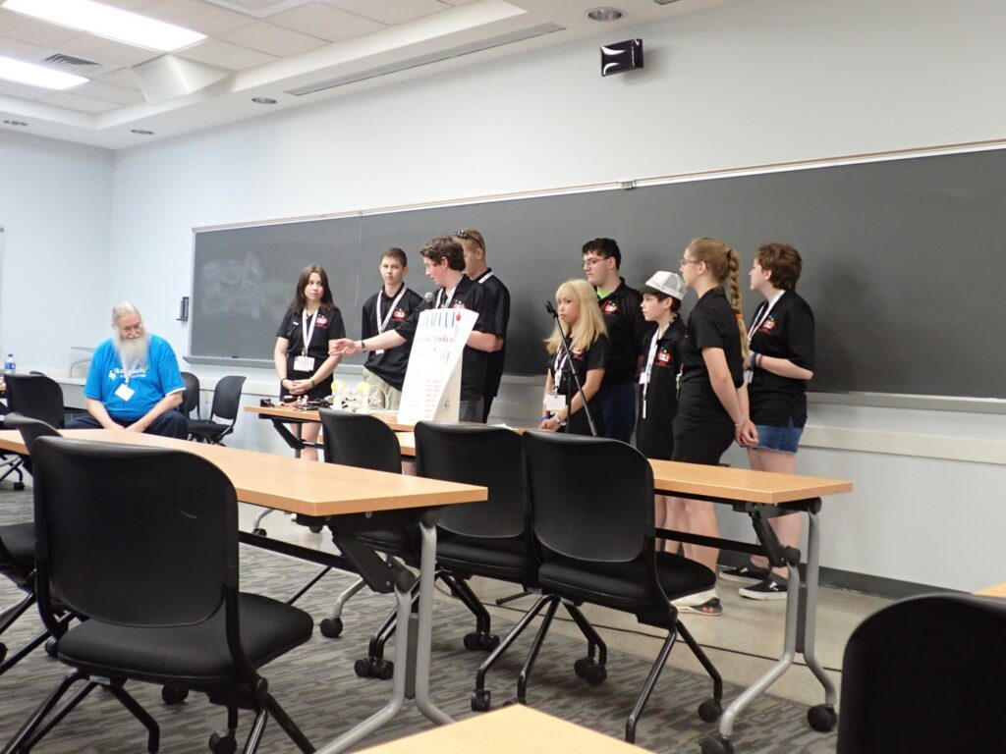

Wahkiakum Robotics Team Presentation

Saturday’s events started with the first competition – presentation of the team’s Engineering Report to other teams at 11:00 am. Students staffed our team table, answering other teams’ questions, while many of our other team members talked to all of the other teams at their own tables – all scouting for next year. Then after lunch, the team drivers got their robots passed through inspection, and waited….finally starting their runs at about 3:45 pm. Team drivers were frustrated that they did not get a perfect score on the Mission Course (one “battery” was dropped). Next came the Obstacle Course competition, where the teams’ best time at home was about 43 seconds. At nationals, the course was stretched out and some hoops turned in ways the teams had not practiced, resulting in a best run time of about 54 seconds.

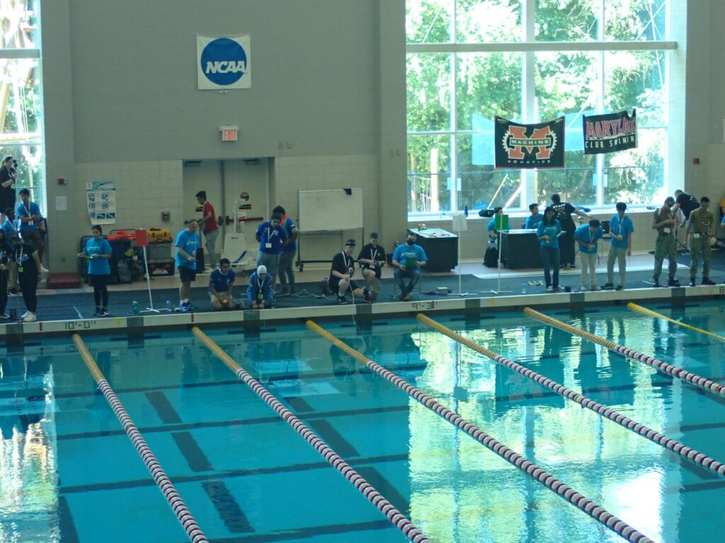

The Robotics Contest “Battlefield”

After dinner came the awards presentation – and the announcements:

Second Place in Open Division for Engineering Design Report: Naselle

Third Place in Open Division for Obstacle Course : Wahkiakum

and finally,

Second Place in Open Division for Mission Course: Wahkiakum

In the first year of participation in SeaPerch. Wahkiakum and Naselle came home to southwest Washington with three trophies! In the Wahkiakum team debrief, the team talked about what was learned from scouting other teams and what can be done better to prepare for next year. Next season starts now for both teams.
Congratulations to the Naselle and Wahkiakum teams for their incredible accomplishment – particularly for a county of 4,200 people with limited school resources. The result speaks eloquently to what 4-H and school collaboration, plus awesome volunteers and community support can accomplish together.

Washington State 4-H Dairy Judging Contest

Set For July 19th

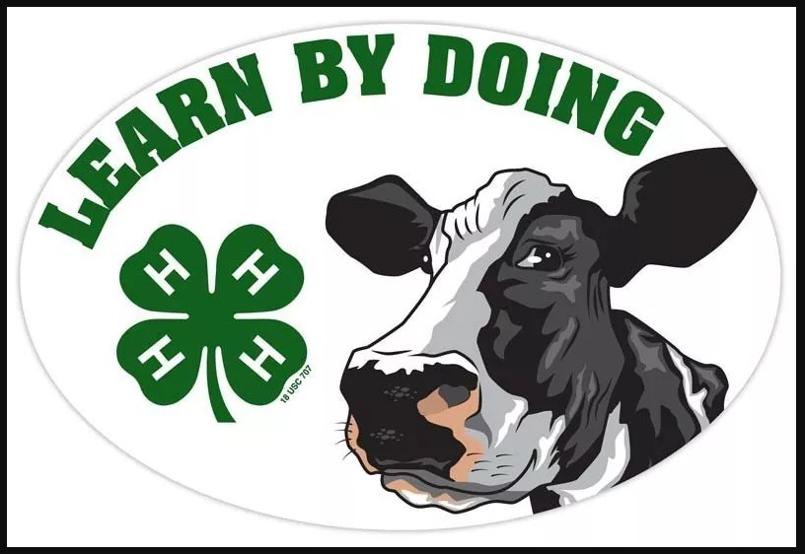

The State 4-H Dairy Judging contest determines the individuals that will represent Washington participating at the National event in 2023.

This year the contest will be held: on July 19, 2022, at the Fairgrounds in Monroe, Washington, starting at 11:00 am.

If you have an individual 4-H’er or team that wants to compete, please contact Gary Fredricks at 360-577-3014 Ext. 3 or at garyf@wsu.edu.

Gary Fredricks
WSU Extension\Cowlitz County
304 Cowlitz Way
Kelso, WA 98626
360-577-3014 Ext. 3
garyf@wsu.edu

COVID-19 RESOURCES

4-H COVID-19 HEALTH AND SAFETY PROTOCOLS

UPDATED MARCH 12, 2022

Washington State University has adopted the Governor’s updated mask policy which is effective March 12, 2022. This policy eliminates the general masking requirement in both indoor and outdoor situations, unless specifically required for a particular location for health reasons (such as clinics). Also eliminated is the general requirement for social distancing among vaccinated individuals. WSU has extended the relaxation of the masking and distancing requirements to those employees who have exemptions from the vaccine requirement (for religious or medical reasons) and have approved accommodations at their workplace.

WSU Extension has therefore adopted the following:

Vaccination Requirements Continue

The vaccine mandate for WSU employees and volunteers remains in place. WSU employees and volunteers must be fully vaccinated or have an approved exemption with an accommodation on file to engage in work with WSU Extension.

Masking Policy Changes

WSU Extension has adopted the Governor’s mask policy effective March 12, 2022. This policy eliminates the general masking requirement in both indoor and outdoor situations, unless specifically required for a particular location such as health care settings and public transportation. This extends to individuals who have an approved accommodation based on a medical or religious exemption, who no longer are required to wear a mask as a condition of that accommodation.

Social Distancing Changes

WSU Extension applies the relaxation of social distancing requirements to those volunteers who are fully vaccinated or have an approved exemption with an accommodation (for religious or medical reasons) on file at their workplace or county office.

PLEASE NOTE – individual offices and locations may continue to require masking and/or distancing at the office level for all office programs in light of local risks and conditions.

GOVERNOR INSLEE’S VACCINATION PROCLAMATION
Announcement Revised September 7, 2021
Governor Jay Inslee issued a health and safety proclamation on August 20, 2021, in response to a continued state of emergency that exists in all counties due to the Covid-19 pandemic. The health and safety proclamation, as ordered by the Governor, includes employees, contractors and volunteers engaged in activities with state agencies and in educational settings. Therefore, WSU (including WSU Extension and the 4-H program) is required to comply with Governor Inslee’s recent vaccination proclamation directives.

With regard to volunteers, below are a series of references, deadlines and explanations that provide further details.
- The Proclamation (21-14.1) can be found HERE.
- Deadline: All current WSU Volunteers are required to be fully vaccinated or exempted by October 18th. Volunteers who are not fully vaccinated or who do not have an approved exemption on file by October 18 will be put on inactive status. They will not be able to engage in any volunteer activities with WSU Extension until proof of full vaccination can be observed or until an exemption request has been reviewed.
- Proof of vaccination: Contact your local 4-H office for information on how to share proof of your vaccination status..
- Exemption process: The state-level exemption process (for religious or medical reasons) can be found at https://extension.wsu.edu/volunteer-exemption/https://extension.wsu.edu/volunteer-exemption/

More information on WSU’s Vaccination Policy is available on the web at https://extension.wsu.edu/vaccination-policy/.

Questions regarding WSU’s Vaccination Policy can be directed via e-mail to extension.vaccinepolicy@wsu.edu

A Reminder: COVID-19 Resources Available from WSU Extension

The WSU Extension COVID-19 Updates and Resources page is updated as new information becomes available. The Link to the page is https://extension.wsu.edu/covid-19/

WASHINGTON STATE RESOURCE GUIDE
FOR PARENTS AND CAREGIVERS:

Caring for Your Family During COVID-19

The Washington State Department of Children, Youth and Families has created a
resource for parents during COVID-19. The WASHINGTON STATE RESOURCE GUIDE FOR PARENTS AND CAREGIVERS: Caring for Your Family During COVID-19 was developed to help parents and their families navigate the pandemic and the days to follow.

The publication is available at
https://www.dcyf.wa.gov/sites/default/files/pubs/FS_0039.pdf

