Extension COVID Update

20 January, 2021

**Trends and Cautions**

Overall, COVID-19 remains a significant safety concern. Continued community transmission, the development of new strains which are more contagious, and reduced compliance with hygiene, sanitation, masking and distancing protocols mean that WSU Extension personnel, volunteers and participants should remain vigilant. Safety remains our first concern – despite the limited availability of vaccines.

**Roadmap to Recovery**

On Monday, January 12, 2021 Governor Inslee issued a new “Healthy Washington – Roadmap to Recovery” proclamation (<https://www.governor.wa.gov/sites/default/files/proclamations/proc_20-25.12.pdf?utm_medium=email&utm_source=govdelivery>). Key elements of that roadmap (<https://www.governor.wa.gov/sites/default/files/HealthyWashington.pdf>) are:

1. Eight regions have been defined to inform a regional approach to managing COVID-19.
   1. Counties within each region are tracked and assigned to (newly-defined) phases by region, rather than at the county level.
   2. All eight regions (hence, all counties) started out in Phase 1.
   3. Phase eligibility is calculated by the WA Department of Health every Friday and will take effect the following Monday.
   4. Regions move up in phases based on new metrics which have been established:
      1. Decreasing trend in 14-day rate of new COVID-19 cases per 100K population;
      2. Decreasing trend in 14-day rate of new COVID-19 hospital admissions per 100K population;
      3. Average 7-day percent occupancy of ICU staffed beds less than 90%; and,
      4. 7-day percent positivity of COVID-19 tests less than 10%
   5. Regions must continue to meet at least three of the four (3/4) metrics to remain in Phase 2. Failure to meet less than three metrics will result in the region (all counties) being moved back to Phase 1 on Monday.
      1. Decreasing or flat trend in 14-day rate of new COVID-19 cases per 100K population;
      2. Decreasing or flat trend in 14-day rate of new COVID-19 hospital admissions per 100K population;
      3. Average 7-day percent occupancy of ICU staffed beds less than 90%; and,
      4. 7-day percent positivity of COVID-19 tests less than 10%
2. As of Tuesday, January 19, 2021, all eight regions remain in Phase 1.
3. Only two phases were defined in the Proclamation. Others will be defined as the situation improves. Below is the summary of activities allowed in Phases 1 & 2:

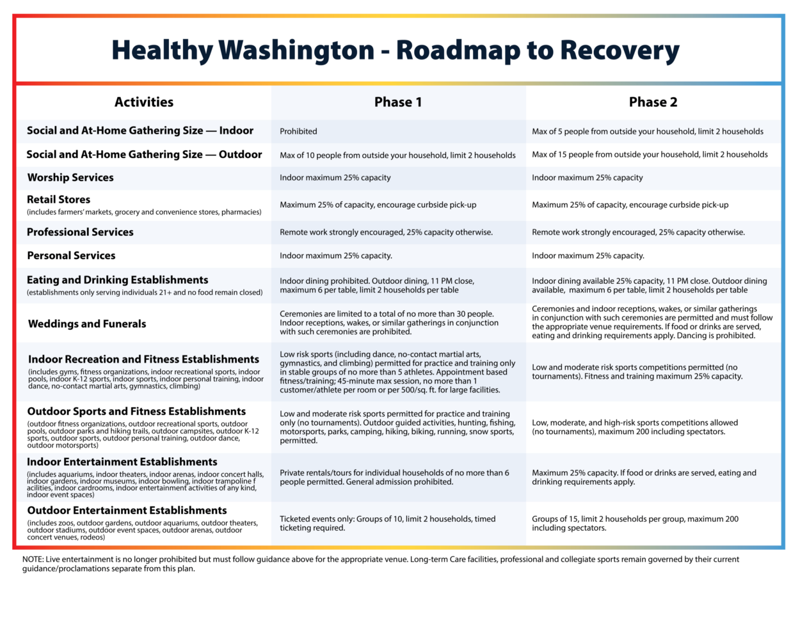

**Vaccination Program**

Washington established a statewide program for vaccination based on input from the CDC and Operation Warp Speed. Washington defined vaccine Phases (different from Roadmap to Recovery Phases). Those original phases have just been changed to reflect changes in federal guidance, and are pending modification (perhaps this afternoon) as the state continues to adapt to new Federal guidelines. The initial Washington vaccination plan was as follows:



There is no specific category for university employees in general or Extension in particular. Individuals may determine which vaccination phase they are eligible for by visiting the WA Department of Health site: <https://form.findyourphasewa.org/210118771253954>

**WSU Extension Activities and Planning**

WSU has determined that the Roadmap to Recovery Phases do not mandate a change in WSU operations under the State’s Higher Education guidelines. (<https://www.governor.wa.gov/sites/default/files/proclamations/proc_20-12.2.pdf?utm_medium=email&utm_source=govdelivery>)

The master planning documents approved by the President’s Council at the beginning of last semester remain in effect. Working from those documents, updated forms for WSU Extension, including a general ***Proposal for In-Person Activity*** and one specific to 4-H have been prepared and will be available through County Directors and Program Directors, or from Mike Gaffney directly. Activities under regional Phases 1 and 2 should include no more than 5 individuals from outside a single household, not counting responsible Extension participants. Any proposed resumption of in-person activity must be routed through the appropriate County Director for review & endorsement, then through the appropriate program director to Mike Gaffney and Vicki McCracken for final review and approval. Continuing efforts should complete the required approval process within three weeks. The emphasis in any proposed resumption of in-person activities must be on safety, with reference to specific guidance for “Child Care, Youth Development, and Day Camps During the COVID-19 Outbreak” issued by the Washington Department of Health dated December 21, 2020, as amended. Any activity which can be accomplished at a distance should be.